Standard Operating Procedures
Club Name: Wombourne Kayak Club
Affiliation Type: Unincorporated association
Club Chair Name: Paul Elkington
Number of club members: 77
Open to the Public: Yes, at the pool until person has attended 3 sessions.
Contact Details: Chairman paulelkington@gmail.com Secretary John Teuwen johnteuwen@hotmail.co.uk
Paddle UK - Go Paddling: Wombourne Kayak Club | Paddling Clubs Near You (gopaddling.info)
Club Address: Short Wood Sports & Outdoor Centre, Arthog Outreach
Limekiln Lane
Wellington
Postcode: TF1 2JA

Unincorporated association

An unincorporated association is particularly well suited to smaller, simpler clubs.
This is the most common type of structure for an amateur club, largely because it is the easiest, cheapest, and most informal way of forming a club.
Typically, these clubs would not employ staff, own significant assets (e.g., land, investments, or facilities) or enter significant contracts.
Some of the advantages and disadvantages of running a sports club as an unincorporated association A
Paddle UK - British Canoeing Membership
See Wombourne Kayak Club Welcome Pack or an explanation of the different membership categories.
Paddle UK/British Canoeing Insurance
A Definition of Club Activities – See Paddle UK- Insurance information, Insurance Contact and “The Club Activity Triangle” set out in page 3:
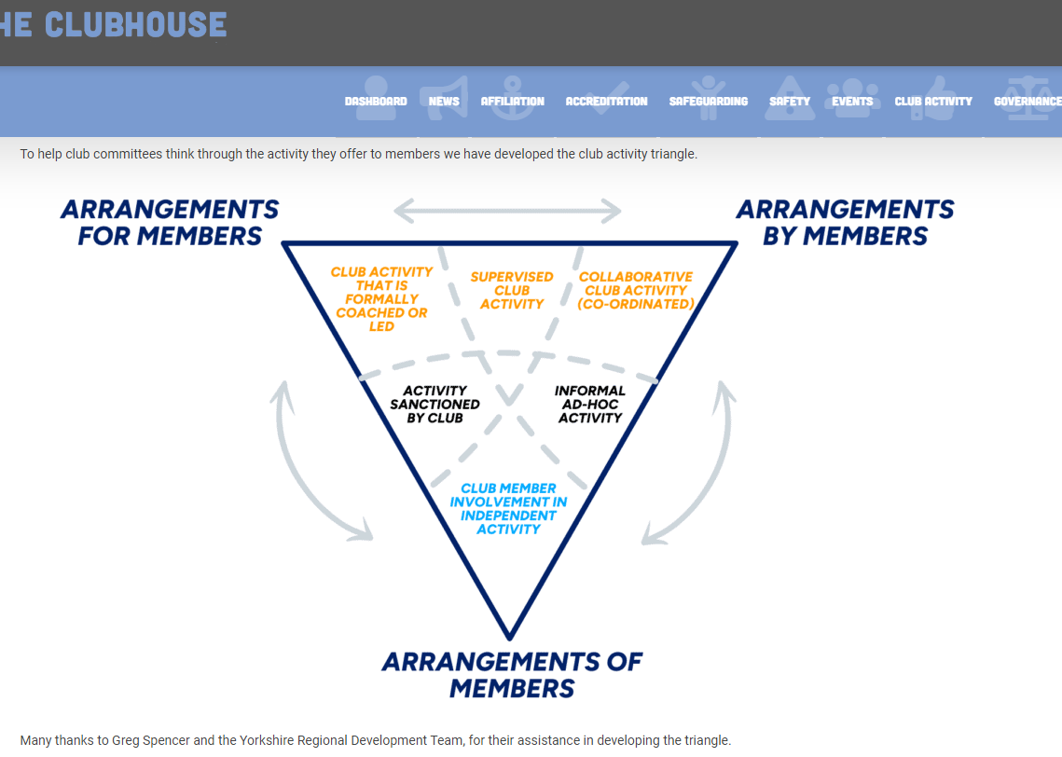

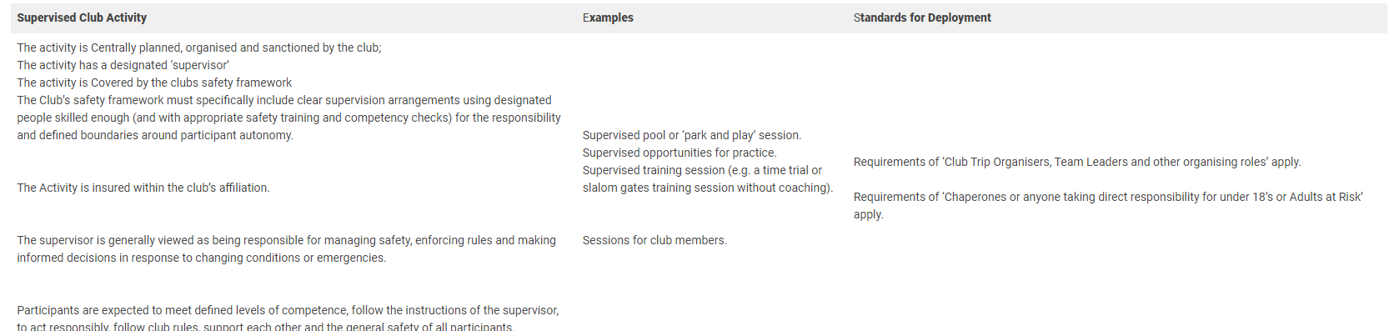
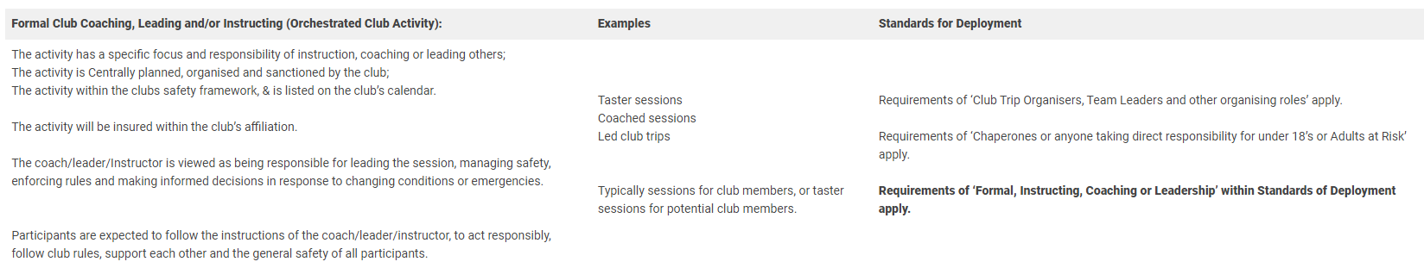
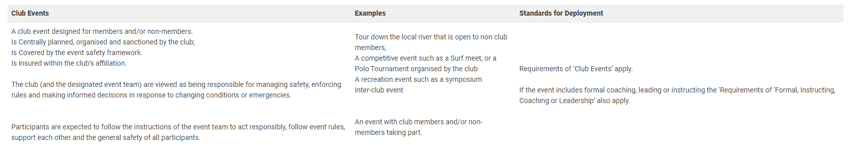
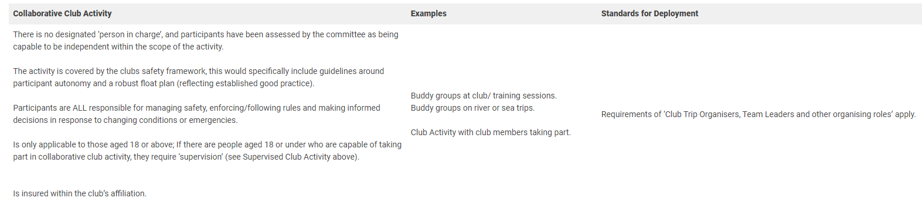
“Event activities can also include inter-club activities where one club (host club) is responsible for risk assessment, management of the activity and sharing this information with the other clubs who take part, providing all clubs involved recognise it as part of their official club activities” (see above definition)
“Club Associate Members are covered for third party liability insurance for any paddling activity within their club that has had due diligence/risk assessment carried out by the relevant and accountable club representative(s) and is organised and delivered by club members (or others appointed by the committee) for club members and promoted on the official club calendar, website, social media or noticeboard”
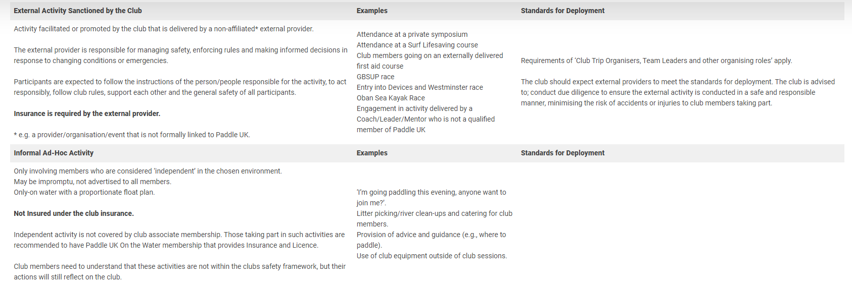
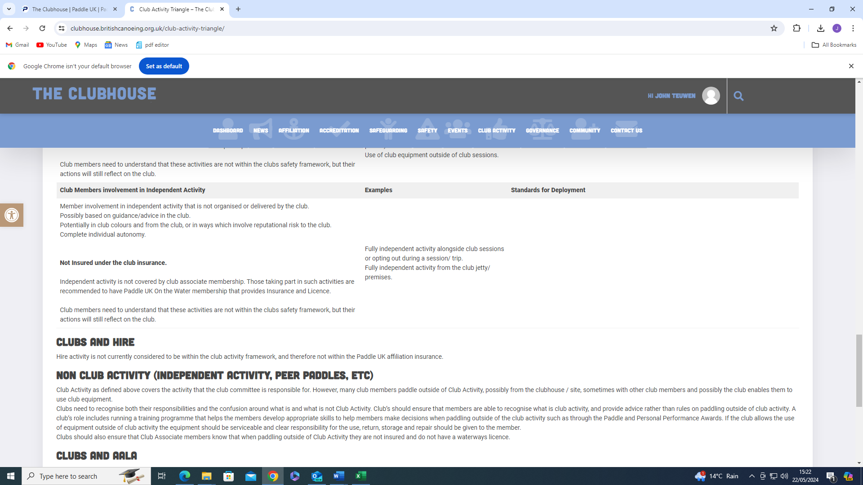
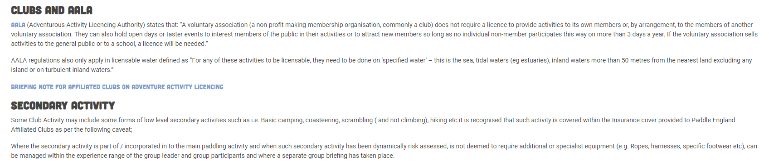
Q. What do we consider as a “Peer or Club Trip”? Phil Hadley’s definition?
“PEER” = Communicate with paddlers by PERSONAL mobile, WhatsApp, email but NOT through the CLUB social media, such as WhatsApp, Facebook, website, emails etc.
“CLUB TRIP” = Communicate through CLUB social media, mobiles, CLUB emails, CLUB Website, etc.

Guide to Insurance Cover
The following is a guide to insurance cover provided by the Club’s governing body British Canoeing.
It is important to note that the insurance described below is Third party / civil liability insurance
This provides cover that protects a member if they cause an accident injuring or damaging someone else or someone else’s property. Compensation is paid from the insurers to the person pursuing the claim with the injury/damage, so the member does not have to pay. Coaches and leaders also have Professional Indemnity insurance, which is cover that protects coaches who provide advice or a service to the people they are coaching. It protects coaches against legal costs and claims for damages to third parties which may arise out of an act, omission, or breach of their professional duty during their coaching.
It should be noted that “peer paddles”, independent paddling and competitive paddling are not included. Individuals taking part in these activities are recommended to join as full members of British Canoeing or seek alternative insurance arrangements.
Paddle UK / Canoe Wales Members
Members of National Governing bodies receive Third party / civil liability insurance during all paddling activities, whether Club or independently organised
Paddle UK / Canoe Wales Non - Members
Full Club members who do not belong to a National governing body receive Third party / civil liability insurance during Club organised activities as part of the Club’s BC Affiliation. You are not covered if you are participating in activities that are not organised by the Club, e.g. peer paddles (paddles that are organised independently by a group of people who may or may not also be members of Wombourne Kayak Club)
Pool Sessions
All attendees at pool sessions organised by the Club receive Third party / civil liability insurance
Paddle UK – Guidance for Paddlers & Pool Managers

Club Guests
Guests are covered for 3 sessions. After 3 sessions the guest must decide if they will join the Club or not.
It is very important that you understand that the insurance described above is third party liability insurance to protect you from claims against others, and does not in any way cover you, the participant, for injury, loss of earnings, or loss of equipment while participating in any white-water kayaking activity or pool session
If you wish to be covered for personal injury, loss of earnings, or loss or damage to equipment you must take out this insurance privately at your own cost.

Health and Safety (Policy)
See Wombourne Kayak Club Health & Safety Policy – Bibliography for an explanation of General Statement of Policy, Organisation and Responsibilities for carrying out the policy and Arrangements for ensuring safety and health of members, see WKC H&S website. Hence, the Paddle UK/WKC – Safety Officer Role Descriptor, WKC –Safety Officer-What to do? oversees health and safety within the club and advises the Committee, particularly on Duty of Care. Paddle UK “PaddleBot” – Duty of Care:
In the context of paddlesport, "Duty of Care" is a fundamental principle that everyone involved in the sport should adhere to. This includes National Governing Bodies, coaches, leaders, paddlers, club officials, centre managers/providers, and event organisers. The key points of Duty of Care are:
1. Responsibility for Safety: Everyone should take responsibility for their own safety both on and off the water.
2. Avoiding Risk to Others: Ensure that your actions do not put others at risk.
3. Using Skills and Knowledge: Use your specific skills, knowledge, and experience to protect others from foreseeable risks.
In legal terms, Duty of Care means that we owe a duty to our ‘neighbours’ not to cause them injury through negligent acts or omissions. A dynamic approach to decision-making is recommended, considering the environment, individual abilities, and the activity being undertaken. Recording decisions and reporting incidents to Paddle UK is encouraged as good practice.
Paddle UK – Duty of Care
Hence members must complete WKC Membership & electronically:
- WKC Consent Forms
- WKC Code of Conduct
WKC must implement Paddle UK policies – Environmental Definitions , standards of deployment Policy , summary of roles and requirements for Club Coaches, Instructors, Leaders, Committee Members – Note: Coaches, Leaders, Instructors must operate within their Remit when organising club activities. Standards of Deployment; Glossary, Terms, Paddle UK- Standards of Deployment Website page, e.g. FAQs, DBS process
An annual audit of activities to be undertaken, See Paddle UK/British Canoeing – H&S Trip Checklist
First Aid & Accidents
Where are the first aid kit and accident book located?
Pool: Lifeguard attending the session has a 1st Aid Kit at hand and in the Leisure Centre Office
River Trips: Each coach carries a 1st aid kit, depending on the location, e.g., Jackfields located in vehicle in the car park. On river trips paddlers designate a person to carry 1st aid & other essential kit in group’s boats.
Who is the main contact for First Aid at the club?
Each river trip will have a designated leader, however within paddling groups will be coaches at different levels with appropriate and current 1st aid training.
Where can the contact be located?
As part of the Wombourne Emergency Plan (Pre-On the water), a designated person is contacted to inform when “On & Off” river to ensure appropriate support, e.g., Emergency services can be contacted if required or designated leader has a phone and automatic “Text” to contact them.
Paddle UK – Reporting an Incident any significant Paddlesport incident reported helps to establish an accurate picture of safety across the country and help identify any issues and concerns to improve safety. Paddle UK – Safety Updates can also update the club about current issues and concerns.
Who is responsible for the maintenance of the first aid box?
Each coach is responsible for their own personal kit on river trips; however, at the pool the Centre Manager manages the maintenance of the 1st Aid.
Who else is responsible for providing First Aid?
Pool: Centre Manager
River Trips: Individual coaches & members: Rich Dowen, John Teuwen, Paul Elkington, Rich Teague, Neil Robinson, Shellie Hughes, Ellie (Paramedic) & Steven Drakeley, Rob Statham, Stephy Blount

Is there a document in the club to detail who can provide First Aid?
Pool: Centre Manager
River Trips: Individual coaches, however, as part of the club routine paddlers check who is providing the necessary 1st aid and other essential kit during the trip or club night, which is part of the “Safety” briefing.
Coaches/leaders use personal 1st Aid Kits – Responsibility of individual members to check and update 1st aid kit.
See Paddle UK – Paddlesafer 2025 is a comprehensive guidance to safety for paddlers, clubs, coaches, event organisers, and anyone involved in paddlesport.
SECTION 4 - HEALTH AND MEDICAL CONDITIONS
4.1 First Aid
4.1.1 e-learning activity – Free first aid package
First Aid Outdoor kit list

Fire & Evacuation
Please detail the clubs fire and evacuation procedure (e.g., where is the fire exits, where should members meet once evacuated?)
Pool: Centre Manager, club members are aware of the fire exits & assembly points
Where is the location of fire extinguishers?
Pool: Centre Manager and her staff have overall responsibility.
Who is responsible for maintenance of fire extinguishers?
Pool: Centre Manager
Do you have a signing in sheet to record members inside the premises?
Pool: Centre Manager, no. Although money is collected through bank transfer to WKC Account and names are recorded into the Pool Account when using the pool.
Who is responsible for the roll call, to ensure no one is missing? (Name/Position)
Pool: Centre or Duty Manager, designated Committee member attending the pool session.
Where are the Emergency contact details (for all members) kept in case of an emergency?
Emergency contact details (for all members) kept – John Teuwen Secretary 07960603786 johnteuwen@hotmail.co.uk
All members have Next of Kin on Mobile Phones in “Locked” mode.
In addition, Committee Members have access to:
Paddle UK – Club Portal, which records personal details and Next of Kin and https://wombournekayakclub.org/
Emergency Procedures
Source:
See Wombourne Emergency Plan (Pre-On the water)

See Paddle UK - Paddlesafer for Paddlers, Clubs & Volunteers, See WKC – Safety Checklist – Trip Activities 2025

See WKC Checklist Clubs & Activities
- Section 2 – Planning 2.1 (a), (b), (c) 2.2
- Section 3 – People 3.1, 3.4
- Section 4 – Equipment 4.4, 4.5
- Section 5 - Reporting & Recording of Incidents - 5.1
Do you complete Incident/Accident Forms? Yes
Pool: Centre Manager – Yes River Trips: Yes Agreed at AGM March 2020

Complete the Incident Form found on the Wombourne Kayak Club (Club Website). Inform John Teuwen, before we complete the Paddle UK/British Canoeing Reporting an Incident, and Guidance for Paddlers & Pool Managers
Who is responsible for completing the Incident/Accident Forms?
Pool: Centre Manager – Yes River Trips: Individual coach to be sent to John Teuwen
017960603786 johnteuwen@hotmail.co.uk

How often are the Incident/Accident Forms reviewed? Who are these reviewed by?
Pool: Centre Manager – Yes River Trips: Yes after each incident/Accident by The Committee.

Note: It is usually best practice for the forms to be reviewed by the Club Committee and copies should be forwarded to Paddle UK/British Canoeing for insurance reasons.

How long are forms kept on record for within the club? Forms should be kept more than five years!
Pool: Centre Manager – Yes River Trips: Yes – Agreed at AGM March 2020

Name of designated Paddle UK/British Canoeing expert to help with enquiries:
River Trips: Rich Dowen, Paul Elkington, Stephy Blount, John Teuwen

Paddle UK – Major Incident Response Checklist
Paddle UK - Emergency Response Card
WKC - Casualty Card

Note: In the event of a serious incident, what instructions are there with respect to dealing with the media. Speak to Paul Elkington, Club coaches must NOT discuss any event with the press or admit liability to any party!

Discipline
Please outline the club’s policy regarding bad behaviour, infringement of the rules etc.

Some clubs operate a three-strikes-and-you’re-out response. In these cases, the individual or parent/guardian shall be informed of each strike in writing from the Club Chair.

In some instances, it may be necessary to ban a member at the first infringement for the safety of club members or in the interest of the club’s reputation

Source:

Club Constitution 2022,

Disciplinary Procedure –

- Paddle UK/WKC – Disciplinary Procedures 2025
- Paddle UK/WKC – Guidance for holding a Disciplinary hearing 2025

Paddle UK/British Canoeing– Paddlesafer SECTION 1 – CULTURE AND PRACTICE
1.1 Safety Culture and Duty of Care
- Paddle UK – EDI Statement 2025
- WKC – EDI Policy 2025
- WKC- Social Media Policy 2025

1 .4 Roles and Responsibilities
Coaches, Leaders, Instructors must operate within their “Remit” and Standards of Deployment Summary of roles and requirements, e.g. Update & complete
- Code of Conduct for coaches
- Risk Management & Risk Assessment
Committee Members under Standards of Deployment Summary of roles and requirements:
- Safeguarding
- Recommendation; Risk Management & Risk Assessment

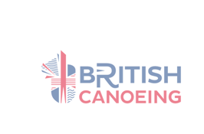
Safeguarding
Non-members/ Visitors:
Safeguarding:
Members or guests under 18, must be supervised by Parents/Guardians at the pool, club night or club river trip including transporting to the location and accompanying them on the river supported by valid qualified river leaders or coaches who have a current DBS Extended Certificate.
What are the clubs’ policies regarding non-members or visitors in the changing room facilities?
Public changing room to be supervised by Parents/Guardians. This applies to Thursday Club Night and Saturday river trips where under 18 members have appropriate changing towel for the Jackfield site and specific river locations.
Children will not be permitted to leave the centre without the knowledge or permission of the Coach.
Saturday Pool session will start time is 4pm to be supervised by Parents/Guardians. This applies to Thursday Club Night, which starts at 5pm., until twilight and for Saturday River Trips at specific river locations.
Unknown person(s) picking up a child should make themselves known to the Coach on arrival of dropping the child at the centre.
Finish time is 5.00 to be supervised by Parents/Guardians.
Club Child Protection and Vulnerable Adults Policy
Qualified river leaders or coaches and designated Committee members to follow designated Safeguarding policies, procedures to be found:
WKC – Safeguarding Website
Paddle UK – Safeguarding Website
Paddle UK – G21 Safeguarding Training Requirements

Does the club have a Child Welfare Officer? Yes
If yes, please detail Name and Contact details: Neil Allen, Welfare Officer (Consultant)
John Teuwen Phone: 07960603786 Email: johnteuwen@hotmail.co.uk
How often is this Policy reviewed? This Policy is reviewed annually
Club Equipment
Please detail who is responsible for logging equipment and routinely safety checks?
David Allen
Source:
See Paddle UK- Paddlesafer for Paddlers, Clubs & Volunteers 2019

See WKC – Safety Checklist – Trip Activities 2025
Who can use club equipment and when?
See WKC – Booking Equipment Procedure
Pool: Designated coaches & club members River Trips: Designated coaches & club members
What are the requirements for non-members using the equipment? (E.g., school groups)
Not applicable

Can club equipment be taken off site for use?
See WKC – Booking Equipment Procedure
River Trips: Designated coaches organise & allocate to club members
How and where should equipment be stored?
River Trips: Collected from either designated Committee members homes or Telford Canoe Club container or individual personal equipment is loaned to paddlers.
How are faults reported and recorded?
David Allen will report to the Committee.
Who opens? (E.g., Officials, Club members)
Telford Canoe Club: designated WKC coaches
Who locks up?
Telford Canoe Club (TCC): designated (TCC) Committee members supported by WKC coaches
What are the rules for locking the Club at the end of the day?
Telford Canoe Club: designated (TCC) Committee
Where are keys kept?
Telford Canoe Club: designated (TCC) Committee

Who has keys/access to keys?
Telford Canoe Club: designated (TCC) Committee
Where are spare keys kept (if any)? None Where are the keys to equipment stores kept (if any)? None

Declaration
Wombourne Kayak Club hereby adopts and accepts this as a current operating guide regulating the actions of members. Electronically signed, but to be confirmed by individual Committee Members.
Name | Paul Elkington | Position | Chair
Sign | Paul Elkington | Date | 17/05/2025 Re-elected
Name | Stephy Blount | Position | Vice Chair
Sign | Stephy Blount | Date | 12/08/2024
Name | Paul Elkington Signed Signatures: J.Teuwen, Paul Elkington, Rich Dowen | Position | Treasurer
Sign | Paul Elkington | Date | 17/05/2025 Re-elected
Name | Neil Allen | Position | Welfare
Sign | Neil Allen | Date | 12/08/2024
Name | John Teuwen |  | Health & Safety, Secretary, Clear Access, Clear Water
Sign | John Teuwen | Date | 12/08/2024
Name | David Allen | Position | Equipment
Sign | David Allen | Date | 12/08/2024
Name | Rich Dowen | Position | Coaching Coordinator for beginners (New Role)
Sign | Rich Dowen | Date | 17/05/2025 Re-elected
Name | Shellie Hughes | Position | Committee Member (North Wales)
Sign | Shellie Hughes | Date | 17/05/2025 Re-elected
Name | Cris Hughes | Position | Committee Member (North Wales)
Sign | Chris Hughes | Date | 17/05/2025 Re-elected
Name | Ellie Drakeley | Position | Committee Member (West Midlands)
Sign | Ellie Drakeley | Date | 12/08/2024
Name | Adam Cooke ??? | Position | Membership Secretary
Sign |  | Date

Reviewed by John Teuwen 15/07/2025
British Canoeing, National Water Sports Centre, Adbolton Lane, Holme Pierrepoint, Nottingham, NG12 2LU

