Wombourne Kayak Club – Standards of Deployment, Club Structure Checklist
Club Structure- Policies and Procedures As part of our existing affiliation process, any affiliated club must have relevant and up to date policies and procedures that contain information on best practice. These must be publicly available and include, as a minimum.
Policies: Publicly available | Website: https://wombournekayakclub.org/
Constitution, Articles of Incorporation or similar governance document (Guidance) | √
Safeguarding Children Policy | √2025
Safeguarding Adults Policy | √
River Guides | √2025
Risk Assessment | √2025
H&S Policy | √2025
Code of Conducts | √2025
Equality Policy | √2025
Disciplinary Policy | √2025
Privacy and GDPR Policy | √
Club Membership (Club Portal) | √
Club Volunteers: Members Full or Associate Affiliation renewal | √Check Oct.25
Club Volunteers: Role Descriptors (Not EDI) | √
Operating Standards (Review & update) | √
Draft Quality Club Affiliation Toolkit Assessment | √Review

Wombourne Kayak Club Committee: Standards of Deployment
Safeguarding:  Committee Members  NB: every 3 yrs., Safeguarding refresher  (C) Committee |  | Code of Conduct: Coaches, Leaders |  | Risk Management & Risk Assessment: Coaches, Leaders, Trip Organisers |  | Time to Listen:  Welfare Officer  NB: every 3 yrs., safeguarding refresher |  | UK Coaching Safeguarding Children in Sport or LA Designated Safeguarding Lead Training L3: Welfare Officer,  Trip Organisers & Team Leaders (Intro to Safeguarding or UK Coaching Safeguarding Children in Sport)  NB: every 3 yrs., Safeguarding refresher |  | Event Safety Management Training:  Safety Officer |  | DBS
John Teuwen SWC C | √ |  | √ |  | √ | ? | √ | NB: every 3 yrs., refresher |  | Event Safety Trg. | √ |  | √
Paul Elkington WWL, C | √ |  | √ |  | √ |  |  |  |  |  |  |  | √
Stephy Blount WWL, WWC C | √ |  | √ |  | √ |  |  |  |  |  |  |  | √
Rich Dowen WWCC | √ |  | √ |  | √ |  |  |  |  |  |  | 2027 | √
Dave Bennett SWC | √ |  | √ |  | √ |  |  |  |  |  |  |  | √
Zoey Rowe?????
(Not Valid -Coach)
David Allen C | √ |  |  |  |  |  |  |  |  |  |  |  | √
Neil Allen C | √ |  | √ |  | √ |  | √ | L3&4 Safeguarding Children/Adults | √ |  |  |  | √
Ellie Drakeley C  Adult and Paediatric Training. | L3 |  |  |  |  |  |  |  |  |  |  |  | √
Matt Clive WWLT | √ |  | √ |  | √ |  |  |  |  |  |  |  | √
Neil Robinson WWLT | √ |  |  |  |  |  |  |  |  |  |  |  | √
Andy Boulton | √ |  | √ |  | √
Rob Statham SWC | √ |  | √
Charlotte Statham SWC | √ |  |  |  |  |  |  |  |  |  |  |  | √
Chris Edwards | √
Cris Hughes C
Shellie Hughes C
Keith Bold |  |  |  |  |  |  |  |  |  |  |  |  | √
Ken Dinning | √

Wombourne Kayak Club Committee: Standards of Deployment
Safeguarding:  Committee Members  NB: every 3 yrs., Safeguarding refresher |  | Code of Conduct: Coaches, Leaders |  | Risk Management & Risk Assessment: Coaches, Leaders, Trip Organisers |  | Time to Listen:  Welfare Officer  NB: every 3 yrs., safeguarding refresher |  | UK Coaching Safeguarding Children in Sport or LA Designated Safeguarding Lead Training L3: Welfare Officer,  Trip Organisers & Team Leaders (Intro to Safeguarding or UK Coaching Safeguarding Children in Sport)  NB: every 3 yrs., Safeguarding refresher |  | Event Safety Management Training:  Safety Officer |  | DBS
Julia Ginniff | √ |  | √ |  | √ | ? |  | NB: every 3 yrs., refresher |  | Event Safety Trg. | √ |  | √
Gemma Holloway | √
Issac Linney | √
Simon Pond (1st Aid -Expired)
Keith Pullen (1st Aid -Expired)
Tanya Trott

Committee Member (C )
Whitewater Leader Training (WWLT), Whitewater Leader (WWL), Whitewater Coach/Moderate White water (WWC) Sheltered Water Coach (SWC)

NB. When completing any eLearning or other listed courses, can you print out your certificate, because the Club Portal Members qualifications do not always record.

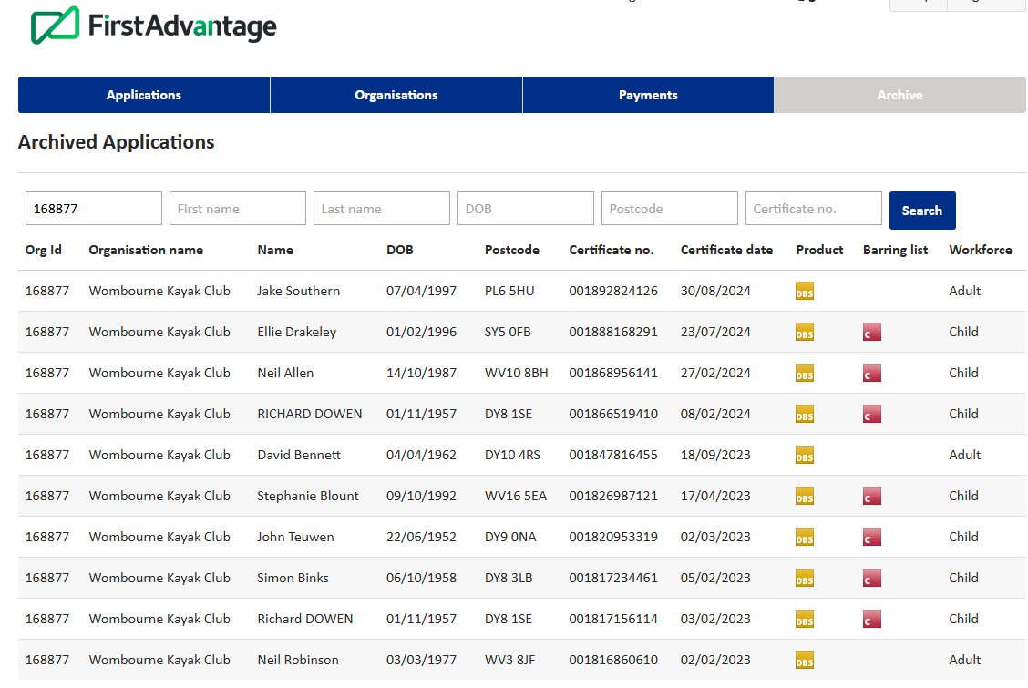
Status Check by Paddle UK

Rich D.Renew in 2027
19/08/25

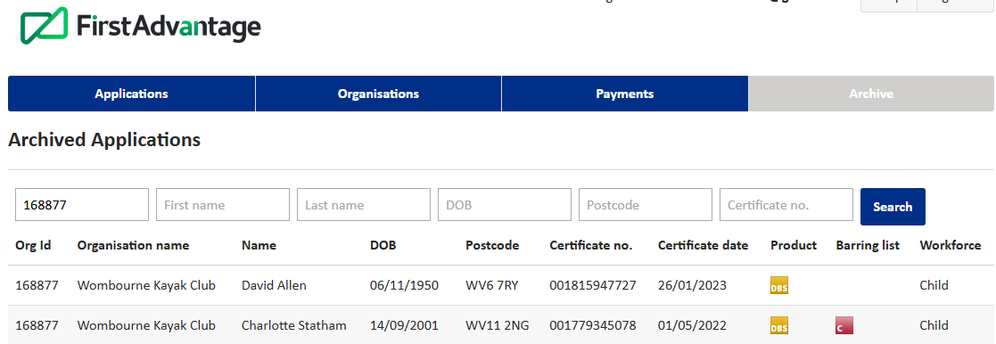
Status Check by Paddle UK

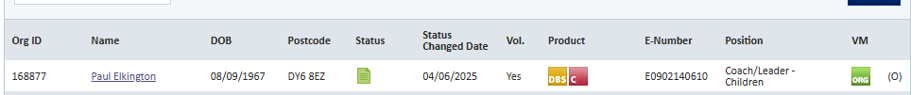

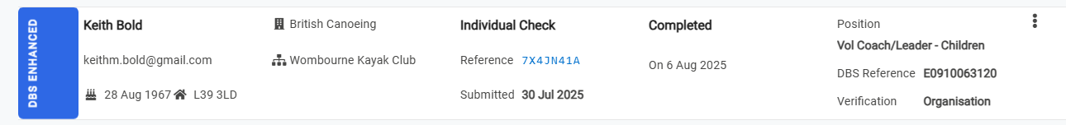

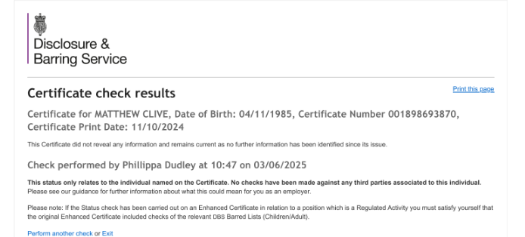

Club Development Plan: Candidates

Andy Boulton Paddlesport Instructor & Provider, 1st Aid √
Matt Clive WWLT (To do): Code of Conduct, Risk Management & Risk Assessment
Chris Edwards Paddlesport Touring (Multi Craft) (To do): Code of Conduct, Risk Management & Risk Assessment, DBS
Gus Ventnor WW Safety Advanced (To do): Code of Conduct, DBS
Andy Neilson Paddle Sport Leader & Instructor (To do): Code of Conduct, Safeguarding, Risk Management & Risk Assessment, DBS
Keith Pullen WWL, WWC WW Safety Advanced (To do): Code of Conduct, Safeguarding, Risk Management & Risk Assessment, DBS
John Edwards England C1 canoe slalom team for 4 years (To do): Code of Conduct, Safeguarding, Risk Management & Risk Assessment, DBS
Prem division paddler for longer
Charlotte Frazier WWLT, Paddle Sport Instructor, WWS Ad (To do): Code of Conduct, Safeguarding, Risk Management & Risk Assessment, DBS
Issac Liney SWC (K&C) WWL, WWC (To do): Code of Conduct, Safeguarding, Risk Management & Risk Assessment, DBS
Keith Bold BCU 3* Kayak, WWSR (To do): Code of Conduct, Safeguarding, Risk Management & Risk Assessment, DBS
Ken Dinning WW Safety Advanced, WWLT/C (Expired) (To do): Code of Conduct, Risk Management & Risk Assessment, DBS
Tanya Trott WW Safety Advanced, Sheltered/Flat Water Coach, core (To do):
Gemma Holloway PSR PSL Core coach, Sheltered WT, no assess. (To do):
White water performance award
Julia Ginniff PSI PSL, Core Coach (To do) Code of Conduct, Risk Management & Risk Assessment, DBS

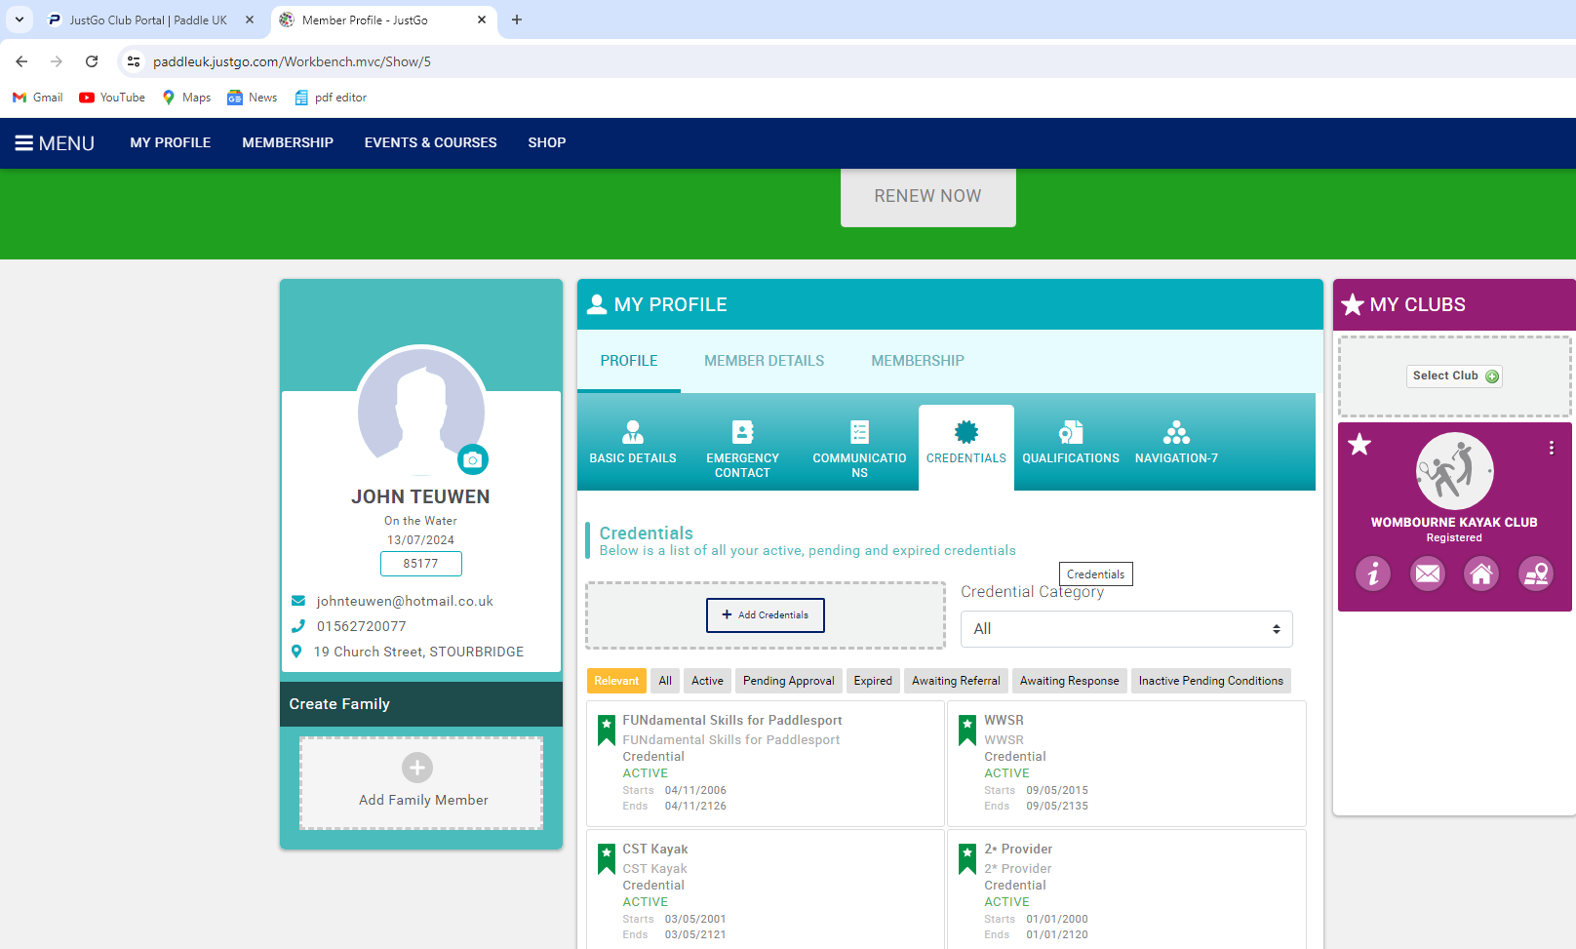
Also check your Individual Members Portal, see below.

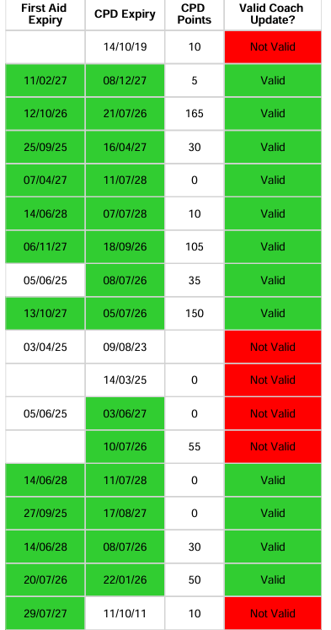
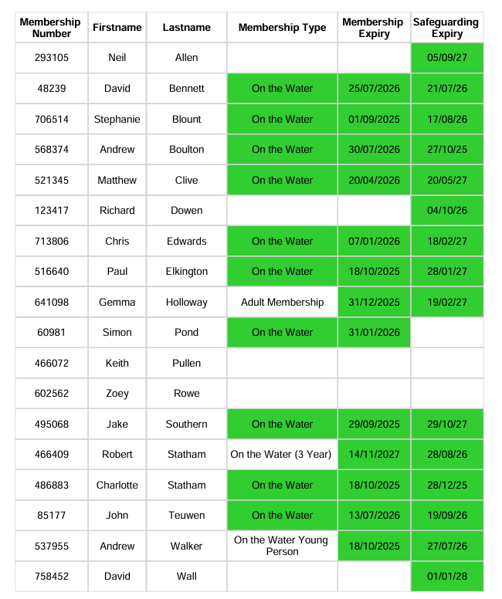

DBS = Enhanced Certificate; will be updated every year by Paddle UK under annual renewal service, 3 pieces of evidence, e.g. = Birth Certificate, Driving Licence, Passport
Website Links.
https://drive.google.com/file/d/1JWJybgJZ37rF8nrhjfYBxtA58ARMgn5G/view Standards of Deployment (Webinar 1) presentation
https://paddleuk.org.uk/standards-for-deployment/
https://paddleuk.org.uk/shared-files/31461/Standards-for-Deployment-Policy-April-24.pdf
https://paddleuk.org.uk/shared-files/31471/SFD-Summary-of-roles.pdf
Check requirements for Committee, Coaches, Leaders, Instructors
https://paddleuk.org.uk/shared-files/31474/SFD-Glossary-and-useful-links.pdf
https://paddleuk.org.uk/shared-files/17357/Environmental-Definitions-4Jan23.pdf
https://paddleuk.org.uk/shared-files/26457/G21-Safeguarding-Training-Requirements-July-21.pdf
The BCAB Introduction to Safeguarding eLearning can be accessed here:
Access the BCAB Introduction to Safeguarding eLearning for FREE with code: Safeguardingclubs25
Committee Members/Coaches/Leaders:
Access the BCAB Risk Assessment and Risk Management eLearning for FREE with code: Riskclubs25
Recommend all coaches, Leaders, Instructors = 5 CPD
https://wombournekayakclub.org/membership/health-safety/
https://paddlesuptraining.com/coaching-code-of-conduct/#page-content
All coaches, Leaders Instructors = 5 CPD, free!

