AFFILIATION PROCESS – How to do it?
Step 1 - Log in to Club Portal:
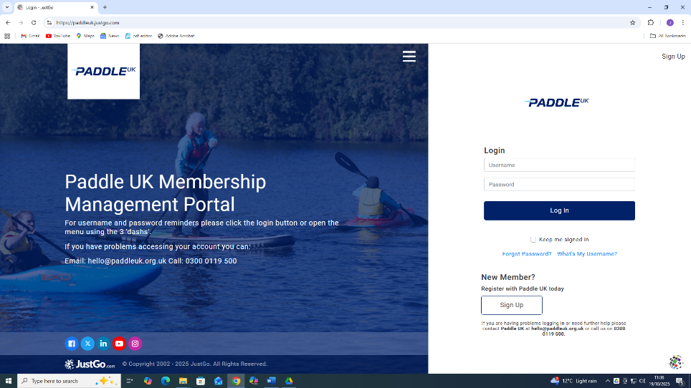
Membership Number Password

Step 2 – Click onto Menu.

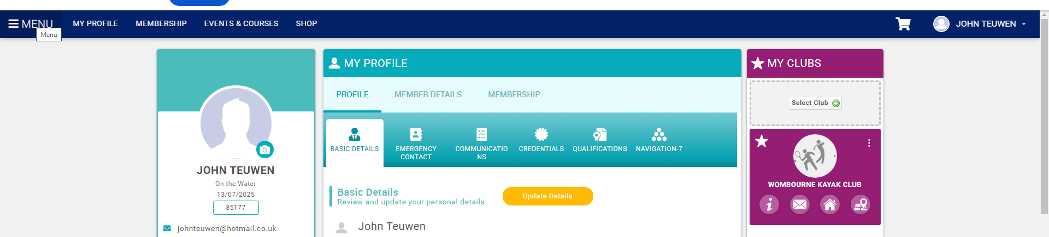

Step 3 – Click on Club Members in My Club Section

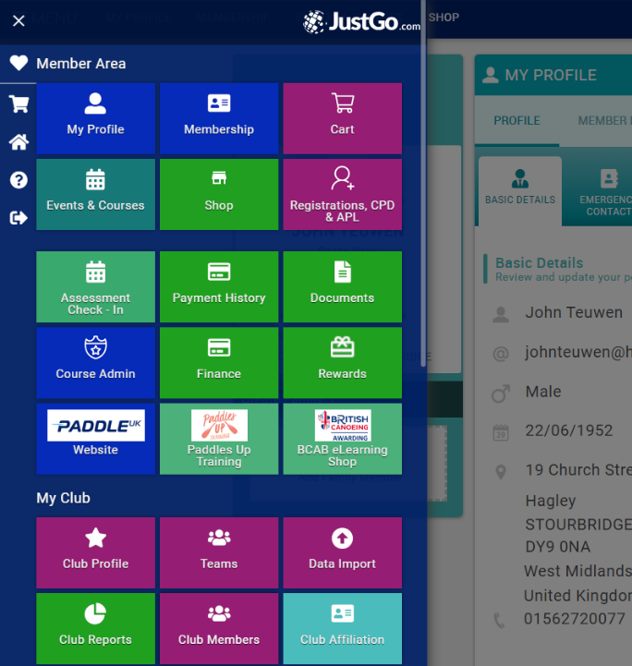

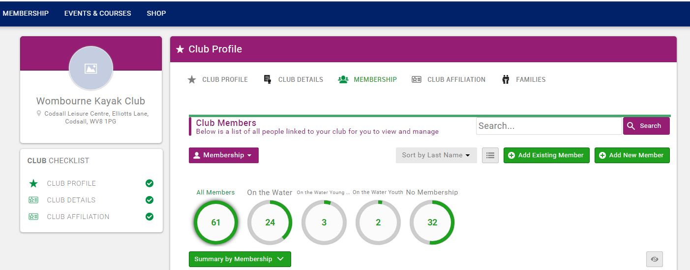
Step 4 – Click onto Club Affiliation

Step 5 – Click to renew.
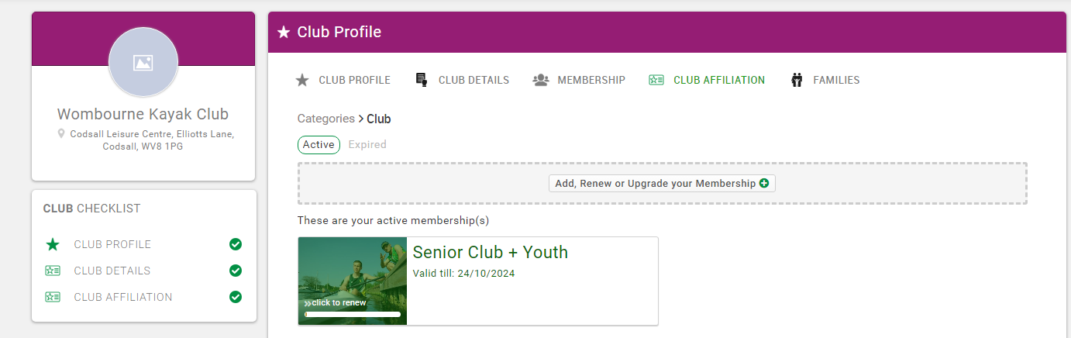
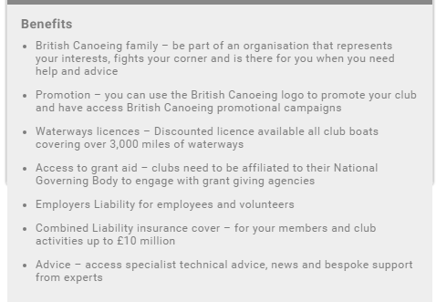
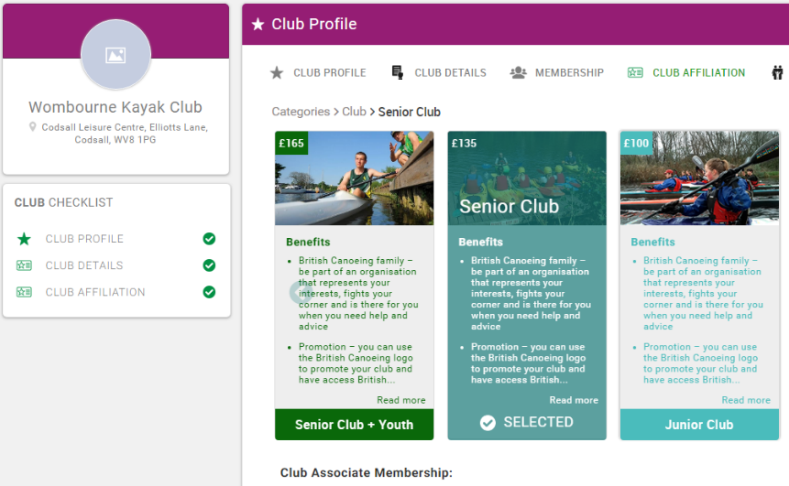
Step 6 – Click to renew.

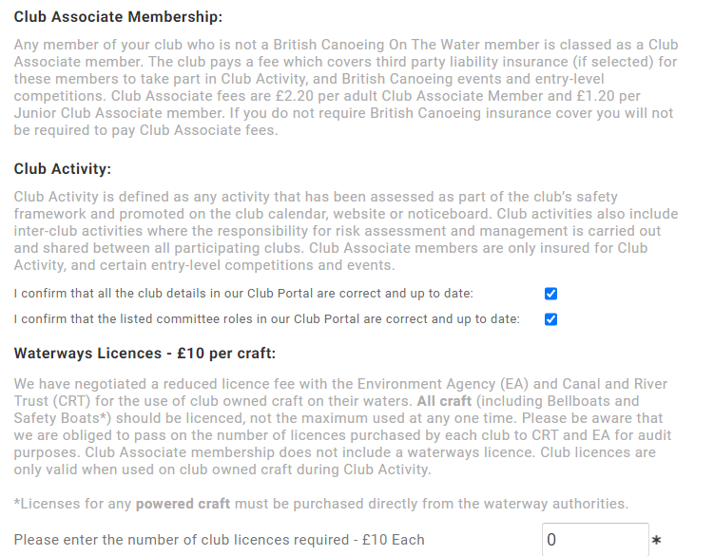

Step 7 – Click to enter licence number?
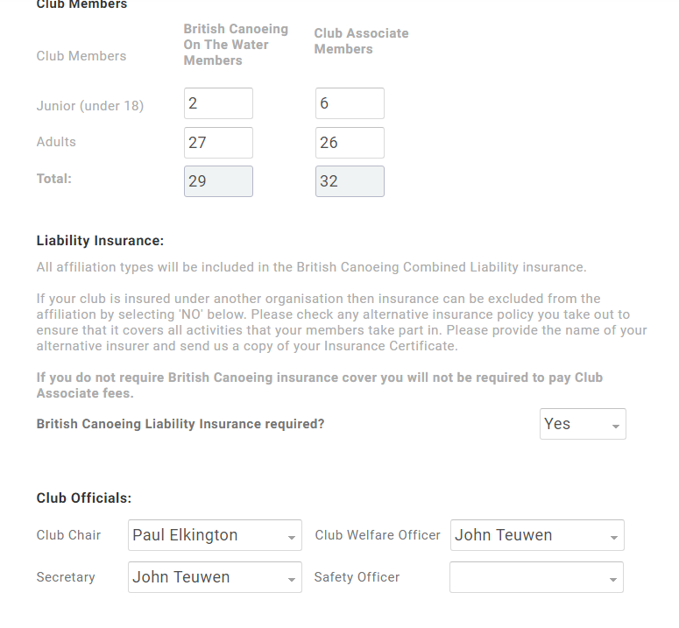
Step 8 – Click to review

Step 9 – Click to boxes, complete payment.

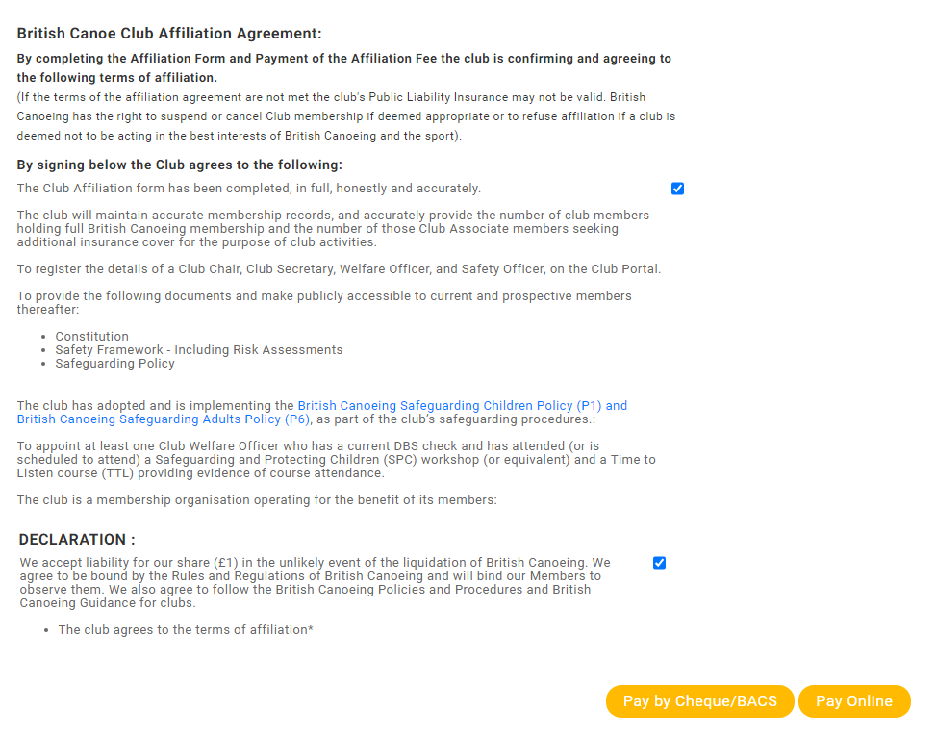
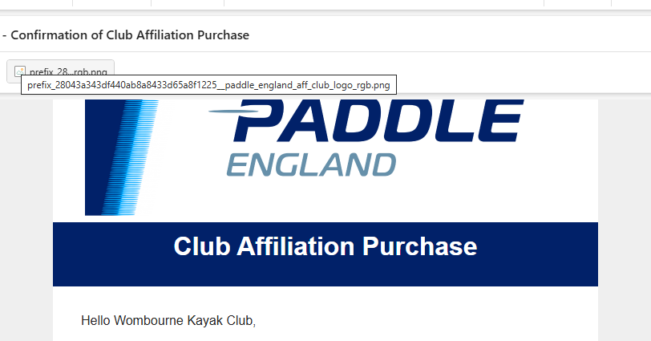
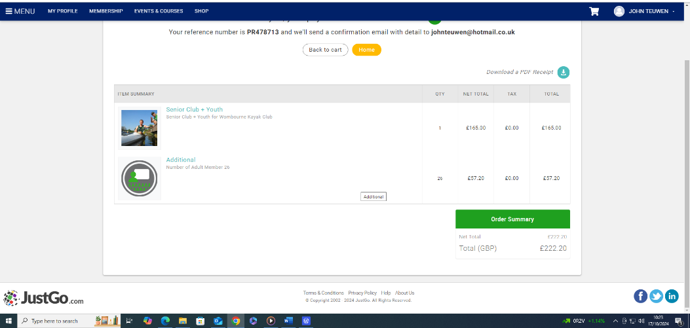

Step 10 – You receive an email to confirm.
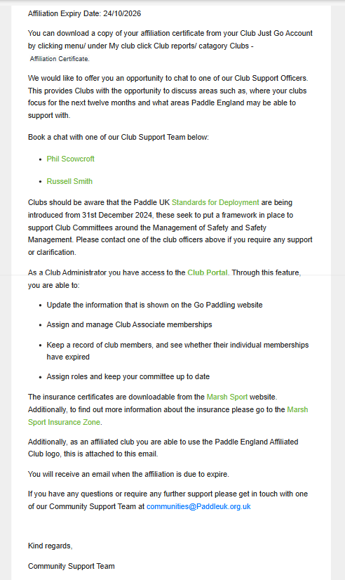

Step 11 – Upload new Affiliation Certificate & Insurance Certificate to

Website.
Home

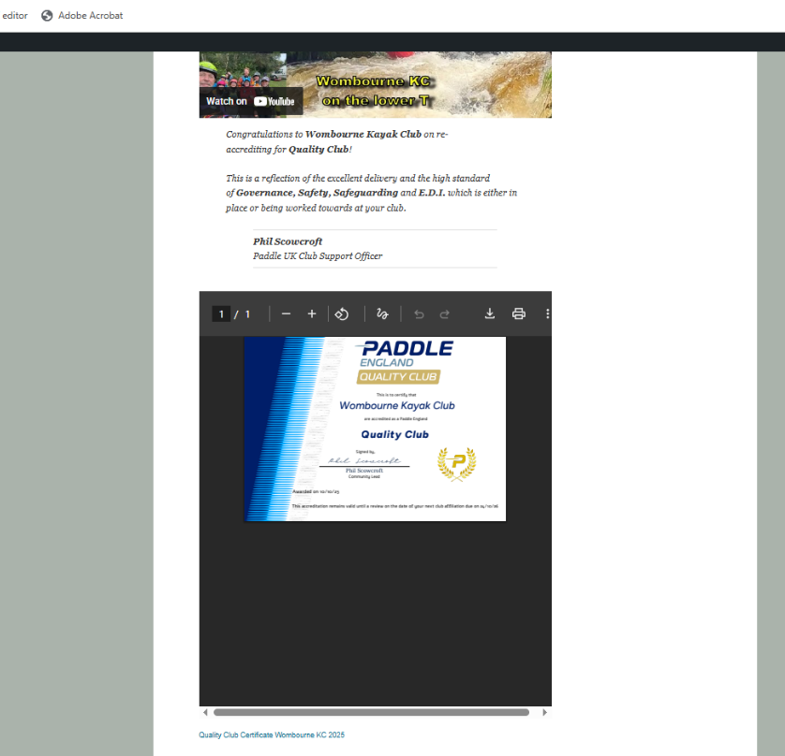
Paddle UK – Affiliation Insurance

