Paddle UK – Quality Club “ToolKit” Part 1 & 2
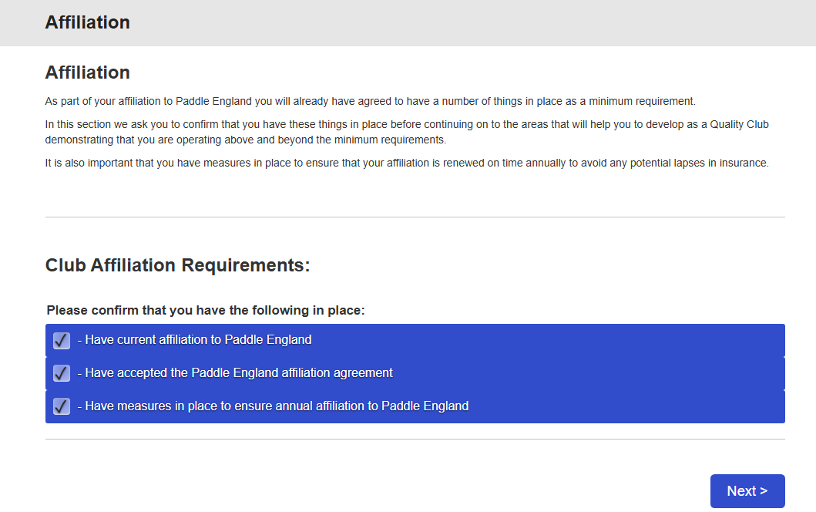
Tick Box

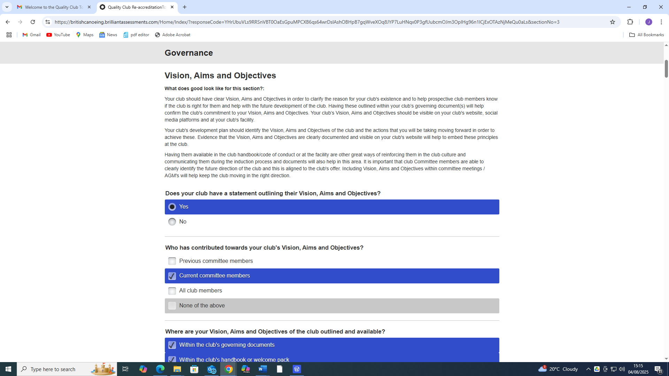

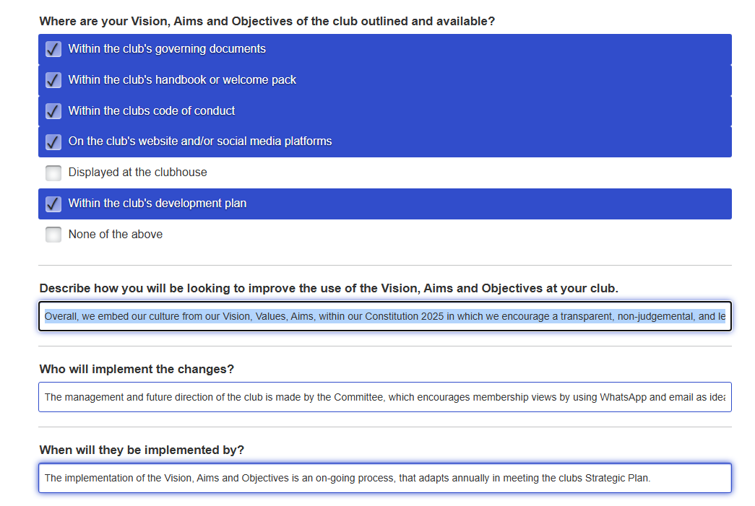
Describe how you will be looking to improve the use of the Vision, Aims and Objectives at your club
Overall, we embed our culture from our Vision, Values, Aims, within our Constitution 2025 in which we encourage a transparent, non-judgemental, and learning culture to our membership. This has provided an identity and direction for the club to sustain its future, subsequently there has been an increase in membership numbers which includes experienced and qualified paddlers since the club joined the "Quality Club" process in 2021 from 25 to 70.
The club’s Vision, Aims, and Objectives are clearly visible on the club’s website under the menu item “Committee” and sub-heading “Constitution”, whilst it is discussed and reviewed annually as an AGM agenda item. In addition, the social media platforms such as the “WhatsApp, and Facebook, such as members personal videos of club activities.
Furthermore, the membership has grown and broadened from the West Midlands to include, Berkshire, Somerset, East Midlands, North Wales and the Northwest into Lancashire. The club’s “Unique Selling Point” has been to provide a range of regular planned weekly club activities in which the new experienced paddlers can contribute to the safety, enjoyment and aspirations of individual members, whilst supporting the existing coaches and leaders in whitewater environments and sheltered water, e.g. organised trips.
Who will implement the changes?
The management and future direction of the club is made by the Committee, which encourages membership views by using WhatsApp and email as ideas and issues arise. E.g. AGM was held both in West Midlands (66% members) and North Wales/ North-West (22% members) to ensure that members had a voice. In addition, the experienced paddlers can support the delivery of the planned activities in meeting individual needs from beginners to competent whitewater paddlers. Furthermore, the implementation of the changes is quicker because the club is not restricted by the management of a club facility, which requires more in-depth discussion and decisions to deliver activities, manage resources, safety, welfare and safeguarding.
When will they be implemented by?
The implementation of the Vision, Aims and Objectives is an on-going process, that adapts annually in meeting the clubs Three-year Strategic Development Plan as it reviews its progress. As part of this process the Committee record a Risk Register, that is agreed, dated, whilst a record of decision making is made in the Committee Discussions -logbook and minutes of meetings found on the website.
The club culture is reinforced by the members “Welcome Pack and Induction Process”, that encourages a transparent, non-judgemental, and learning culture to our membership in which it can be discussed at the AGM’s as well the social media platforms that has supported the growth of the membership from across the country.

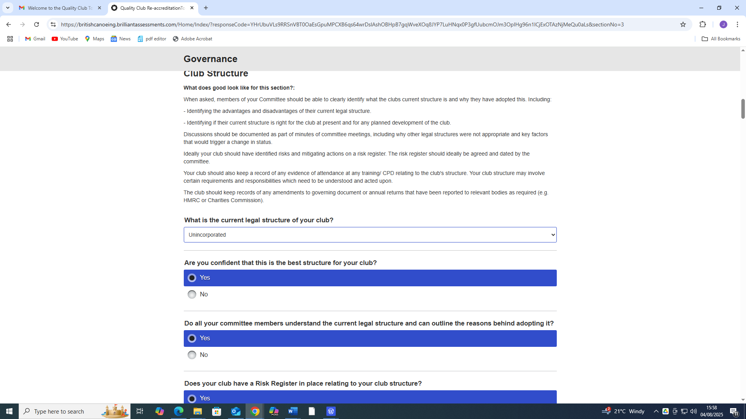
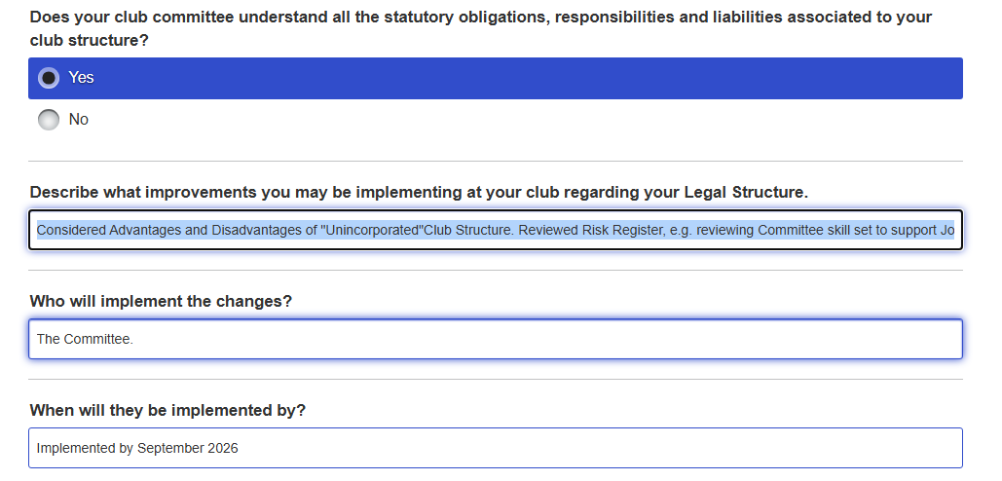

Describe the improvements you may be implementing at your club regarding your legal structure.
Getting the Right Club Structure Source: “Buddle”
The secretary completed the – Club Matters – Good Governance modules and circulated the PowerPoint slides to Committee Members to help them understand the current position regarding the club legal structure. This was improved within the “Constitution” to include supporting material to review the current “Unincorporated” structure, e.g. Advantages and Disadvantages of "Unincorporated" Club Structure. Consequently, the club has started to formulate a “Succession” Plan and consider suitable members to takeover Membership Secretary and Safeguarding & Welfare. This will be recorded in the Committee Discussions -logbook, e.g. The Committee WhatsApp dates agreed actions because the nature of its membership live in a variety of locations, such as West Midlands & North Wales.
Consequently, we do not undertake a formal skills audit; volunteers usually offer their expertise verbally rather than through an application form and interview process. To support the appointment of a new committee members, the club has designed an Induction Pack, and individual Committee job role descriptions to help them to understand their specific responsibilities.
A record of specific Committee role training such as “Time to Listen” required for the Club Welfare Officer has been recorded in the Training A/c.
Finally, the club needs to develop a “Succession Plan” to support the implementation of managing the administration policies, procedures and processes, that is carried out by one individual committee member and is recorded with the Risk Register.
Who will implement the changes?
The individual Committee member with the responsibility of managing the administration has planned a Succession Plan with supporting documents to mentor the Committee.
When will they be implemented by?
Three-year Strategic Development Plan will help the implementation of succession during this period by mentoring Committee members to identify specific skills set that can support the administration of the club.

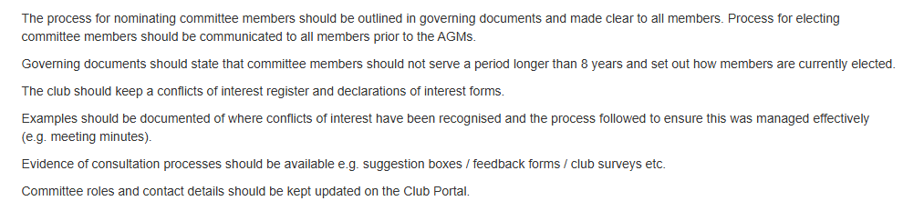
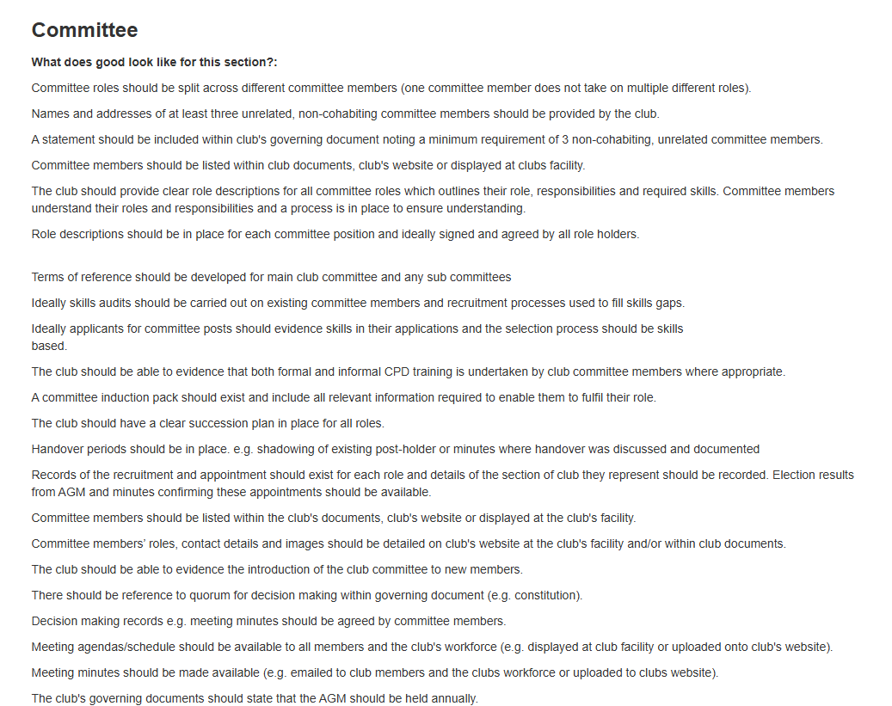
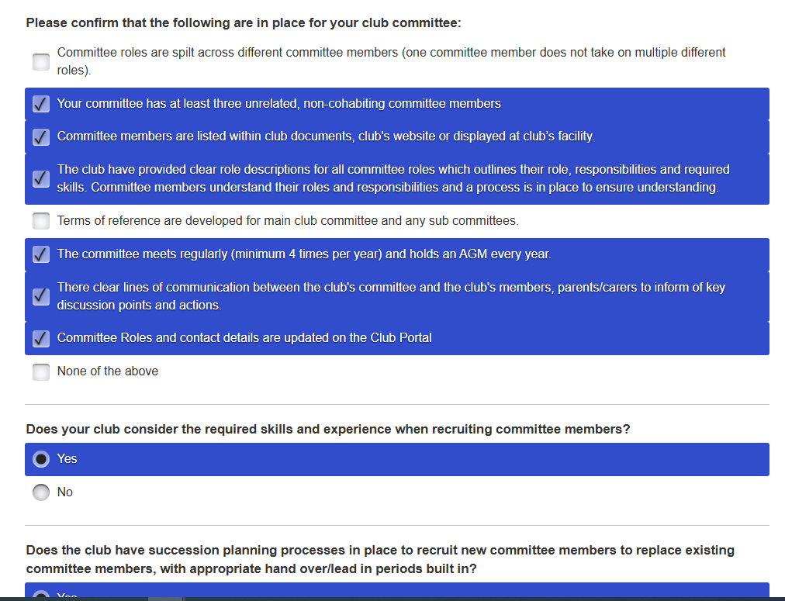
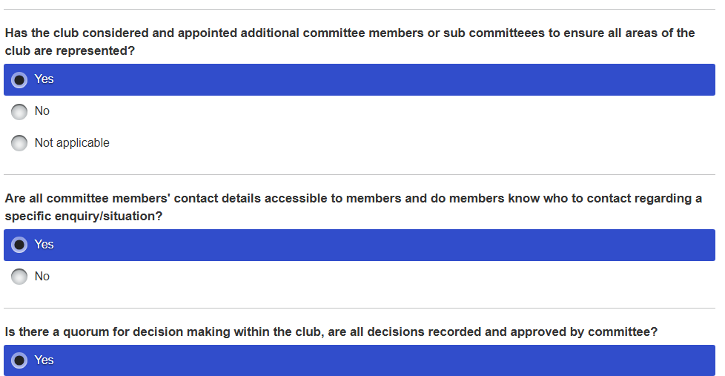

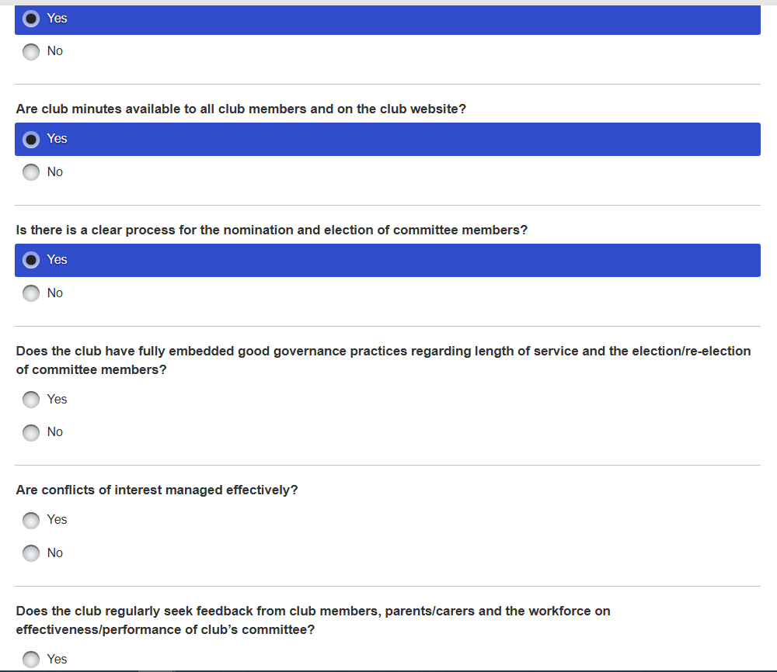

Describe the improvements you will be looking to implement regarding your club committee.
The club has identified that it needs to develop a “Succession Plan” because one committee member has taken on multiple roles to support the management of administering policies, procedures and processes. However, this depends on members wishing to volunteer their time and energy on the Committee. Hence, it is difficult to identify suitable candidates, particularly as current work pressures take a priority, e.g. One experienced member had to resign because of home and work pressures. Subsequently, the Governing documents specify a longer period to serve as committee members of 15 rather than 8 years, which provides some continuity but also reinforces the transparent, non-judgemental, and learning culture that exists in the management of the club.
Consequently, we do not undertake a formal skills audit; volunteers usually offer their expertise verbally rather than through an application form and interview process. We have produced an Induction Pack, and individual Committee job role descriptions to help them to understand their specific responsibilities when appointed and recorded in the website meeting minutes AGM minutes. The Governing document in which the Committee refer to the practical operations of the club is The Constitution , such as stating that an AGM should be an annual event. The Register and Declaration of Interest records individual members interests and members are aware of existing cohabiting couples in which there are no conflicts, that effects the management of the club.
We have not created any “Terms of Reference” for any Committee, or Sub Committee to develop with regards to any policy, which is covered within the “Constitution. However, Continuous Professional Development was applied to the Welfare Officer Role, and some Committee members have completed White-Water Leaders and Coach Awards to support the club as part of Paddle UK - Bursary.
On-going decisions are discussed through emails and WhatsApp., which are recorded in The Committee Action Logbook (Copy sent to Phil Scowcroft), in which a “Quorum” is required, but generally most of the Committee agree. E.g., recorded in the club website – meeting minutes.
Committee members contact details can be found on the clubs WhatsApp, which is used to request any information and new members are introduced on Club Nights or club river trips to key members. In addition, the “Welcome” pack and Members Induction Procedures provides additional information and links to relevant information.
We have not undertaken any club surveys, although we plan to start this process in September using an electronic method on the club website. However, we have piloted an electronic Course Review on the Website, e.g., Paddle Safer, Paddle Explore, White-water Award. Furthermore, Zoey Rowe, a Paddle UK Director, did carry out an informal survey at the Club’s AGM to be discussed in her National Governing Body role. In addition, because of receiving a Paddle UK - Bursary, Phil Scowcroft requested some participant feedback by members who completed a range of courses such as Whitewater Leaders.
CPD Training has been applied with a record of specific Committee role training such as “Time to Listen” required for the Club Welfare Officer has been recorded in the Training A/c.
Who will implement the changes?
The electronic “Club Survey” has been designed and will be “Piloted” in the Autumn 2025 with the support from a past member helping an existing Committee member, whilst the questions have also been checked, and quorum have agreed the content.
Paddle UK – Club Portal has been updated with a “Flux” of new members, as well as Committee roles, coaches and leaders in meeting WKC “Standards of Deployment” Plan, which includes DBS verification using the new 1st Advantage process. As part of the “Quality Club” affiliation preparation the club policies, procedures and processes have been reviewed and updated.
When will they be implemented by?
Three-year Strategic Development Plan will help the implementation of “Quality Club” affiliation in October 2025 during this period as part of the “Succession” process by mentoring Committee members to identify specific skills set that can support the administration of the club.
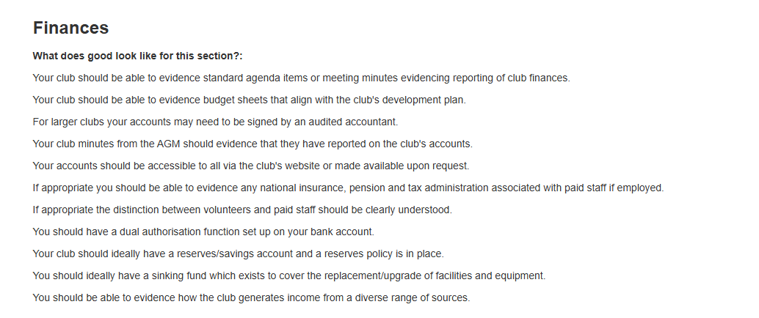
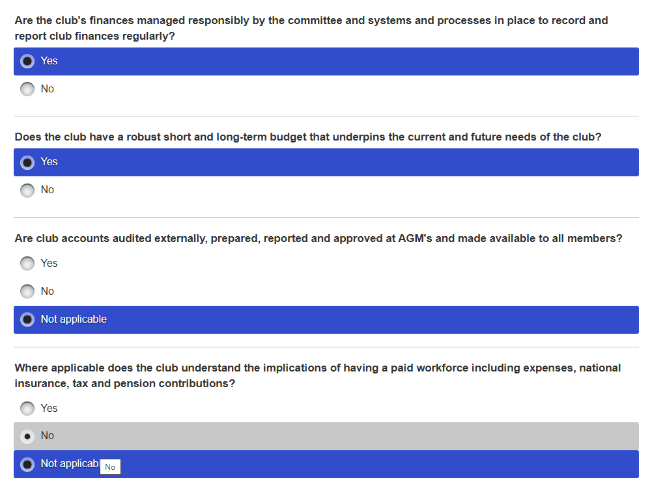
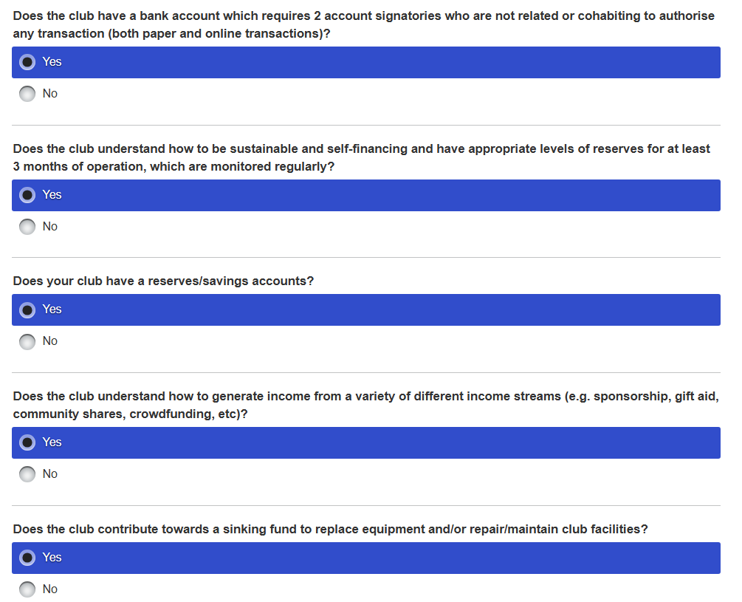

Describe what improvements will you be implementing at your club regarding your club finances.
The implementation of club finances is managed by John Teuwen & Paul Elkington, who the latter keeps a logbook of incomings and outgoings, whilst John maintains a range of accounts such as Training, Pool, subscriptions. When the Final A/C is presented at the AGM it is interchanged between the two records, as well as recorded on the Meeting minutes. As a club we have decided it is not necessary to “Signed off”, because of the type of structure and limited cash balance, which is “Unincorporated” that is managed by volunteers and an unnecessary expense.
However, the Income & Expenditure A/c is discussed regularly during WhatsApp to inform the Committee when making a financial decision such as club development. In addition, “Dual Authorisation” is maintained between three named Committee members, which includes any expenditure is presented for approval before being paid with an “Online” bank account. With regards to “On-line” banking payments, the Committee is consulted by a WhatsApp before any payment is made and documented in the relevant a/c’s. With regards to a “Sinking Fund” because we only have limited equipment to maintain and no facilities as a fixed or variable cost, and there are sufficient funds to cover any outcome. Hence, we generate enough funding from membership with a balance averaging about £3500 but is freely available on request. The balance has been increased through Paddle UK – Bursary funding, that has contributed to CPD for our coaches and leaders.
Who will implement the changes?
The Committee will discuss any future “CPD” training, that is recorded in the “Standards of Deployment” Plan, to meet that criteria when managing “Club” activities. In addition, it will constantly review any outgoing costs such as organised “Pool Sessions”.
When will they be implemented by?
Three-year Strategic Development Plan will help the implementation of club finances as part of the “Quality Club” affiliation in October 2025 that includes both short and long-term decisions.
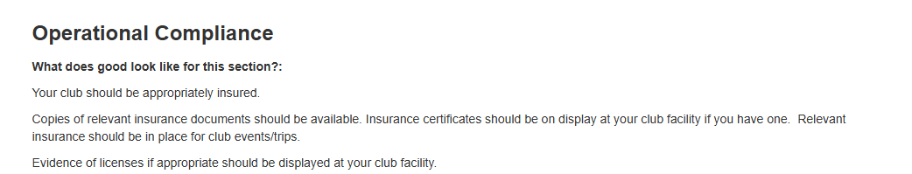

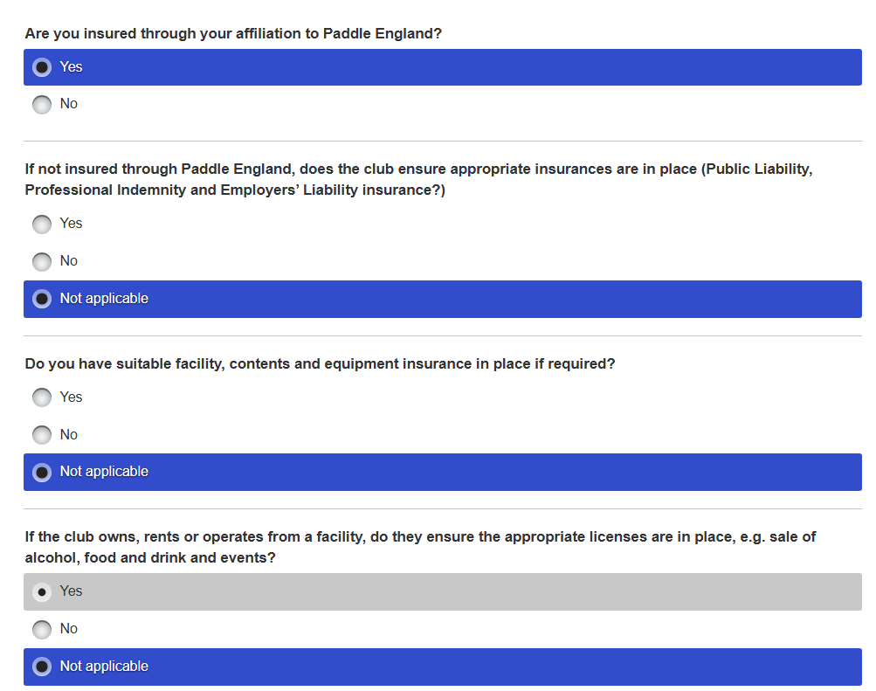

Describe what you will be looking to do to improve your club operational compliance.
The club as part of the Paddle UK – Affiliation members see “Welcome” pack p6, which defines the Paddle UK -Membership parameters with regards to insurance claims. See also Insurance documents on website.
Furthermore, there is no club facility in which it could require further licenses for the sale of alcohol, food or events, whilst further insurance for contents and equipment is unnecessary. However, club boats are stored an individual members homes.
Who will implement the changes?
The club committee will implement operational compliance as part of the Paddle UK – Affiliation process in October.
When will they be implemented by?
Specific club committee members involved in the implementation of Paddle UK – Affiliation process in October.

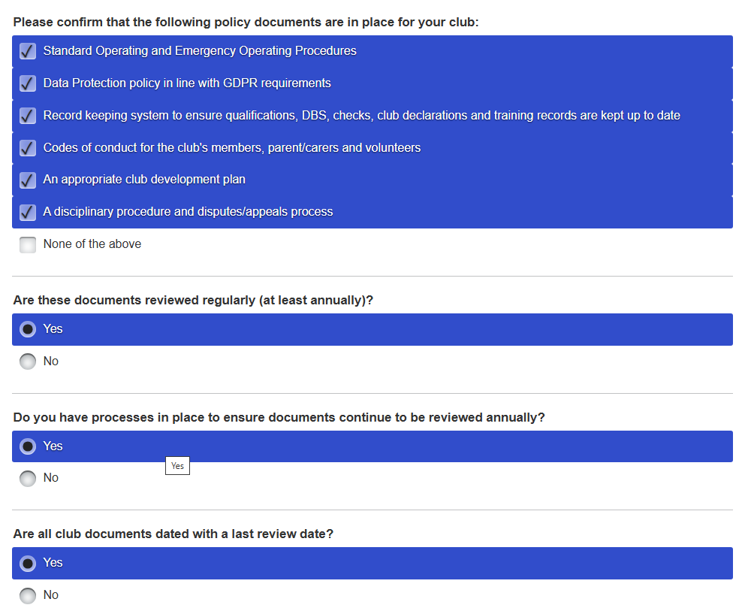
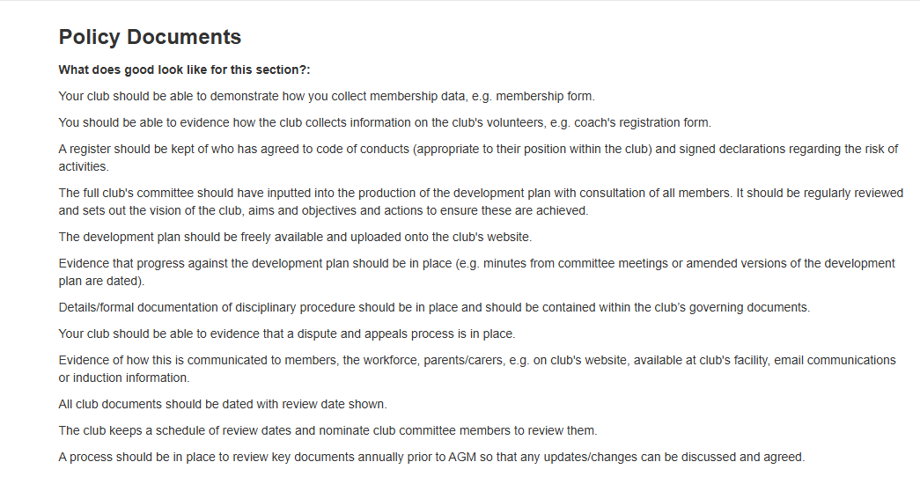
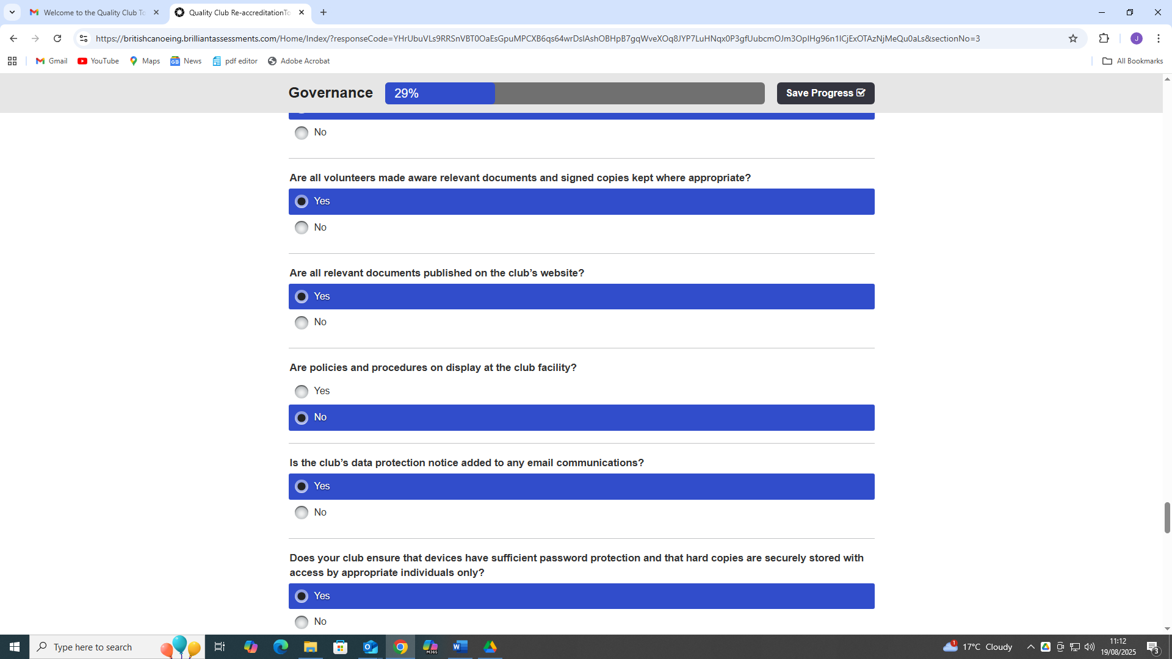

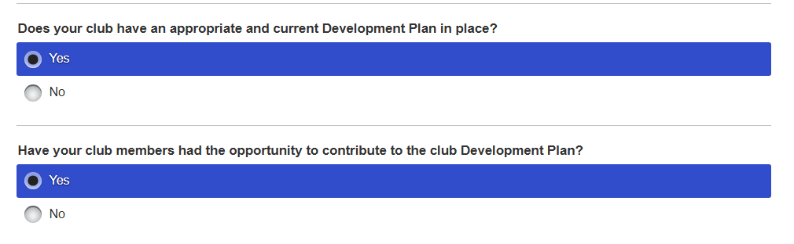

Describe what improvements will you be introducing to improve your club's Policy Documents.
The club committee will improve the club’s Policy documents as part of Paddle UK – Affiliation process in October, that includes the updating of the Club Portal and website such as membership data, qualifications etc, that are dated when reviewed. In addition, this will include current Code of Conduct and Trip Consent records, Disciplinary and other policy documents.
The Committee decision making is documented in the WKC – Consultation and Action Logbook, that supports the Three-year Strategic Development Plan will help the implementation of club policy as part of the “Quality Club” affiliation. Furthermore, it includes a Schedule of review dates, that are, annually checked. Club members will have an opportunity to contribute to the development plan at scheduled annual AGM, any issues that arise on WhatsApp, or the introduction of the Club Survey.
However, Data Protection may be considered when mainly the club’s WhatsApp is used as the format to communicate. In addition, Committee members are made aware of signed updated relevant documents are kept on the club website. With regards to personal data kept on the club website, this is managed and administered by a core of Committee members.
Who will implement the changes?
The club committee will implement operational compliance as part of the Paddle UK – Affiliation process in October.
When will they be implemented by?
Specific club committee members involved in the implementation of Paddle UK – Affiliation process in October.

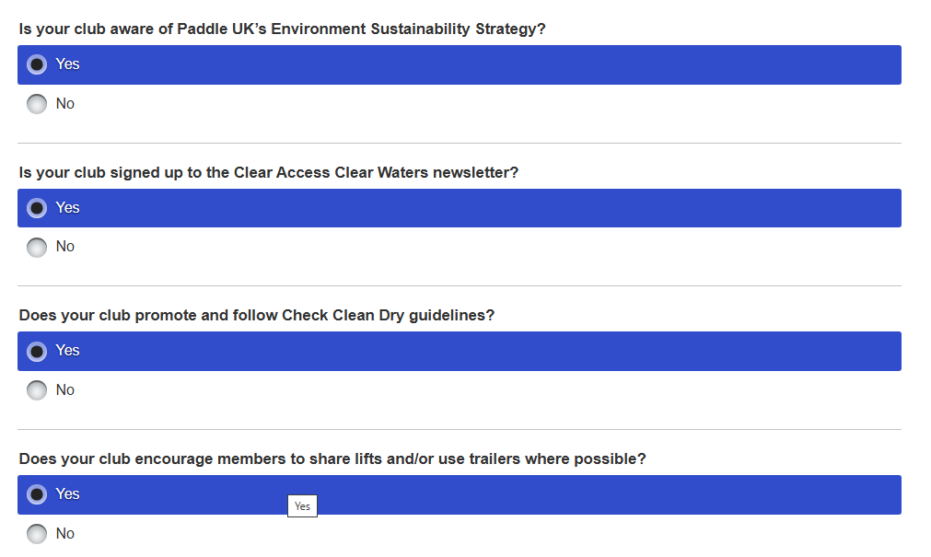
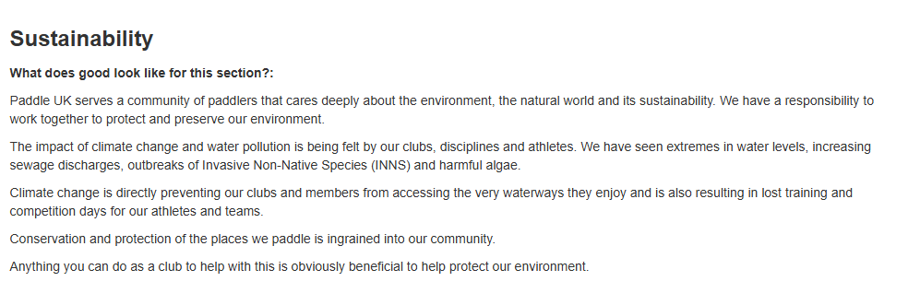
Describe what improvements will you be introducing to improve Sustainability at your club.
Wombourne community of paddlers care deeply about the environment, natural world and its sustainability to work together to protect and preserve our environment, e.g. shared transport on planned club activities to reduce the impact of emissions. The impact of climate change and water pollution have seen extremes in water levels, sewage discharges, non-native species and harmful algae during our regular river trips in which they have been reported or contributed to data collection by concerned lobbyists such as Surfer Against Sewage or Government Committee working parties. In addition, club members have applied the “Paddlers Code” , during planned organised trips that is part of Paddle UK – Sustainability Strategy.
As a Clear Water Crear Access “Champion” club, members try to contribute to the debate by meaningful action such as River Clean-Ups or providing environmental feedback, e.g. The Government Working Party on ‘People need access to green and blue spaces closer to home’.

Who will implement the changes?
Club Coaches and Leaders who organise club activities throughout the year will contribute to the change. In addition, specific members will contribute to data collection by lobbyists such as Surfer Against Sewage or Government Committee working parties or local MP’s, e.g. Water (Special measures) Bill, ‘People need access to green and blue spaces closer to home’ – Government Working Party.
When will they be implemented by?
‘People need access to green and blue spaces closer to home’ – Government Working Party, June 2025
“Access” Definitive Map Modification Order at Ironbridge on the River Severn has been accepted June 2025.
River Clean-up – Ironbridge to Jackfields Sept. 2025

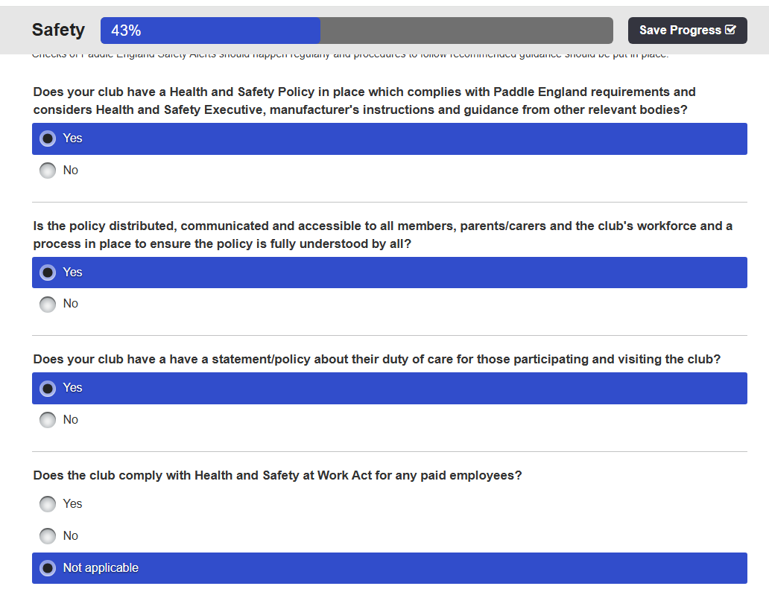
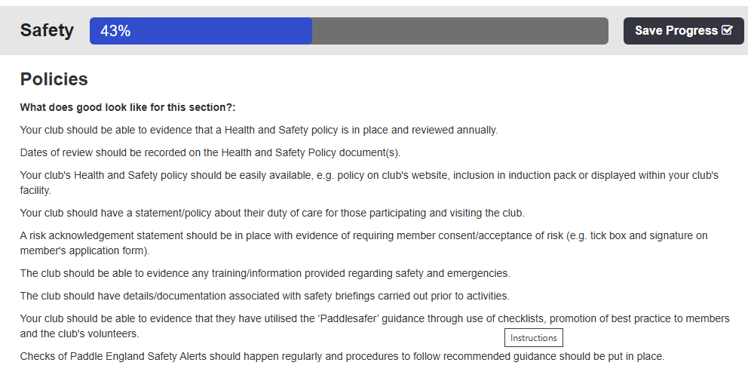
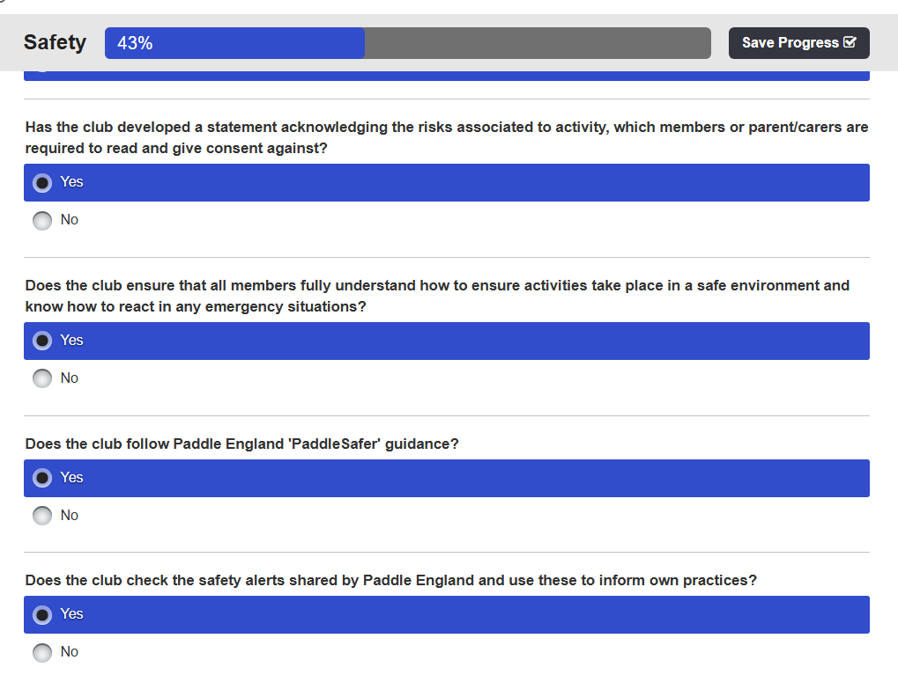

Describe how you will be looking to improve the Safety Policies at your club.
The Health and Safety Policy is reviewed annually and dated by the Safety Officer, which can be easily found under Membership as a sub-heading. The club has included a statement about their Duty of Care for those members participating in club activities within their Operating Standards Procedures on p10
A risk acknowledgement is included in WKC Consent Trip Form requiring the member consent/acceptance of risk, e.g. a tick box and signature is required as part of the joining process.
The club records safety training undertaken by members from WKC Club Portal, that accounts for 68.5% (48) have WWSR, 5.5% (5) have FSRT/PSSW, and AWWS 4% (3). Furthermore, “Standards of Deployment” Plan, p2. records the CPD undertaken by Coaches, Leaders, Committee members such as Coaches Code of Conduct, Risk Assessment & Risk Management, Safeguarding, Event Safety Management. Furthermore, the 3 year cycle was scheduled this year to update present coaches, leaders and members 1st Aid, two day qualification.
The club has produced a Pre-and On the water Emergency Plan, which Club Coaches and Leaders have been informed, with relevant links to support the planning of a trip and documents to assist an incident, e.g. Casualty Card, Major Incident Response, Emergency Response.
The club undertakes safety briefings prior to getting on the water, particularly with new members, when they receive an Induction Pack.
In addition, the club annually review the planned activities using H&S Checklist for Planned Activities, alongside the “Paddlesafer” guidance, and is embedded by promoting good practice to members and club volunteers during planned activities.
The Safety Officer, monitors Paddle England Safety Alerts and “Cascades” the information to Coaches, Leaders and members to ensure that recommended guidance should be put in place.

Who will implement the changes?
A “Quorum” of Committee members will review annually the club’s policies, procedures and processes to update accordingly, such as new Paddle UK policies updates as part of the “Quality Club” affiliation. In addition, members qualifications and credentials are checked as part of membership renewal.
The club coaches and leaders will implement the Safety Policies, procedures and processes when dealing with planned activities to ensure good practice. In addition, they will be encouraged to update their CPD required under Standards of Deployment, which has been identified in the Club Development , see “Standards of Deployment” Plan, p4, p6 Quick Coach Update records from the WKC – Club Portal.
When will they be implemented by?
Specific club committee members involved in the implementation of Paddle UK – Affiliation process in October.
Finally, the Committee decision making is documented in the WKC – Consultation and Action Logbook, that supports the Three-year Strategic Development Plan, particularly in meeting the criteria for Standards of Deployment for 2026.

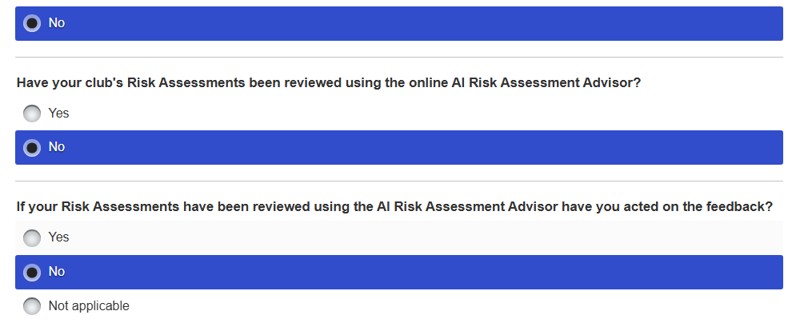
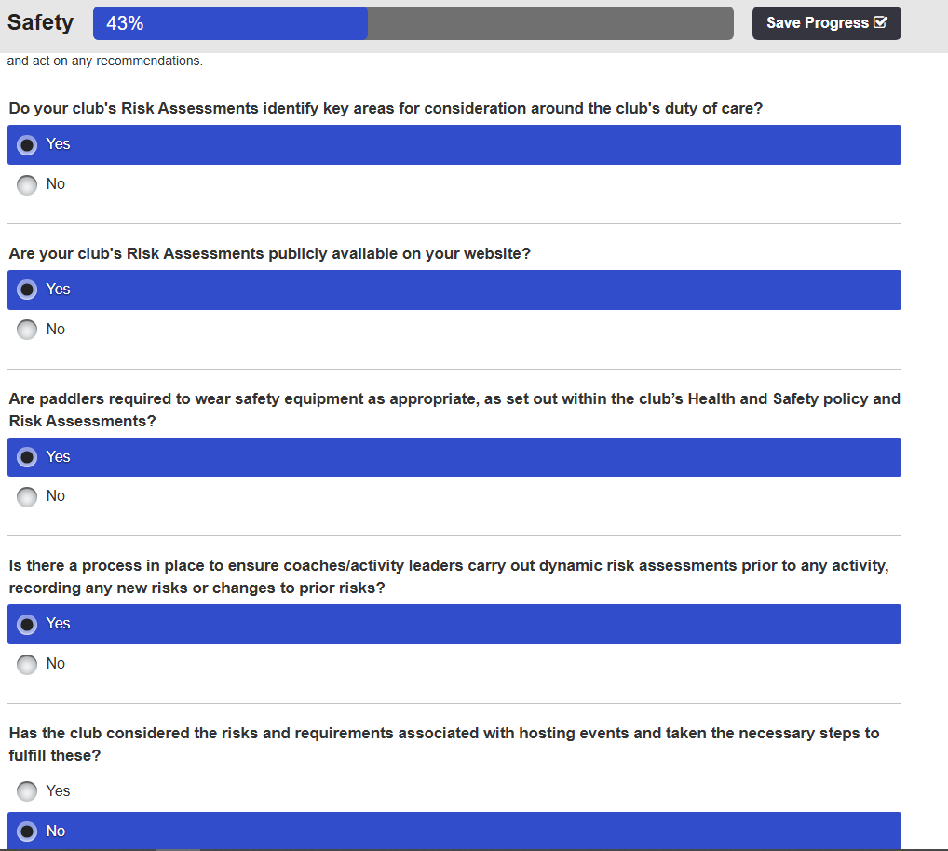
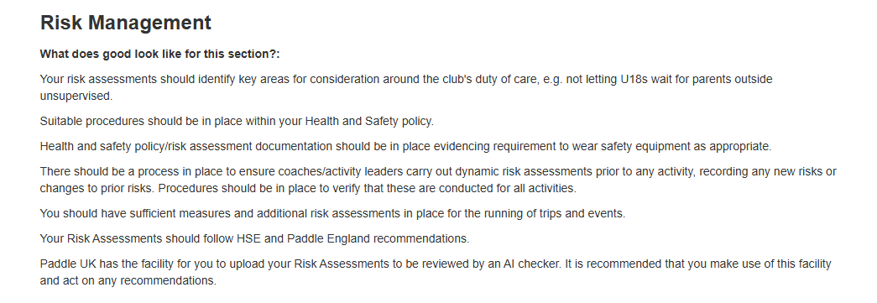

Describe any changes you will make to improve Risk Management at your club.
Risk Assessments are undertaken and checked regularly or updated because of incident, e.g. The Llangollen Bridge incident in 2022 reported in “The Paddler”, Wombourne KC were present at that location and witnessed the impacts off the river to the participants involved. Consequently, we updated our risk assessment for this section of the Dee because of the hazard identified in this incident. The risk assessments identify “Generic, Specific” risks, which is supported by video footage River Conwy: Ysbyty Ifan to Rhydlanfair Bridge. The Risk Assessment used by WKC- replicates Paddle UK Template, with the addition of a ”Consequences and Likelihood” chart to score the risk.

Dynamic Risk Assessments are managed on the river by the coaches and leaders supported by experienced paddlers identified in WKC – Club Portal Club Members Qualifications and Credentials, e.g. AWWS 4% (3). 68.5% (48) WWSR, 5.5% (5) have FSRT/PSSW. Hence, the club puts great emphasis on the implementation and responsibility with regards to “Duty of Care” and has included a statement for those members participating in club activities within their Operating Standards Procedures on p10

Consequently, suitable procedures within the Health and Safety Policy, Operating Standards Procedures using the Paddle UK – Planned Activity Model, p3-7, supported by an annual review using H&S Checklist for Planned Activities, alongside the “Paddlesafer” and Paddle UK Risk Assessment guidance, is embedded within the club by promoting good practice to members and club volunteers during planned activities. Furthermore, a risk acknowledgement is included in WKC Consent Trip Form requiring the member consent/acceptance of risk, e.g. a tick box and signature is required as part of the joining process. The club has also produced a Pre-and On the water Emergency Plan, which Club Coaches and Leaders have been informed, with relevant links to support the planning of a trip and documents to assist an incident, e.g. Casualty Card, Major Incident Response, Emergency Response. Furthermore, the club has produced video River Trip Guides, e.g. River Conway to support members in identifying the location to “Access and Egress”
Who will implement the changes?
A “Quorum” of Committee members will review regularly risk assessments, River Trip guides, whilst the club’s policies, procedures and processes will be updated accordingly, such as new Paddle UK policies updates as part of the “Quality Club” affiliation. The Committee will also sample the Paddle UK – A1 Risk Assessment Advisor to sample a WKC- Risk Assessment.
When will they be implemented by?
Specific club committee members involved in the implementation of Paddle UK – Affiliation process in October.
Finally, the Committee decision making is documented in the WKC – Consultation and Action Logbook, that supports the Three-year Strategic Development Plan, particularly in meeting the criteria for Standards of Deployment for 2026. The Committee will also sample the Paddle UK – A1 Risk Assessment Advisor to sample a WKC- Risk Assessment during the next year.

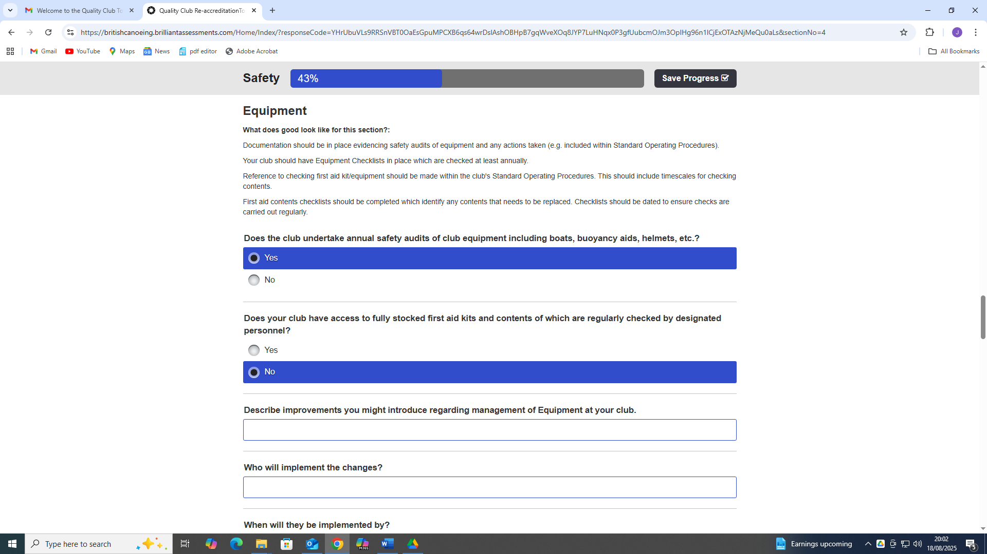

Does the club undertake annual safety Audits of club equipment including boats, buoyancy aids, helmets, etc.
The club has several boats, which are available to support new beginner members, without a boat. A club Boat audit has been undertaken, and according action has been identified.
We also provide PFDs, paddles, and spray decks loaned by members, to support to beginners without kit, to help them decide whether they are committed to the sport or to offset immediate initial costs. The boats at present are stored at designated members’ homes, but recently some have been stored at Telford Canoe Club Container because WKC members also members of this Club. We do not have a club trailer and are transported in members vehicles. Hence, it needs to be noted that Wombourne Kayak Club do not have a designated facility to “Store” equipment, and subsequently the club encourage members to purchase their own equipment, boats etc., which most members have undertaken.
The club coaches/leaders have attended whitewater and safety training and have purchased appropriate safety equipment to manage an incident on the river, which includes 1st Aid kits, that are maintained by individual members to ensure timescales for checking contents. The Operating Standards Procedures p11. refers to 1st Aid procedures for planned club activities, e.g. pool sessions, club night and river trips.
Who will implement the changes?
A “Quorum” of Committee members will review regularly club equipment with regards to club planned activities. It will consider the club’s policies, procedures and processes in relation to 1st aid equipment to ensure timescales for checking contents.
The Committee will recommend that the Paddle UK Equipment Management & Safety eLearning is a suitable CPD to undertake by coaches, leaders and Committee members.
When will they be implemented by?
Specific club committee members involved in the implementation of Paddle UK – Affiliation process in October, but also supports the Three-year Strategic Development Plan, particularly in meeting the criteria for Standards of Deployment for 2026.
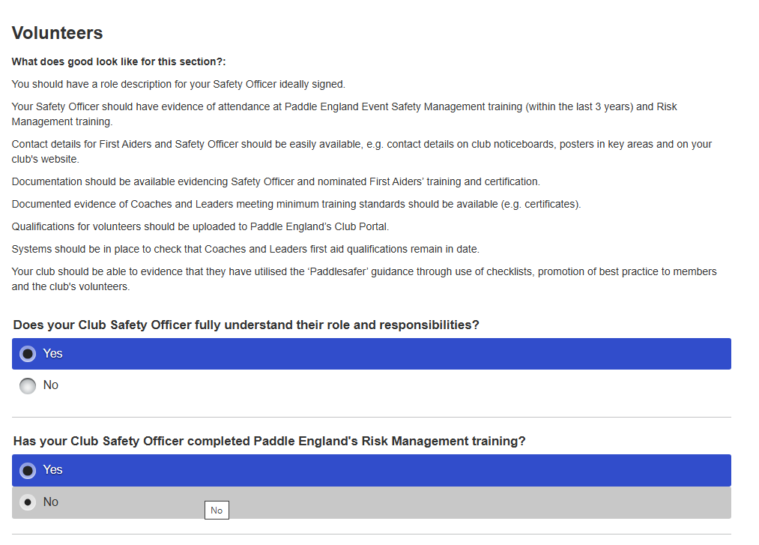
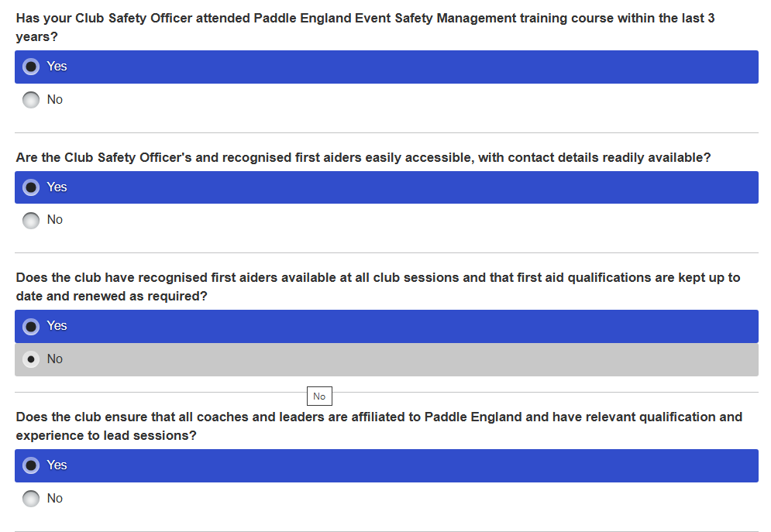
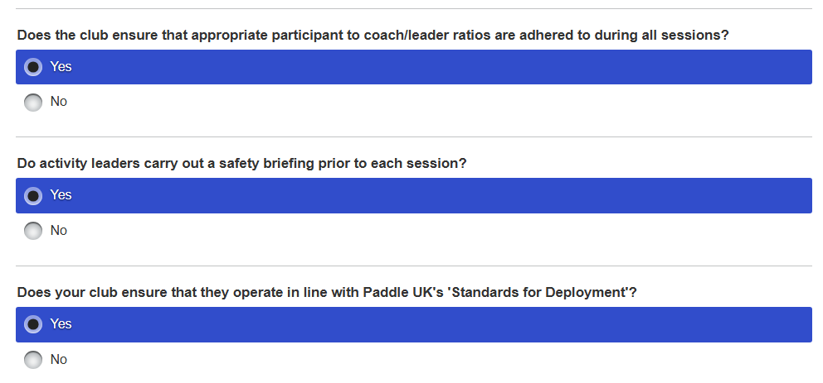

Describe how you will look to implement improvements regarding safety for the Volunteers at your club.
The club has designed a Club Committee Induction Pack, and individual Committee job role descriptions to help them to understand their specific responsibilities, that includes a Safety Officer. Furthermore, for each designated Committee Members’ role, a specific “What’s to do”? e.g. Safety Officer has been created to support the person “In current position”. The see “Standards of Deployment” Plan, p2, p6 Quick Coach Update records from the WKC – Club Portal identify that the current Safety Officer has completed the Event Safety Management Training, and Risk Management and Risk Assessment. Furthermore, club leaders, coaches and committee members CPD Risk Management and Risk Assessment p2., has been recorded, and potential club members within the Club Development Plan p4. The plan also includes current evidence from Wombourne Kayak Club (WKC) – Club Portal, p6 Quick Coach Update records, but also the records verify member’s credentials, e.g. qualifications that are checked by a committee member on a regular basis. In addition, the club annually review the planned activities using H&S Checklist for Planned Activities, alongside the “Paddlesafer” guidance, and is embedded by promoting good practice to members and club volunteers during planned activities. This is supported by 1st Advantage DBS process and recorded on p2. “Standards of Deployment” Plan.
Who will implement the changes?
A “Quorum” of Committee members will review regularly safety for the volunteers at the club with regards to current qualifications, credentials and DBS checks as part of the criteria for Standards of Deployment for 2026 and Paddle UK – Quality Club affiliation.
When will they be implemented by?
Specific club committee members involved in the implementation of Paddle UK – Affiliation process in October.
Finally, the Committee decision making is documented in the WKC – Consultation and Action Logbook, that supports the Three-year Strategic Development Plan, particularly in meeting the criteria for Standards of Deployment for 2026.

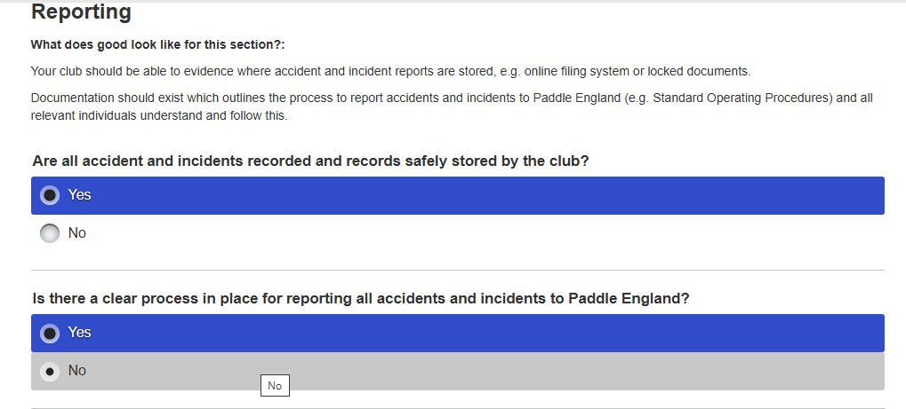

Describe how you might improve Safety Reporting at your club?
Accidents and Incidents reports are kept individually by the current Safety Officer John Teuwen and Chairperson Paul Elkington to ensure “Confidentiality” under GDPR and are used with the individual members involved to discuss and record the true events. Once the report has been agreed by the individuals involved in the accident or incident and reported to Paddle England. In addition, the Operating Standards Procedures p14., state the course of action and links to be used.
Who will implement the changes?
A “Quorum” of Committee members will review regularly safety for the volunteers at the club with regards to recorded Accidents or Incidents to ensure that policies, procedures maintain good safety practice and prevent any subsequent repeat. A designated Committee member will report the final report to Paddle UK, and deal with any inquiry made by the national governing body.
When will they be implemented by?
Specific club committee members involved in the implementation of Paddle UK – Affiliation process in October.
Finally, the Committee decision making is documented in the WKC – Consultation and Action Logbook, that supports the Three-year Strategic Development Plan, particularly in meeting the criteria for Standards of Deployment for 2026 or Paddle UK Inquiry.

