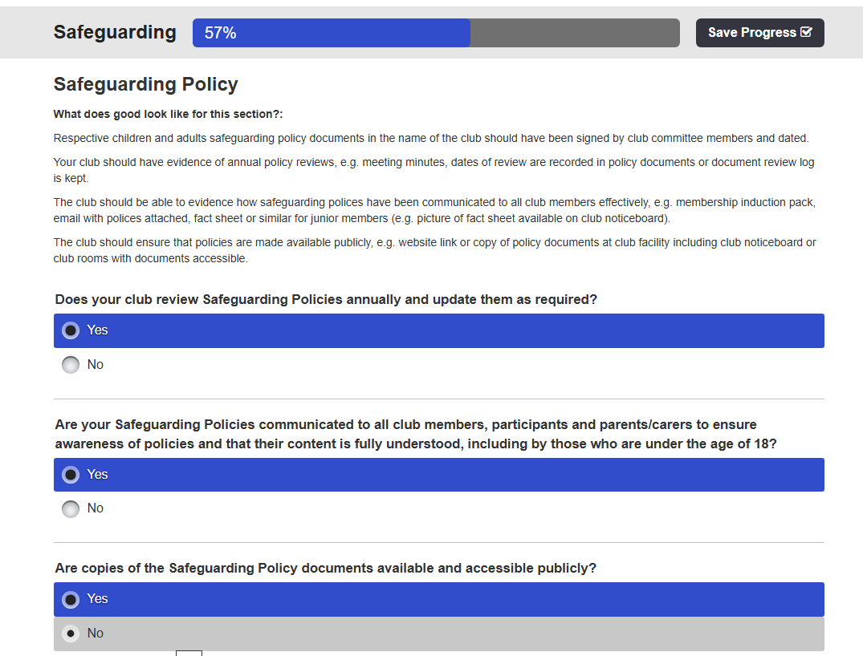
Paddle UK – Quality Club “ToolKit” Part 3 & 4

Describe how you might improve Safeguarding Policies at your club.
WKC -Safeguarding Children Policy in name of club has been signed by Committee & dated in the current review, that has been recorded and dated in the Committee Logbook, and uploaded to the website with other relevant policies, procedures and processes. Furthermore, WKC – have produced a Safeguarding “How to find Information” Flowchart, that provides links to Paddle UK – Safeguarding, Processes, and Templates website pages.
However, the evidence of safeguarding policies communicated to all members, was highlighted as an issue in the WKC – Club Survey Results Report in Question 6:
The planned club activities meeting the needs of Young Members (U18) and Vulnerable Adults provided a mixed result between Very Satisfied, Satisfied and Don’t Know, that may suggest the membership has an understanding or lack of understanding with regards to managing “Safeguarding”. Hence, it is important to consider the next question before answering this anomaly.
Question 7:
This response to, “Does the Club provides appropriate Safeguarding Guidance to meet the needs of Young Members (U18) and Vulnerable Adults”? This response to supports the previous conclusion between Very Satisfied, Satisfied, Don’t Know, but identified further that 25% were “Very Dissatisfied” members! Hence, the Committee member responsible for the Survey informed the Chairperson about his concern that perhaps some members had not fully understood, lacked knowledge or the question was “Ambiguous”.
The chairperson also felt that some members may not understand “Safeguarding” and the necessary steps to ensure that good practice is embedded in the club, we had an example yesterday where we were ready to do the shuttles for all the drivers to collect their vehicles, but it would have meant a 15-year-old being left alone. One adult offered to stay with the junior but that’s also not acceptable, so the junior came on the shuttle leaving the adult at the bottom to watch the kayaks. In addition, Cris a Committee member stated it happens as a matter of course, but you probably wouldn’t spot it unless you were involved. Shellie also another Committee member mentioned that’s a great point, and I will post the link to the club chat. Subsequently, also Paul mentioned, that members may not know about “safeguarding” guidance because the club has never had any concerns and has implemented the policies, procedures and processes to reduce or prevent any situation from arising.
Finally, it must be noted that Wombourne Kayak Club do not have a “Clubhouse” to promote “Safeguarding” information on a notice board. In addition, most volunteers have no contact or irregular contact with minors under 18, and the club does not currently have any members identified as “Vulnerable adults”.
Who will implement the changes?
WKC Committee – will discuss the Safeguarding Policy issue of communicating to all members, as well as the Induction Pack, and Welcome Pack, and posting “How to find Information” Flowchart on. We will issue a WKC -WhatsApp message to all members to ask them to look at the policy, and provide a link to it, including the other listed documents. This will be supported by Chairperson Paul Elkington statement.
When will they be implemented?
The Committee, and Quorum concerned with the Quality Club Toolkit review will implement the change prior to Octobers Affiliation meeting with Paddle UK.
In Describe how you might improve Safeguarding Policies at your club.,
Also, although you say that the policy has been put on the website, would it be good to say we’ll issue an email to all members to ask them to look at the policy, and provide a link to it?

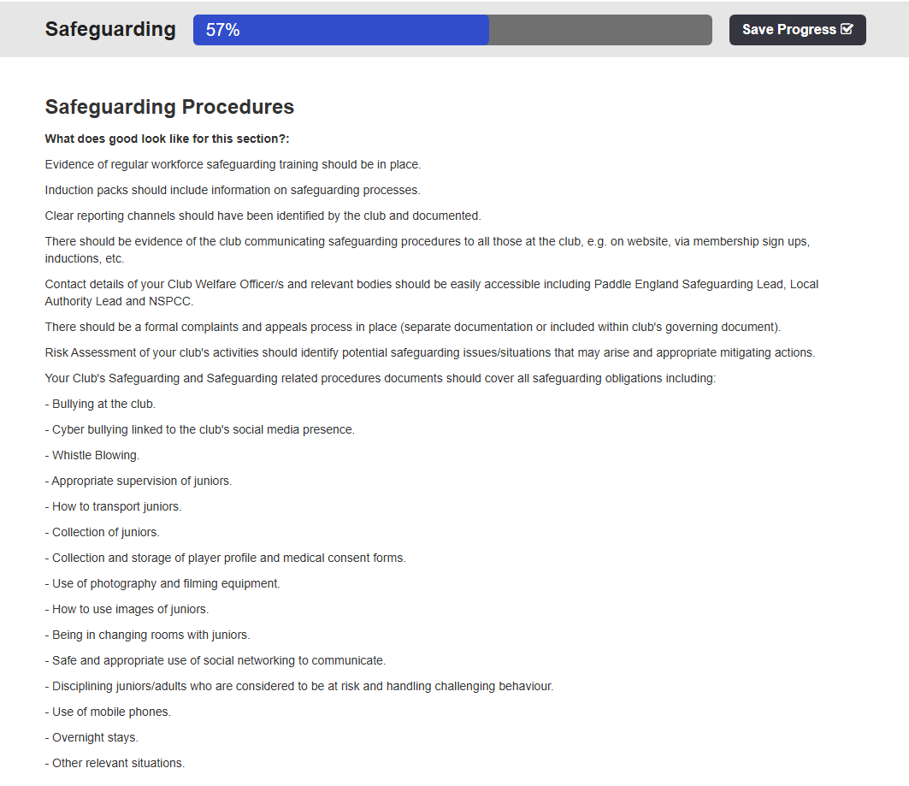

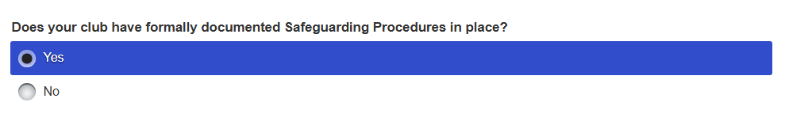
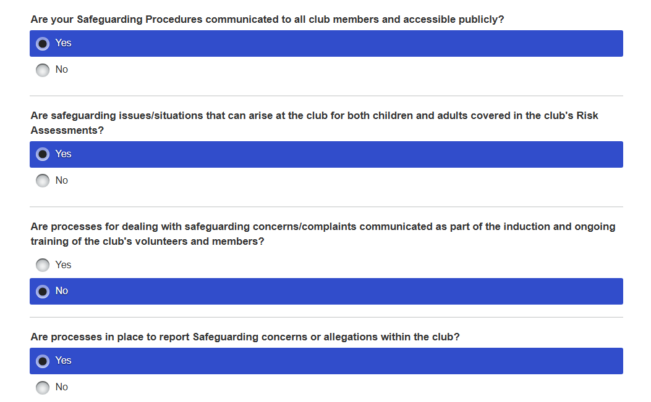
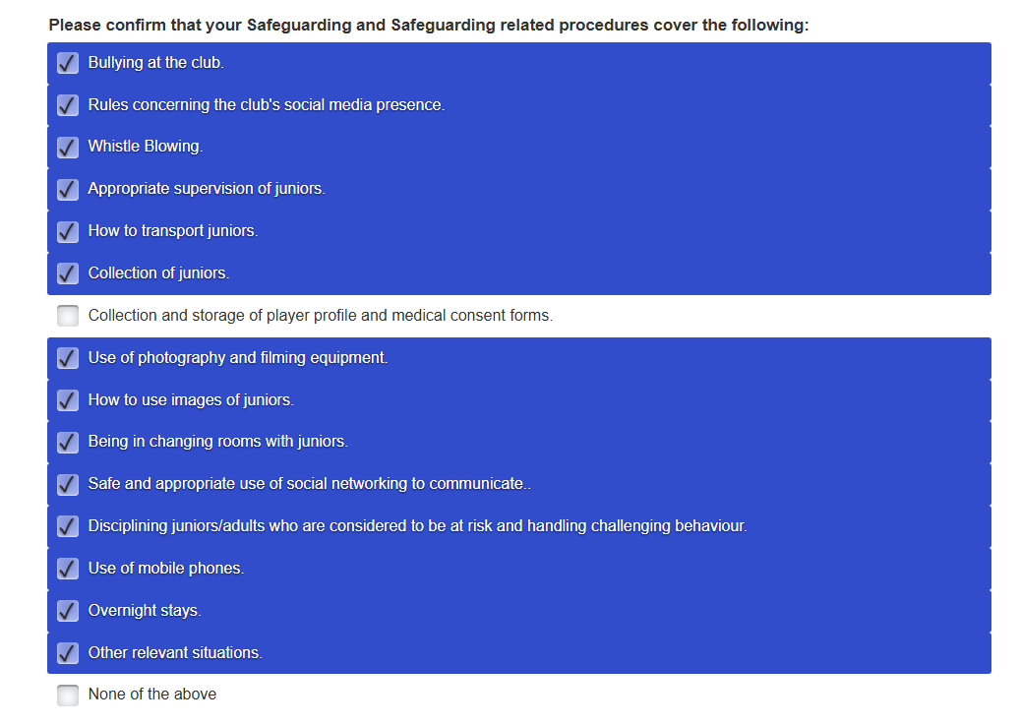
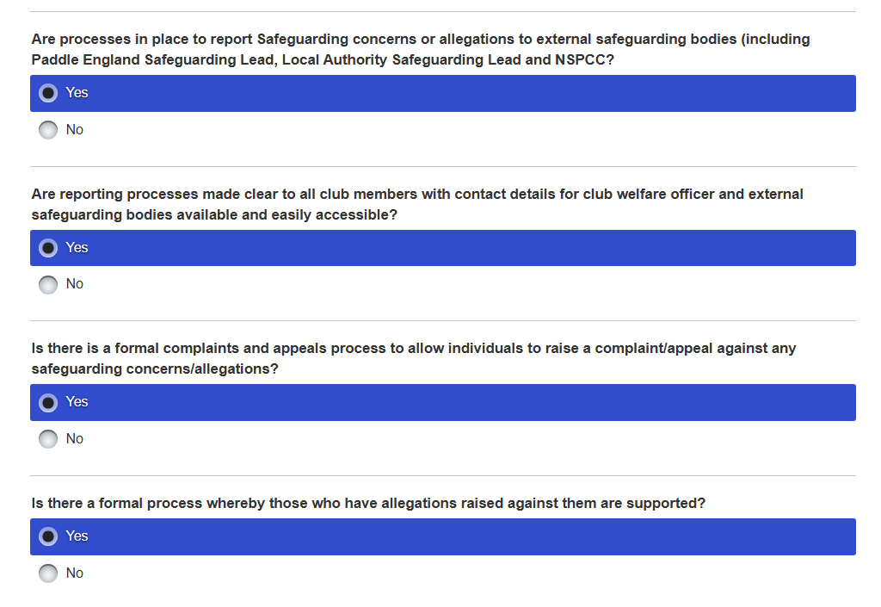

Describe what you will be implementing at your club to improve Safeguarding Procedures.
The WKC- evidence of safeguarding training has been implemented in the Standards of Deployment plan p2-3, identify the current Committee have completed a Paddle UK – Safeguarding programme, whilst two new members will be asked for a “Self-Declaration”, particularly as within their present employment it is a necessary requirement, e.g. the club refers to G21 Safeguarding Training Requirements. Furthermore, the Committee members have undertaken DBS checks recorded on p2-5, whilst the two new members will be asked to undertake the 1st Advantage DBS process. In addition, this applies to the current leaders and coaches with regards to Safeguard Training and DBS checks identified on p2-5.
However, the evidence of safeguarding policies communicated to all members, that was highlighted as an issue in the WKC – Club Survey Results Report will also be applied to the procedures in which an updated “Welcome Pack” will be sent by email, e.g. Safeguarding “How to find Information” Flowchart, that provides links to Paddle UK – Safeguarding, Processes, and Templates website pages. In addition, the chairperson will make a statement on WhatsApp concerning this issue and provide links to the “How to find Information” document and updated “Welcome Pack”. Subsequently, it will help to reinforce the current practice of managing members under 18, as illustrated in the example on the River Clywedog when making decisions about the shuttles for all the drivers to collect their vehicles, which would have meant a 15-year-old being left alone. Current risk assessments include Safeguarding & Welfare procedures as a generic risk River Conwy: Ysbyty Ifan to Rhydlanfair Bridge. , p2 explaining “How it is controlled? By whom? and the” Consequences and Likelihood” chart to score the risk.

Hence, there are clear reporting channels and procedures identified in the Safeguarding “How to find Information” Flowchart, within the club, Paddle UK and other agencies, but also the Chairperson will emphasize in the WhatsApp statement that any safeguarding concerns that might have arisen within the Members Survey, the individuals who expressed them can contact him. In addition, the safeguarding procedure to investigate a concern is explained in the Disciplinary Policy, Paddle UK- Holding a Disciplinary Hearing

Who will implement the changes?
WKC Committee – will discuss the Safeguarding Policy issue of communicating to all members, as well as the Induction Pack, and Welcome Pack, and posting “How to find Information” Flowchart on. We will issue a WKC -WhatsApp message to all members to ask them to look at the policy, and provide a link to it, including the other listed documents. This will be supported by Chairperson Paul Elkington statement.
When will they be implemented?
The Committee, and Quorum concerned with the Quality Club Toolkit review will implement the change prior to Octobers Affiliation meeting with Paddle UK.

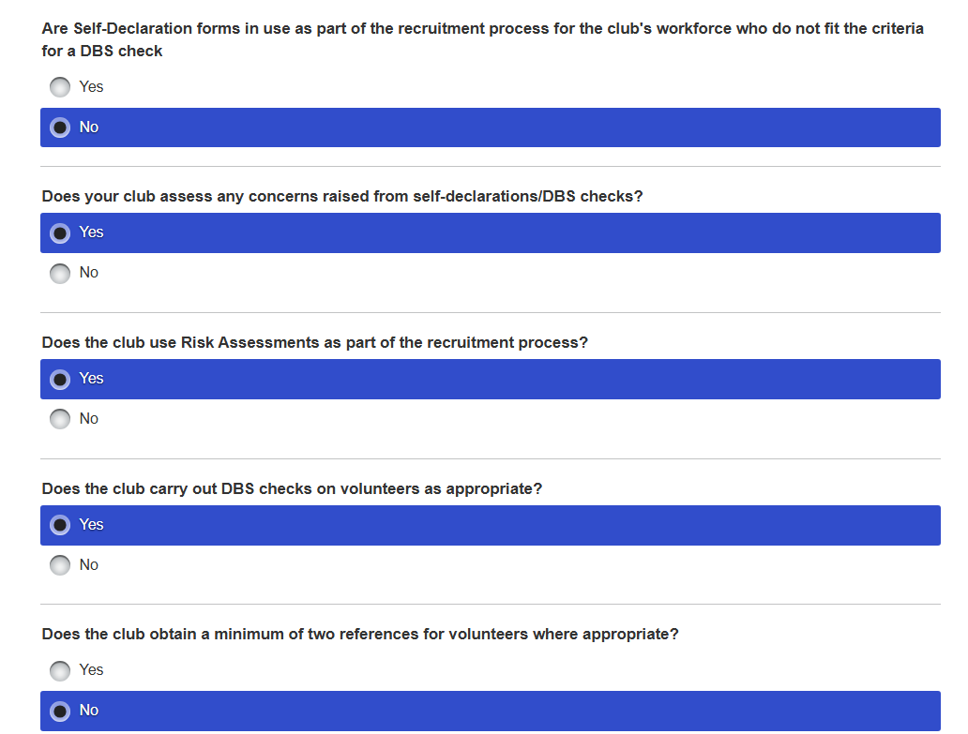
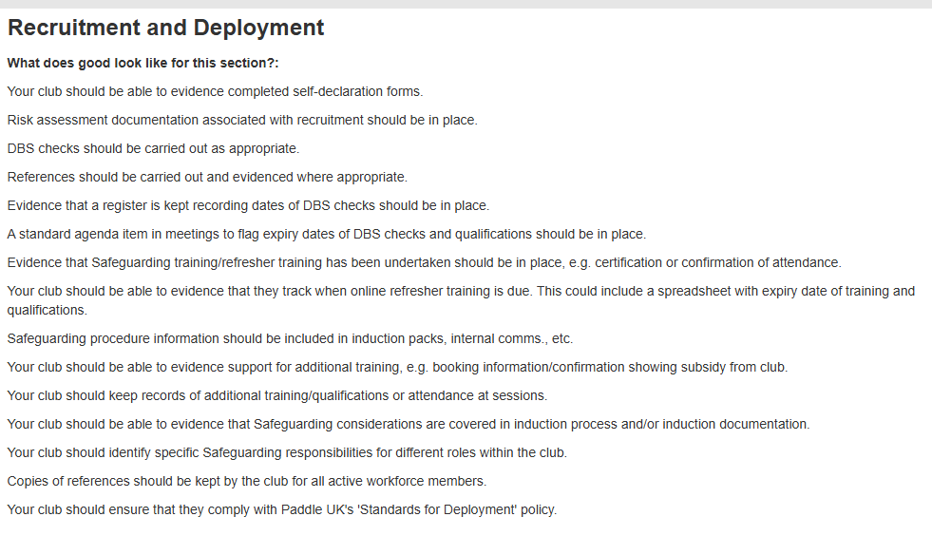
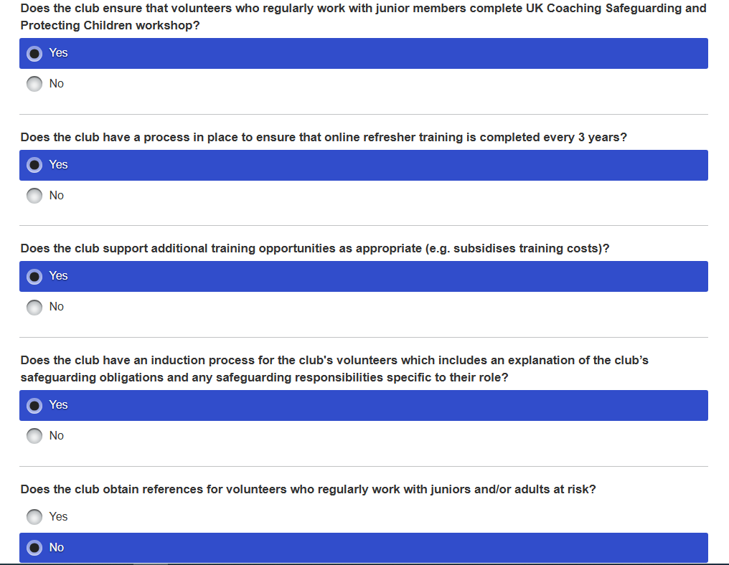

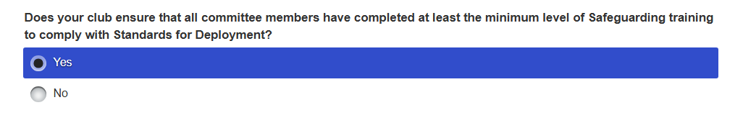

Describe what improvements will you be implementing at your club to improve Safeguarding Recruitment and Deployment.
The Committee Self-declaration Forms will be offered to the two new Committee members, particularly if they have work based current Safeguarding Training or they can complete the Paddle UK – Safeguarding course. The Leaders/Coaches who manage minors under 18 in which there are 8 (11.5%), although only 3 (4%) are regular paddlers have completed the Paddle UK Safeguarding Refresher or UK Coaching Renewal: Safeguarding and Protecting Children, that meets the criteria listed under G21 Safeguarding Training Requirements.
Hence, the club have not undertaken Recruitment Risk Assessments or references because they ask the Committee Members, regular Leaders and Coaches to undertake a DBS check, which should identify any concerns. Furthermore, the club welcomes volunteers to support the club, particularly those who have full-time employment in which their occupation brings great demands on their time. The Committee members, Leaders, Coaches qualifications, such as CPD, G21 Safeguarding Training Requirements., DBS 1st Advantage, is recorded in the Standards of Deployment plan p2-5, whilst p8 records leaders and coaches evidence. In addition, the Committee Members, Leaders and Coaches are volunteers, because the club does not have a clubhouse with facilities, hence does not employ an active workforce.
However, the evidence of safeguarding policies communicated to all members, that was highlighted as an issue in the WKC – Club Survey Results Report will also be applied to the procedures in which an updated “Welcome Pack” will be sent by email, e.g. Safeguarding “How to find Information” Flowchart, that provides links to Paddle UK – Safeguarding, Processes, and Templates website pages. In addition, the chairperson will make a statement on WhatsApp concerning this issue and provide links to the “How to find Information” document and updated “Welcome Pack”.
Neil Allen, John Teuwen have completed Paddle UK – Safeguarding and also “The Time to Listen” training to support their Welfare role, whilst the latter contact details are included on the Safeguarding “How to find Information” Flowchart, on the club website. Specific safeguarding responsibilities are identified in Paddle UK- Role Descriptions, particularly those associated with Committee Members.
The club also needs to include on the AGM or Committee agenda safeguarding as an item, but in the past was discussed through WhatsApp Committee discussions when an issue arose associated with dealing with minors under 18.
Who will implement the changes?
The introduction of Safeguarding as an Agenda item will be implemented by John Teuwen WKC Secretary.
WKC Committee – will discuss the recruitment and deployment through WhatsApp, because of the spread of its memberships home addresses, e.g. West Midlands, North-West, North Wales. Hence, the club has managed the “Quality Club Toolkit” by setting up a “Quorum” from the Committee to manage the process. For example, The Members Survey identified a Safeguarding issue with regards to a lack of communicating to all members, relevant information to support their understanding. As a consequence, the Induction Pack, Welcome Pack and the Safeguarding “How to find Information” Flowchart will be posted on WKC -WhatsApp., that will be supported by Chairperson Paul Elkington statement.
When will they be implemented?
The Committee, and Quorum concerned with the Quality Club Toolkit review will implement the necessary changes prior to Octobers Affiliation meeting with Paddle UK., whilst the introduction of Safeguarding as an Agenda item will be immediate.

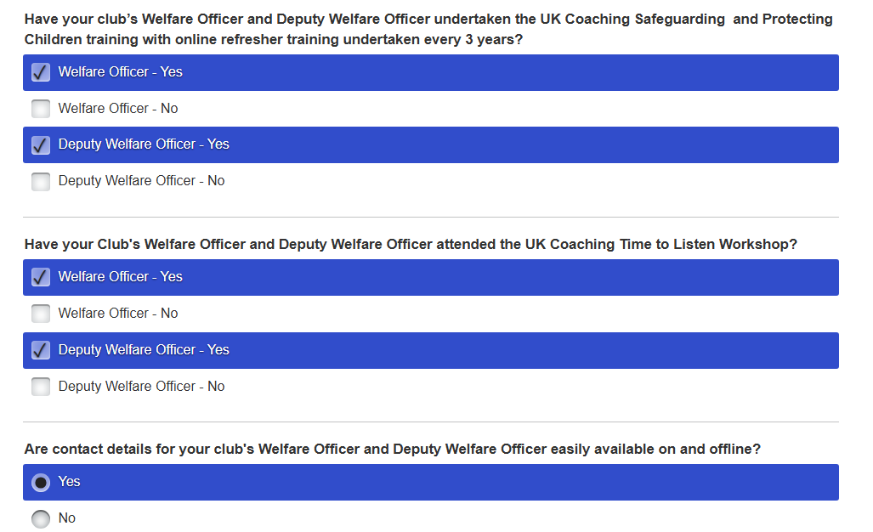
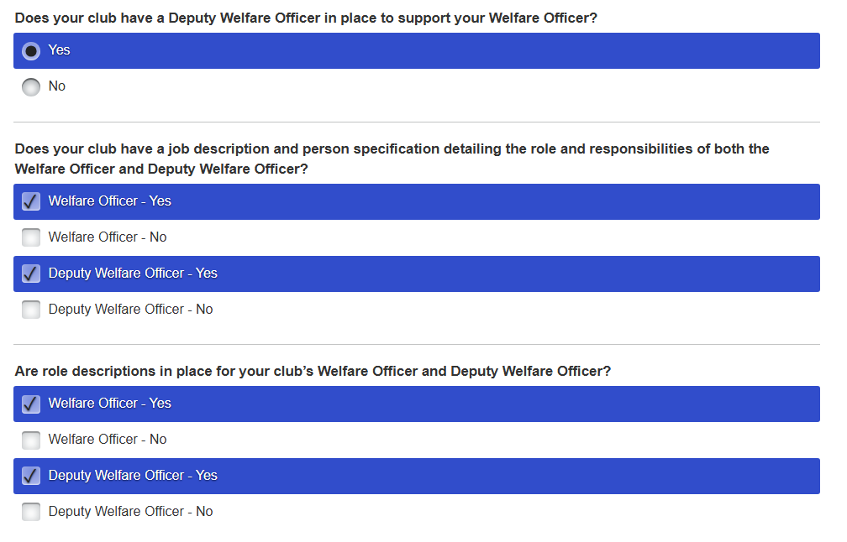
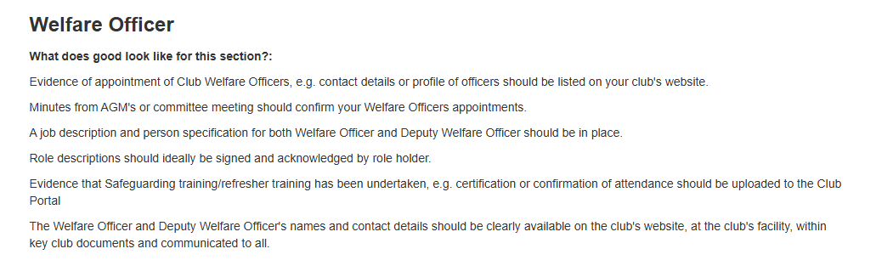
Describe how you could improve the roles of Welfare Officers at your club.
The current Welfare Officer Neil Allen was appointed at the 2024 AGM with a signed electronic signature to support John Teuwen who has moved over as his deputy because of Neil’s vast experience in managing children with issues in a “Care” Home environment. However, the day-to-day dealings of managing WKC safeguarding for example DBS checks, updating Paddle UK policies onto the club website are managed by John, but Neil’s role is to advise the club when discussing procedures and processes. An example was when we discussed the management of minors under 18 members when they participated on planned activities such as a river trip.
Both Neil Allen, John Teuwen have completed Paddle UK – Safeguarding and also “The Time to Listen” training to support their Welfare role, whilst John’s contact details are included on the Safeguarding “How to find Information” Flowchart, on the club website. Committee members, Leaders/Coaches have also completed the Safeguarding Training or Refresher and DBS, which is recorded in the Standards of Deployment plan p2-5, whilst p8 records leaders coaches evidence. In addition, this information will be circulated because the safeguarding policies communicated to all members was highlighted as an issue in the WKC – Club Survey Results Report will also be applied to the procedures in which an updated “Welcome Pack” will be sent by email.
Furthermore, the Chairperson will emphasize in the WhatsApp statement that any safeguarding concerns that might have arisen within the Members Survey, the individuals who expressed them can contact him. In addition, the safeguarding procedure to investigate a concern is explained in the Disciplinary Policy, Paddle UK- Holding a Disciplinary Hearing.
The club also needs to include on the AGM or Committee agenda safeguarding as an item, but in the past was discussed through WhatsApp Committee discussions when an issue arose associated with dealing with minors under 18.
The club has also applied Paddle UK – Welfare Role Descriptors and created a document, Welfare – Job Description; What to do.
Who will implement the changes?
WKC Committee – will discuss the Safeguarding Policy issue of communicating to all members, as well as the Induction Pack, and Welcome Pack, and posting “How to find Information” Flowchart on. We will issue a WKC -WhatsApp message to all members to ask them to look at the policy, and provide a link to it, including the other listed documents. This will be supported by Chairperson Paul Elkington statement.
When will they be implemented?
The Committee, and Quorum concerned with the Quality Club Toolkit review will implement the change prior to Octobers Affiliation meeting with Paddle UK., whilst the introduction of Safeguarding as an Agenda item will be immediate.

- Equality, Diversity and Inclusion: Good EDI Governance,
- Understanding your Club:
- Understanding your local Community:
- Making Paddling Accessible
- Tackling Discrimination:

Describe how
Who will implement the changes?
When will they be implemented?

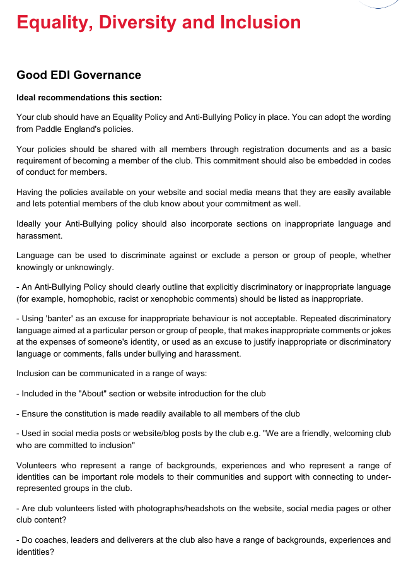

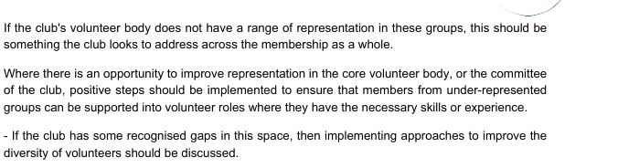

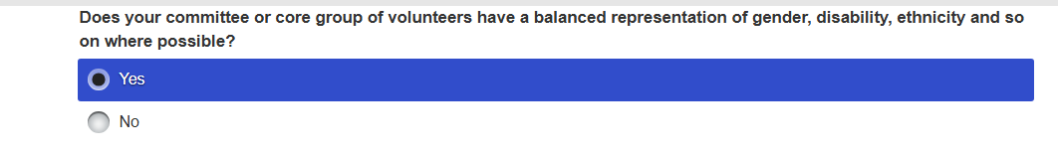
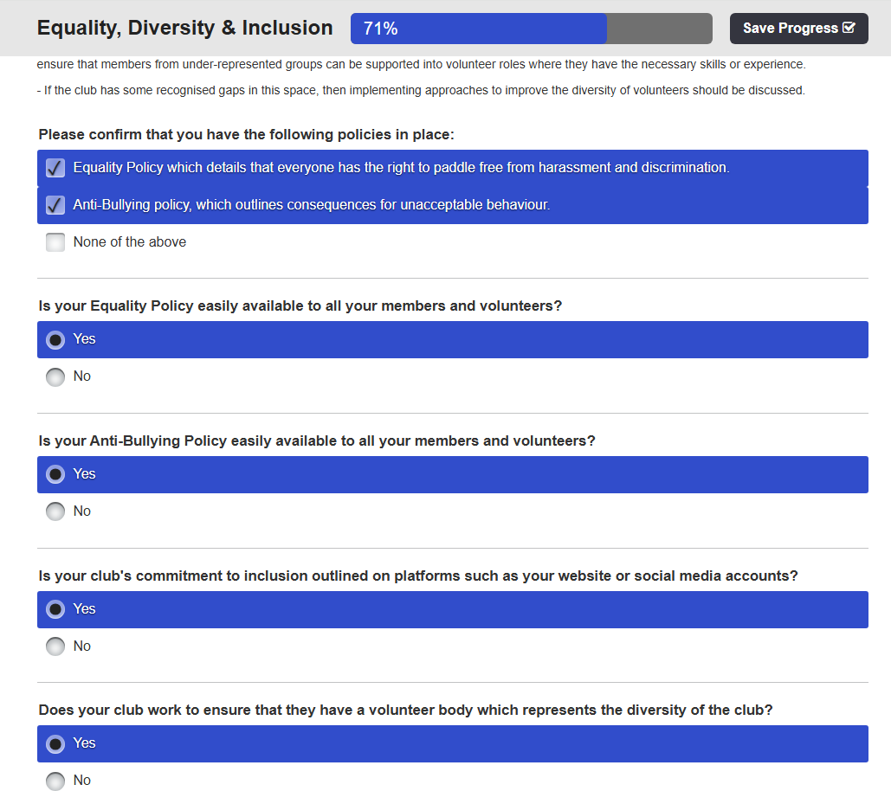
Describe what you could introduce to improve EDI Governance at your club
WKC has a Equality Policy , whilst the Safeguarding “How to find Information” Flowchart has links to (Paddle UK) Policies such as Children, Anti-bullying, Adult, etc. The club embeds its Vision, Values, Aims, as a transparent, non-judgemental, and learning culture to new members during the joining process by asking them to commit to the Adult or Junior Code of Conduct. This is reinforced by the new member receiving an Induction Pack, and Welcome Pack, that includes website links, prior to a planned activity in which a leader or coach introduces them to the participating group. Hence, the club culture promotes inclusiveness amongst its members when conducting themselves during a planned club activity in which inappropriate language and harassment is not accepted or used to discriminate against or exclude a person or group of people, whether knowingly or unknowingly, e.g. the Welcome Pack, includes Paddle UK Inclusive Language – Recognising inappropriate banter p8.,as a point of reference. In addition, the club’s Home page on the website promotes a friendly welcoming approach supported by a video and the “Quality Club” affiliation, as well as the policies, procedures and processes, that the status requires the club to adhere, e.g. the “Constitution” .

Furthermore, the new member is accepted onto the club’s WhatsApp’s groups, which is used to communicate planned activities across a membership spread from the Southeast, Southwest, West & East Midlands, North Wales, and North-West. This is supported by weekly YouTube videos of planned club events with volunteers who represent a range of backgrounds, experiences Standards of Deployment plan p2-5, who play an important role delivering a safe, enjoyable paddle. The Club Survey results, Appendix p18, provides a breakdown of gender, age, ethnicity, home address for the membership and The Committee. This has provided an identity and direction for the club to sustain its future, subsequently there has been an increase in membership numbers which includes experienced and qualified paddlers since the club joined the "Quality Club" process in 2021 from 25 to 70. In addition, the club recognises that 66% of the membership is over 50, whilst the over 30’s has increased by 30%, the under 30’s and U18’s are 11.5% respectively. The female membership has gradually increased to 21%, which is represented on the Committee, alongside the other age groups.
However, the club has difficulties in helping to address barriers for underrepresented groups in accessing green and blue spaces because it does not have a designated club house with well-equipped paddling resources and it operates on a basis that planned activities are organised in relation to weather conditions at the last moment. Furthermore, the planned activities are organised in isolated countryside locations away from urban conurbations in which underrepresented groups live, alongside other barriers such as the ability to travel, cost, not aware of activity opportunities. And yet, the pool session at Codsall Community Centre, Wolverhampton that’s nearer to the bigger population centres could be promoted as a “Taster” session for beginners, whilst using a local nearby canal during the summer.
Who will implement the changes?
WKC Committee – have introduced a Club Survey to monitor members views, as well as organising an AGM in the West Midlands and North Wales to encourage all members to participate in the management of the club. Consequently, the club has identified an issue within the Club Survey with regards to communicating to all members the meaning of safeguarding. Hence, WKC Committee – will discuss the Safeguarding Policy, as well as the Induction Pack, and Welcome Pack, and “How to find Information” Flowchart. We will issue a WKC -WhatsApp message to all members to ask them to look at the policy, and provide a link to it, including the other listed documents. This will be supported by Chairperson Paul Elkington statement.
When will they be implemented?
The Committee, and Quorum concerned with the Quality Club Toolkit review will implement the change prior to Octobers Affiliation meeting with Paddle UK., whilst the introduction of Safeguarding as an Agenda item will be immediate
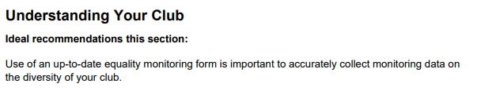

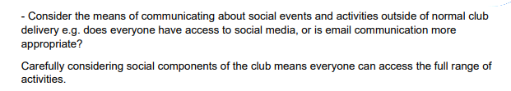
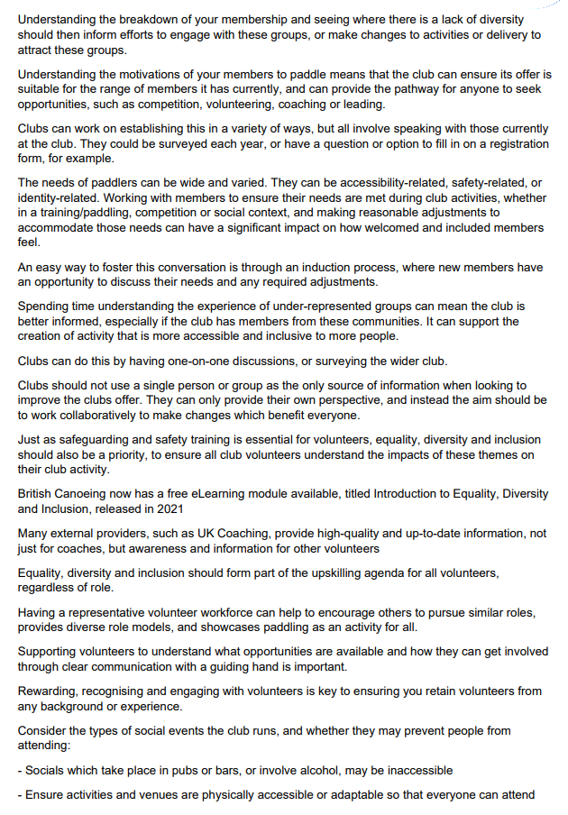
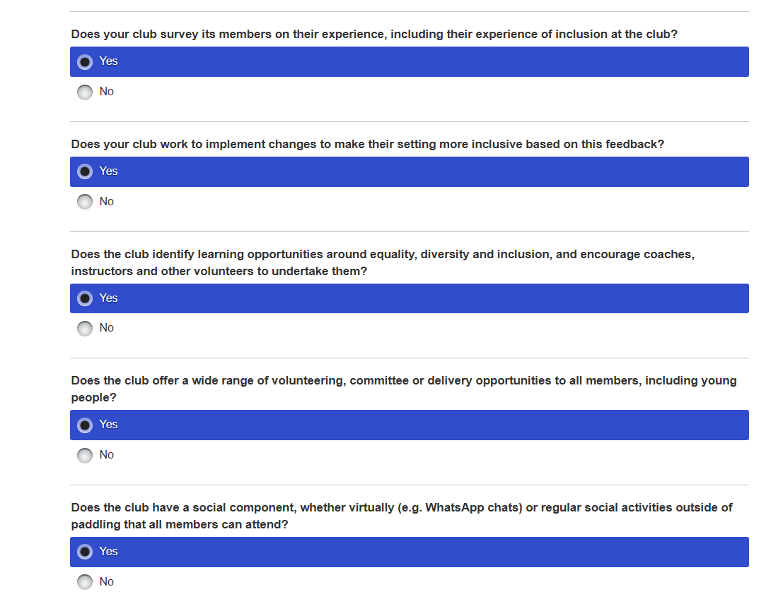
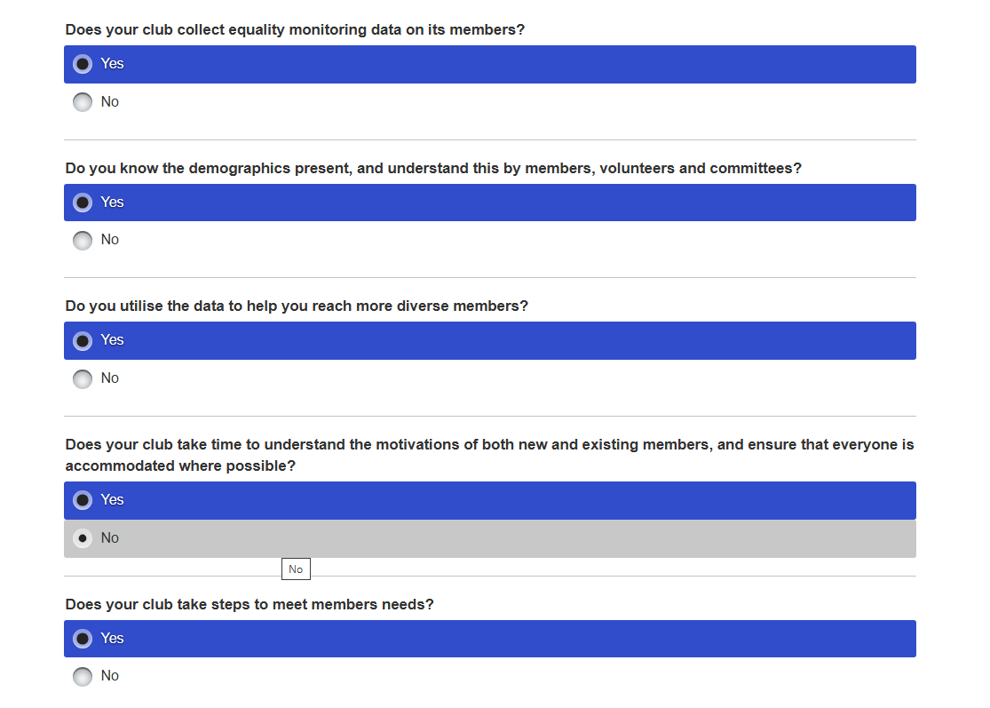
Describe what you could do at your club to improve the understanding of your members.
The Club Survey results, Appendix p18, provides a breakdown of gender, age, ethnicity, home address for the membership and The Committee and has been discussed in EDI about the club’s progress since being awarded Quality Club status.
Hence, we have an address base at Codsall Community School (Pool) near Wolverhampton, that is used from October to April, whilst the Club Night is organised at Telford Canoe Club’s site at Jackfield Rapids, near Ironbridge, between April and September in which most members also belong to that club. Furthermore, Saturday Club Paddles are arranged with the majority of trips in Wales and further afield such as “The Lakes” or Scotland depending on river levels throughout the year. Thus, the club has a unique selling point (USP), in which paddlers are becoming members of the club because there are regular planned, safe and enjoyable activities, particularly over the weekend at various whitewater venues that has attracted a wide spread of membership.
However, the Club Survey p16 “How do we improve”? identified some issues when some members, expressed “That a few more local and intermediate river trips in the calendar could be useful, but this is dependent on leader availability and levels in naturally fed rivers”. Consequently, this “offered only dam-fed ones, which can guarantee river levels that tend to be for more advanced paddlers because it has been a very dry summer. This allows the paddler to progress and encourage the individual to stay with the club with their support, whilst promoting the sport”. Finally, most planned activities are either for “total beginners or too advanced, in which the club seems to be based at the Tryweryn”.
Who will implement the changes?
The Committee has extended its membership by encouraging two new members from North Wales to represent their voice, by organising two AGMs in which one was in the West Midlands and the other in North Wales were promoted on the club’s WhatsApp. The two AGMs were made into a social event alongside a paddle activity to increase participation and involvement with the club, which included free food.
The Committee, and Quorum concerned with the Quality Club Toolkit review will implement the changes prior to Octobers Affiliation meeting with Paddle UK., after discussion with all Committee members.
The points raised by these comments in the Club Survey will also be discussed by the Committee, or alternatively those mentioned can be expressed explicitly to any of Committee members to develop further their ideas. An example would be to provide alternative weekend trips on grade 1-2 rivers such as the upper or lower Banwy, Lower Dee, Ludlow weirs, upper Vyrnwy, upper section Usk, but as stated some coaches or leaders have been unable to organise due to family commitments.
When will they be implemented?
WKC Committee – have introduced an annual Club Survey in September 2025 to monitor members views, as well as organising an annual AGM in the West Midlands and North Wales to encourage all members to participate in the management of the club. Consequently, the club has identified an issue within the Club Survey with regards to communicating to all members the meaning of “Safeguarding”, as well as checking the Induction Pack, and Welcome Pack, and posting “How to find Information” Flowchart on WKC -WhatsApp., that will be supported by Chairperson Paul Elkington statement.
In addition, the club will implement more grade 1-2 river activities to help support the personal development of paddlers to enable them to progress their skills and join planned trips on grade 3-4. Finally, The introduction of Safeguarding as an Agenda item will be immediate and future grade 1-2 planned river activities throughout the year.
Understanding Your Local Community
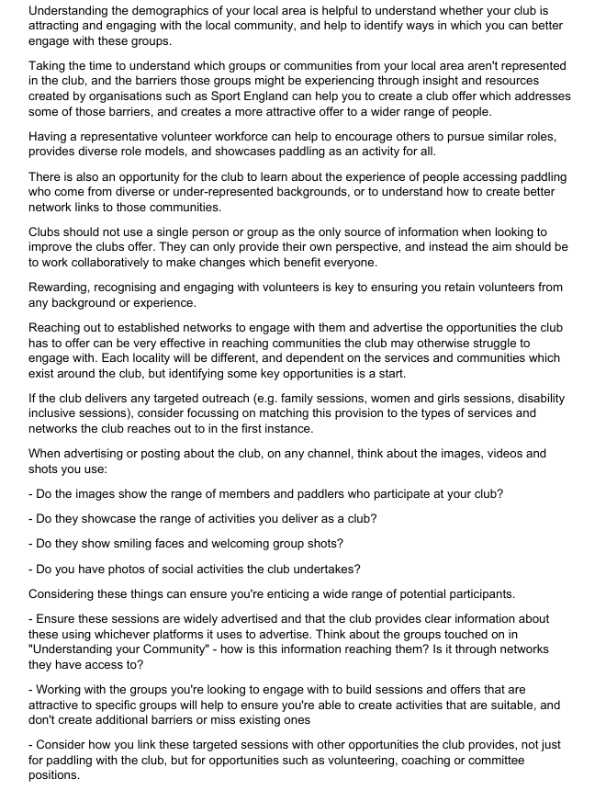

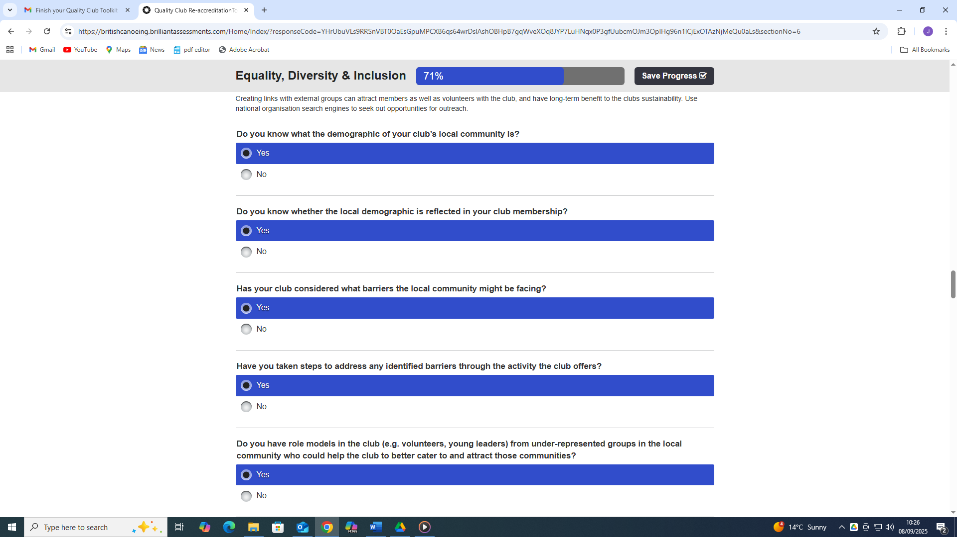

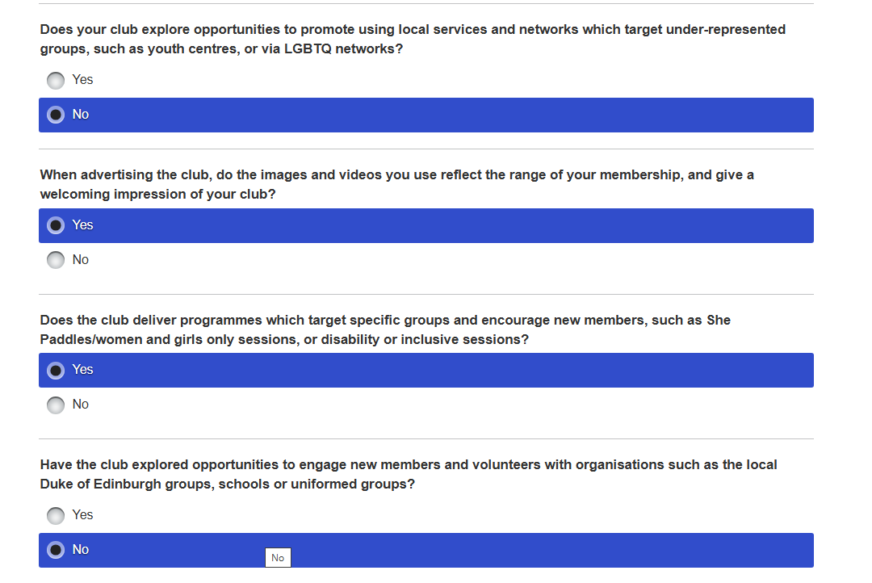
Describe how you could improve the understanding of your Local Community.
Historically the membership has hovered around 20 members for a decade or so for white male paddlers aged between 40-60, that have included 1-2 sons under 18’s. However, the Club Survey results with a 46% response rate, Appendix p18, provides a breakdown of gender, age, ethnicity, home address for the membership and The Committee, which was discussed in “Understanding your club”.
Moreover, one must also consider that attracting and engaging with the local community is a difficult concept because the club does not have a designated club house with well-equipped paddling resources but Codsall Community School (Pool) near Wolverhampton, whilst Club Night is organised at Telford Canoe Club’s site at Jackfield Rapids and Saturday Club Paddles are arranged in Wales and further afield. Hence, as previously stated in EDI the club has had difficulties in helping to address barriers for underrepresented groups in accessing green and blue spaces.
Subsequently, the club has encouraged Continuous Personal Development (CPD), because they have been offered financial support to undertake WWL training and assessment by the Paddle UK Bursary to improve individuals’ knowledge, experience in which they have contributed to the leadership and coaching team. Furthermore, Paddle UK have offered free eLearning such as Safeguarding, Code of Conduct, Risk Management and Risk Assessment CPD, Event Safety Management Training that has been taken up by leaders, coaches and Committee members as part of the Standards of Deployment plan p2-5. In addition, a 2-day 1st Aid training has been financially supported to members to maintain their valid leadership and coaching qualifications to operate, but also in rewarding, recognising, engaging and retaining volunteers from varied background and experience. Thus, the Committee has extended its membership by encouraging two new members from North Wales to represent their voice, by organising two AGMs in which one was in the West Midlands and the other in North Wales were promoted on the club’s WhatsApp.
This is supported by weekly YouTube videos that promotes the club’s planned river trip activities, supported by “Instagram” images of a range of members participating in the event, which has contributed to the growth of the club membership. However, the Club Survey identified “the club may try and attract novice paddlers to upskill them in which enable them to participate on level 1/2 river trips”, rather than the current perception that may portray a club with an emphasis on grade 3-4 whitewater planned activities. Hence, the club may want to promote the pool session at Codsall Community Centre, Wolverhampton that’s nearer to the bigger population centres could be promoted as a “Taster” session for beginners, whilst using a local nearby canal during the summer.
Who will implement the changes?
The Committee, and Quorum concerned with the Quality Club Toolkit review will implement the changes prior to Octobers Affiliation meeting with Paddle UK., after discussion with all Committee members.
When will they be implemented?
The club’s planned river trip activities will be an on-going weekly process, that will depend on the availability of leaders, coaches, the suitability of participants with regards to ability, weather and choice on the day in relation to river levels.

. In the EDI section, perhaps put something about organising more trips for beginners, maybe starting on flat water, e g a canal that’s nearer to the bigger population centres, e g Wolverhampton, Stourbridge, Dudley etc.
This might also help in the Understanding Your Local Community section.

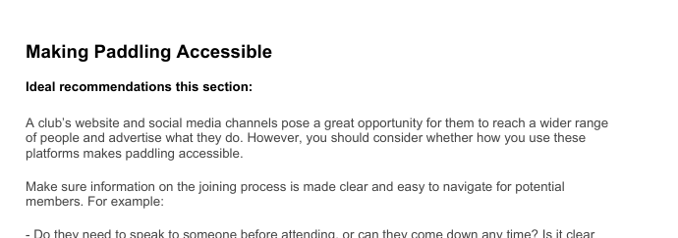
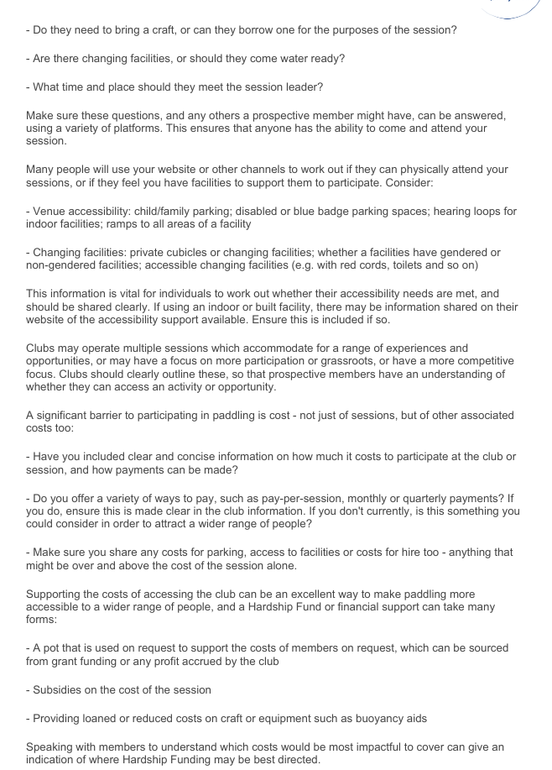
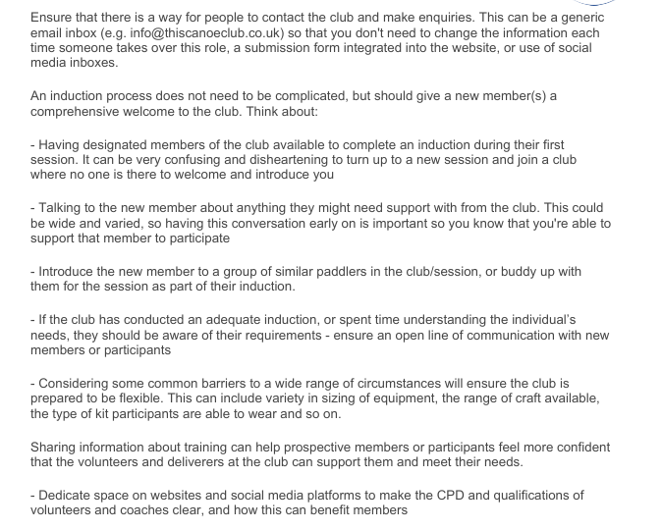

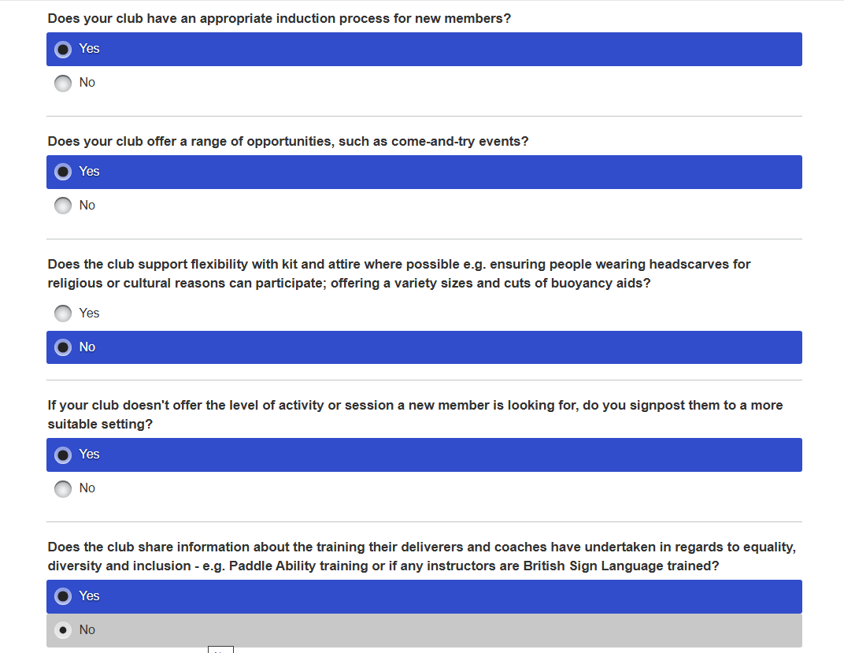
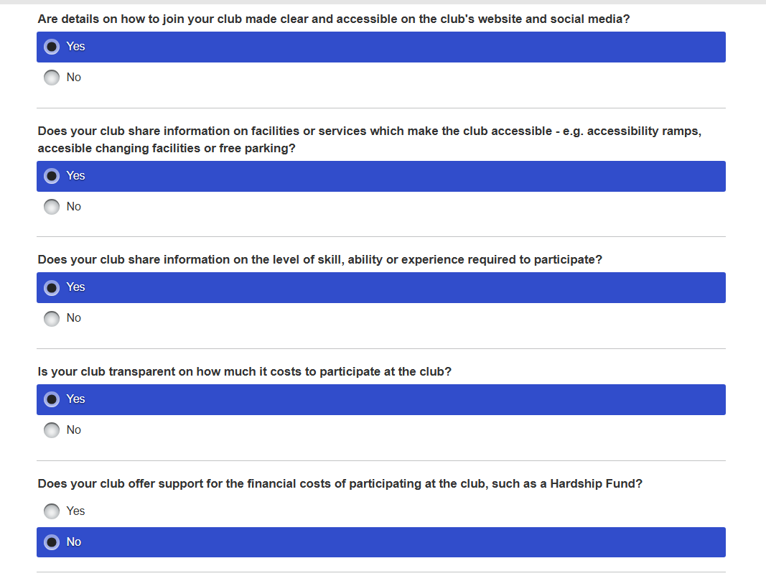
Describe how you could improve Accessibility at your club.
Making paddling accessible has been made easier and supported by membership growth by weekly YouTube videos that promotes the club’s planned river trip activities, supported by “Instagram” images of a range of members participating in the event. The Club Survey results, Appendix p18, provides a breakdown of gender, age, ethnicity, home address for the membership and The Committee, which has been discussed previously.
However, the joining process is made clear because a designated Committee member immediately contacts the interested party with the relevant Membership information to join the club or provides additional support by email or phone, e.g. do they need a boat and other equipment such as for a beginner, specific details about the pool or club night location, time and date, etc. In addition, the club can provide limited equipment to the beginner to get them started, which is offered on a free basis that would include a free pool session. Additionally, there would be changing facilities at the pool, whilst the planned club night or river trips the prospective member would have to change “Discreetly”. Hence, if the individual wishes to join, then payment details and costs are arranged by using a bank transfer but also adjusted depending on the time of the year, e.g. membership starts from January to December, but a reduction is made on membership cost from one month to another. Furthermore, on receipt of payment the new member receives an Induction Pack, and Welcome Pack, that includes website links, prior to a planned activity in which a leader or coach introduces them to the participating group.
Who will implement the changes?
The Club Committee, will discuss any prospective individual or family needs such as a “Beginner”, but is usually managed by coaches from the Committee to support them, e.g. equipment, costs etc.
When will they be implemented?
Initially, the club secretary will manage the joining process and provide the relevant information. The club’s planned activities will be an on-going weekly process, that will depend on the availability of leaders, coaches, the suitability of participants with regards to equipment, ability, weather and choice on the day in relation to river levels to support them.

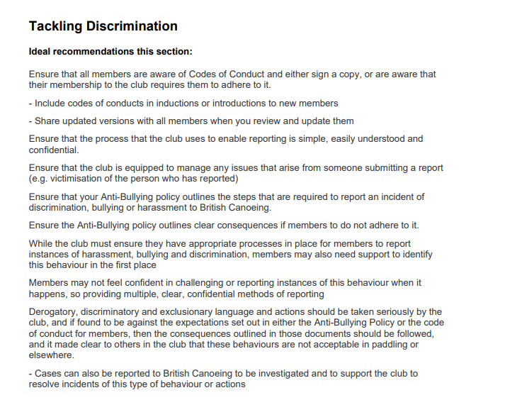
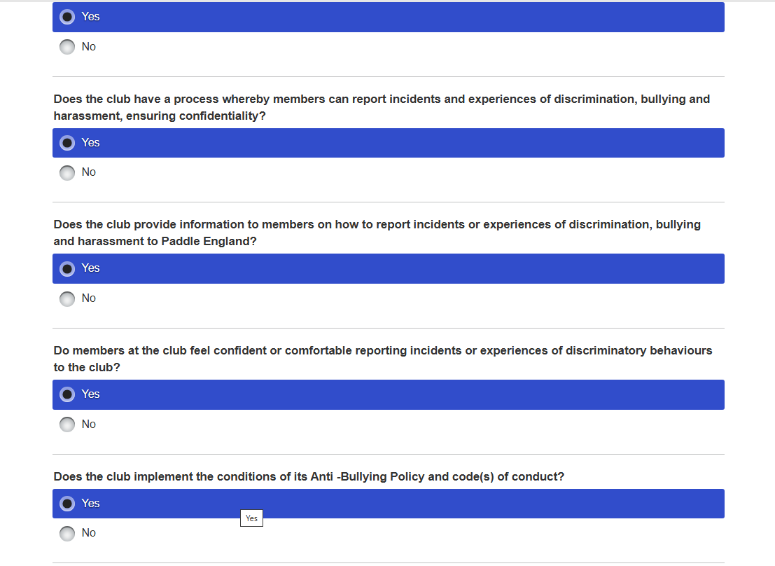
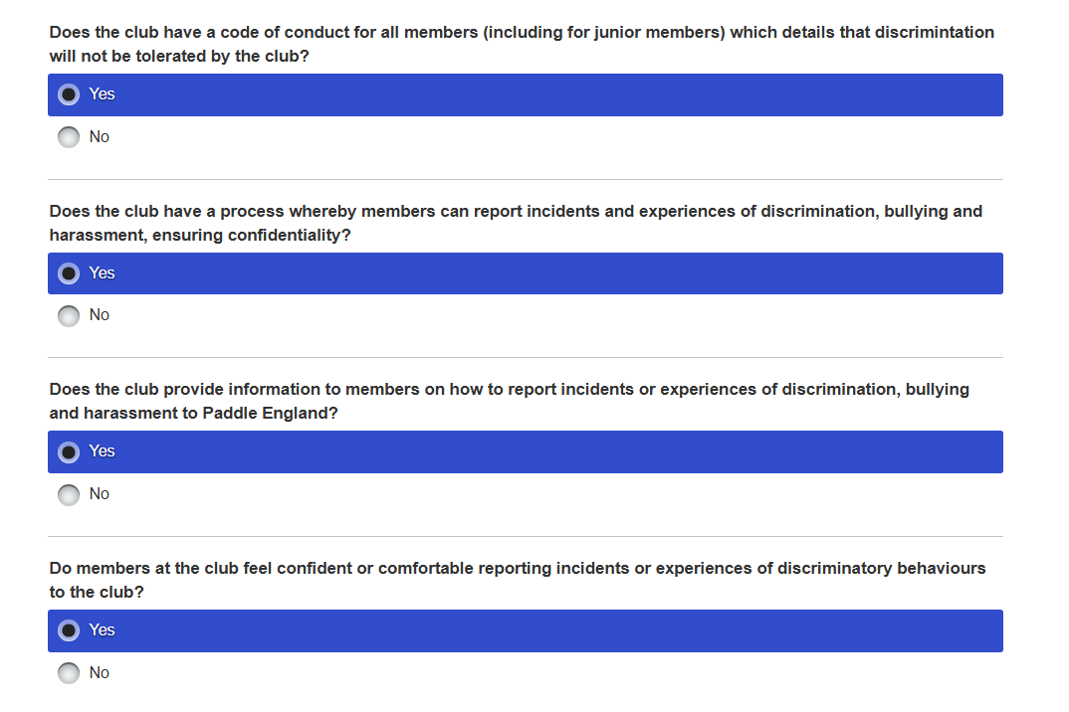
Describe what improvements you could implement at your club to help tackle Discrimination.
The improvements by WKC which could be implemented to help tackle discrimination have been discussed in EDI with regards to policies, procedures and processes, such as the Equality Policy , whilst the Safeguarding “How to find Information Children, Anti-bullying, Adult, etc. For example, the Club Survey Report provided a personal perception from someone attending some Peer Paddles and Stephy's Rolling Clinic “felt very welcomed by fellow members and fully supported and safe on the water”. So much so that after just 1 day’s rolling, “their confidence, fun levels and on/off-side roll have increased dramatically”! Another member reflected “I would like to add that the club activities and people, have enhanced my quality of life. I have been lifted through a recent difficult patch with a health issue and paddling slump just simply by being who they are and doing what they do”.
Furthermore, the club have also received criticism by former members, which was refuted by current members, particularly by one member who produced a “Google” review, which had continuous “Vexatious” remarks towards the club. Subsequently, he was asked to resign or be reported to the police for constant “Text” messaging to a particular Committee member. Additionally, he has influenced other former members to send two Paddle UK Incidents Reports, in which the club had a discussion with Russ Smith who was satisfied by our responses presented to him by Paul Elkington (Chairman), Rich Dowen (Trip Organiser & Senior Coach), John Teuwen (Secretary), David Allen (Committee).
Who will implement the changes?
The Committee, and Quorum concerned with the Quality Club Toolkit review will implement the changes prior to Octobers Affiliation meeting with Paddle UK., after discussion with all Committee members.
When will they be implemented?
The Committee, and Quorum concerned with the Quality Club Toolkit review will implement the change prior to Octobers Affiliation meeting with Paddle UK., whilst the introduction of Safeguarding as an Agenda item will be immediate.

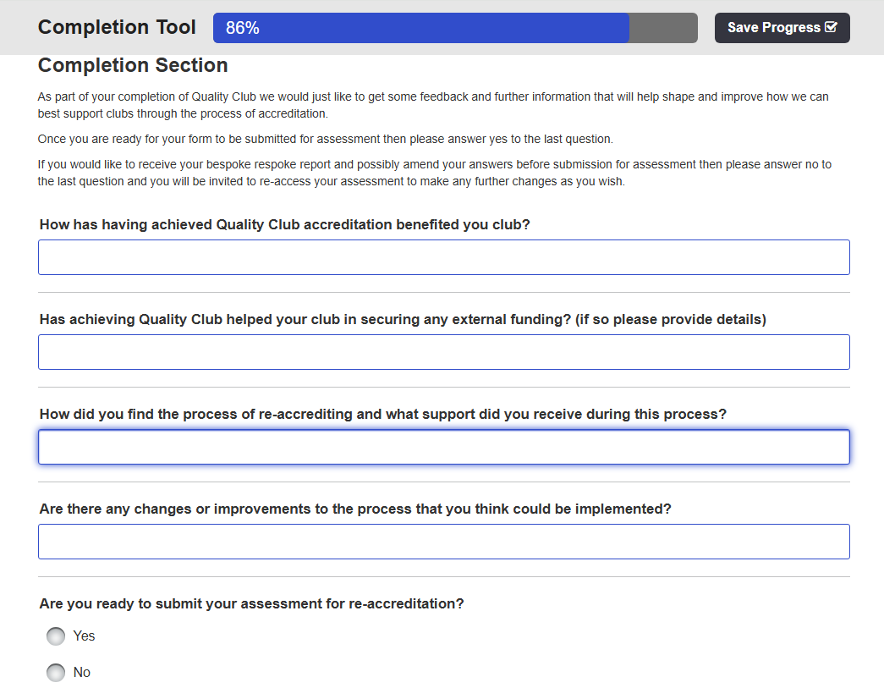

How has having achieved Quality Club accreditation benefited you club?
The Quality Club process of accreditation has assisted the club in preparation for Standards of Deployment implementation in 2026 in which it has identified the necessary policies, procedures and processes are in place to support the delivery of planned activities. This has helped to ensure that the planned club activities have been managed in a safe and enjoyable manner by qualified leaders/coaches who have been DBS checked to maintain the safeguarding and welfare of under 18’s, but also adult members. In addition, the same process applies to Committee members to ensure that they have a knowledge of safeguarding, risk management and risk assessment, and Codes of Conduct for Leaders/Coaches to ensure that they understand their roles and responsibilities as a volunteer in managing the club. Hence, the annual Quality Club Toolkit acts as a checking process to maintain its level of performance, but also to update where necessary with regards to policies, procedures and processes.
Has achieving Quality Club helped your club in securing any external funding? (if so please provide details)
The club has been successful in securing two Paddle UK – Bursaries in which they have invested in club members to foster their professional development by undertaking a range of qualifications, 1st Aid, WWSR, Paddlesport Touring Assessment, WWL Training & Assessment, Core Coaching between 2022-2025. In addition, the club have used the free eLearning for Safeguarding, Code of Conduct for Coaches, Risk Management & Risk Assessment, and Event Safety Management Training.

How did you find the process of re-accrediting and what support did you receive during this process?
The club undertook an in-depth approach when using the Quality Club Toolkit to provide an insight into the management of the club throughout the different sections because my first attempt I briefly described, and we achieved 79%. However, Phil Scowcroft, in our de-debrief was very confident that we had the evidence and was not necessary to re-do the Toolkit assessment. Hence, I have involved a Committee Quorum in this year’s Quality Club Toolkit to ensure they understand the process in maintaining our Club Affiliation with an in-depth analysis in which the evidence is linked to the policies, procedures and processes on the club’s website. In addition, the club have carried out a Club Survey to measure the members’ perception that includes in the Club Survey Report Appendix p18, a breakdown of gender, age, ethnicity, home address for the membership and The Committee. This has helped to explain the unusualness of the club in that it does not have a club house; the membership is not entirely local but spread across the country and Wombourne Kayak Club unique selling point is that it organises regular weekly planned activities that are welcoming, inclusive, safe and enjoyable.
Are there any changes or improvements to the process that you think could be implemented?
My main concern is identified in the Risk Register in that the administering of the club relies on one Committee member, who is attempting to mentor Committee members and provide “How to do guides” such as Role descriptions, Affiliation, Quality Club Toolkit, etc., However, Committee members on the whole have extremely busy work schedules and use their valuable leisure time to paddle to ensure their well-being and health. Hence, Paddle UK as the NGB (National Governing Body) and CIMSPA (Chartered Institute for Management of Sport & Physical Activity that sets clear regulatory standards, which are clearly influenced by central government. Overall, Paddle UK and CIMSPA need to consider that volunteers are giving their “Time” and effort to undertake these responsibilities and need to ensure that the re-accrediting is not so “Arduous” and time-consuming in which it becomes a “Mechanical” process, e.g. how much can a club improve each year? How much reliance on “AI” does the process rely on, that it loses it prospective and perception on assessment? Finally, the Quality Club Toolkit, does not allow links to policies, procedures or processes in which that would support the Paddle UK – Club Support Team to find the evidence on the club website, would make it easier for them.

