QUALITY CLUB PROCESS – How to do it?

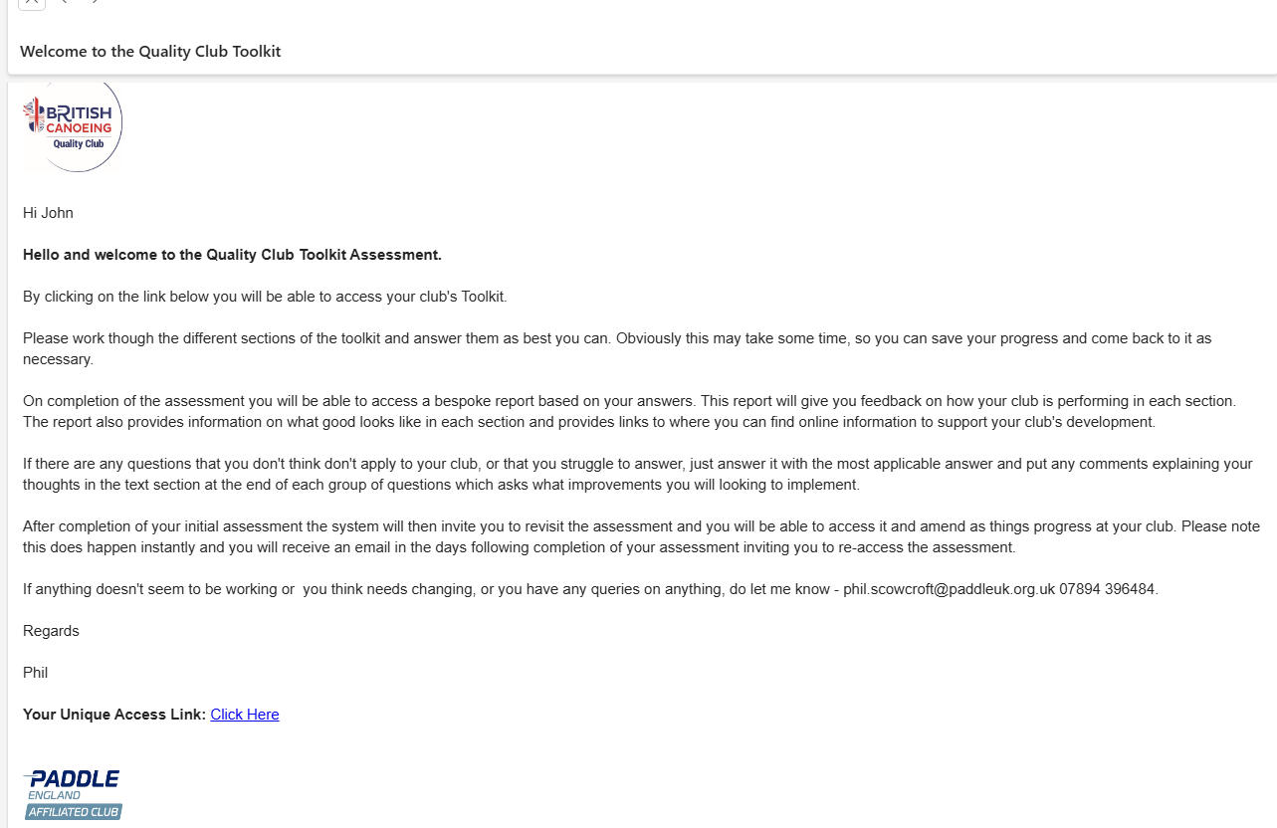
Step 1 – You receive an email with a link to start process.

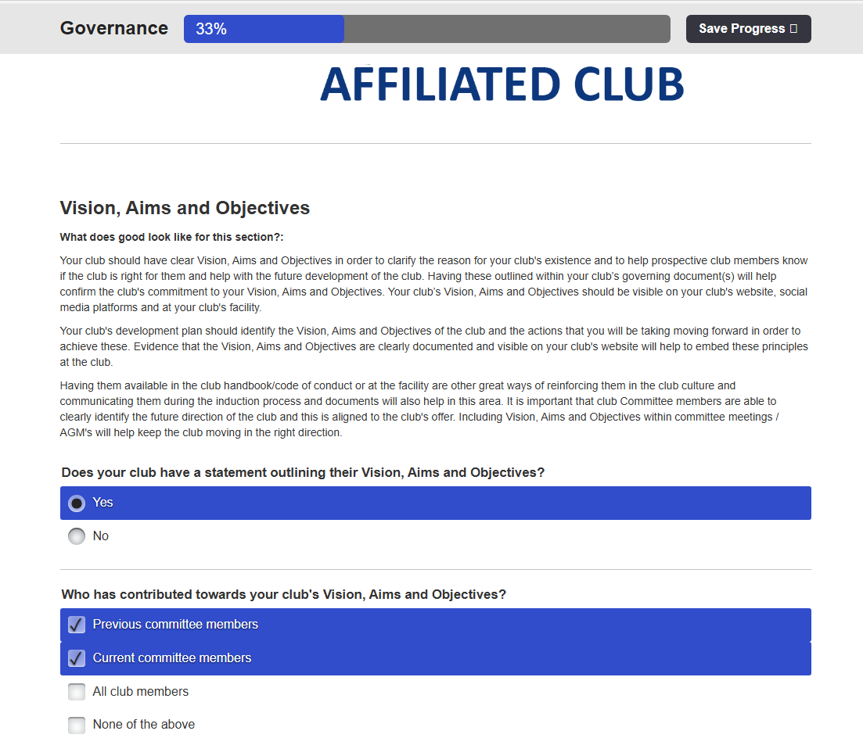
Step 2 – Click on, start process, tick appropriate boxes.

Check Paddle UK – Toolkit Part 1 & 2,
Toolkit Part 3 & 4 for responses.

Note, the YES/NO determine the rating! See Quality Club Analysis: 2025-26, p3.
e.g. Where are your Vision, Aims & Objectives are outlined and available?

Not displayed in clubhouse, is not achieveable as club do not have faculities!

Step 3 – Answer questions, but incorporate into WKC 3 Year Development Plan with links to evidence.
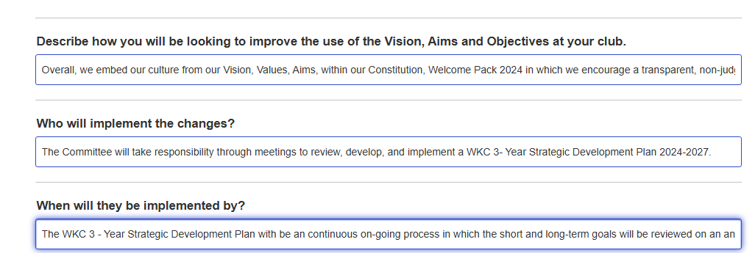

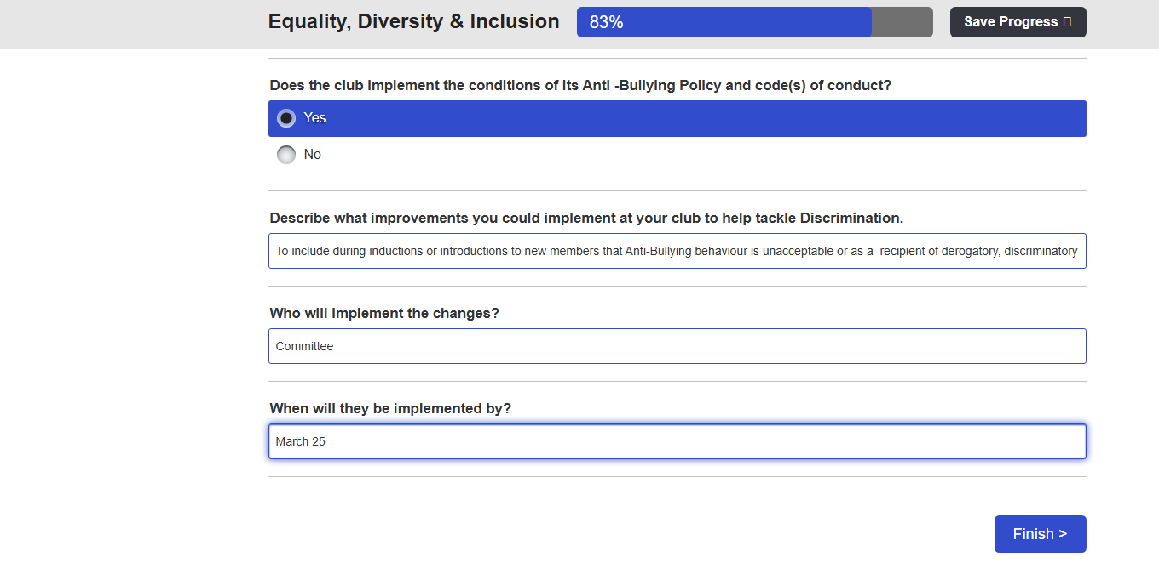
Step 4 – Click onto Finish

Step 5 – Click to view report.
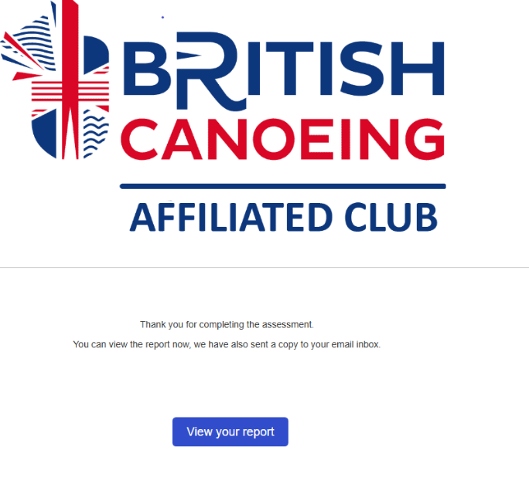

e.g. Quality Club Toolkit 2025-2026 (91%)

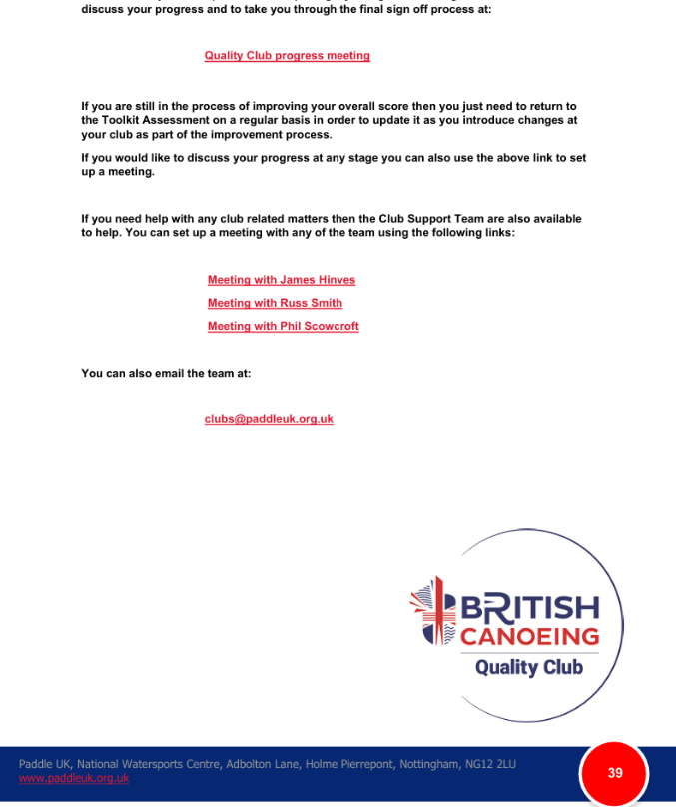
Step 6 – Book an appointment

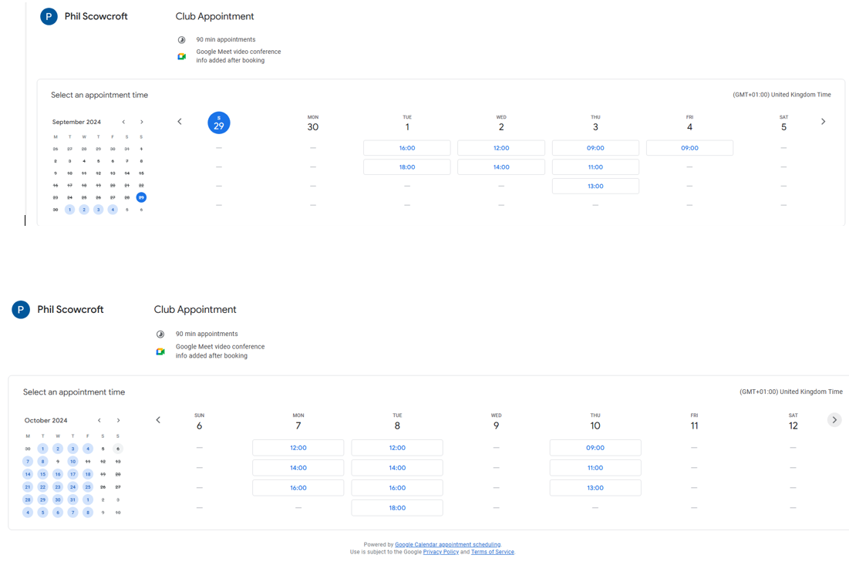

Step 7 – Complete the Quality Club Process Feedback

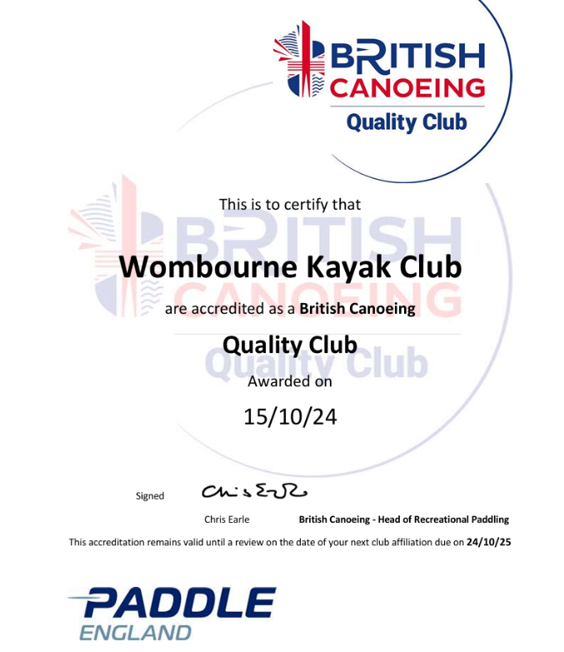
Step 8 – Download onto Website.

