Quality Club Toolkit 2023 -2024 (79%) Completed in July 2024
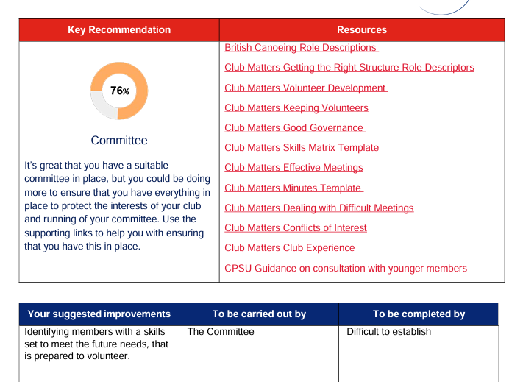
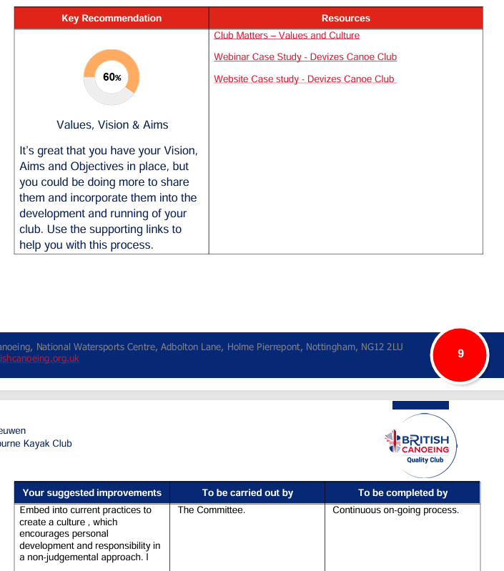
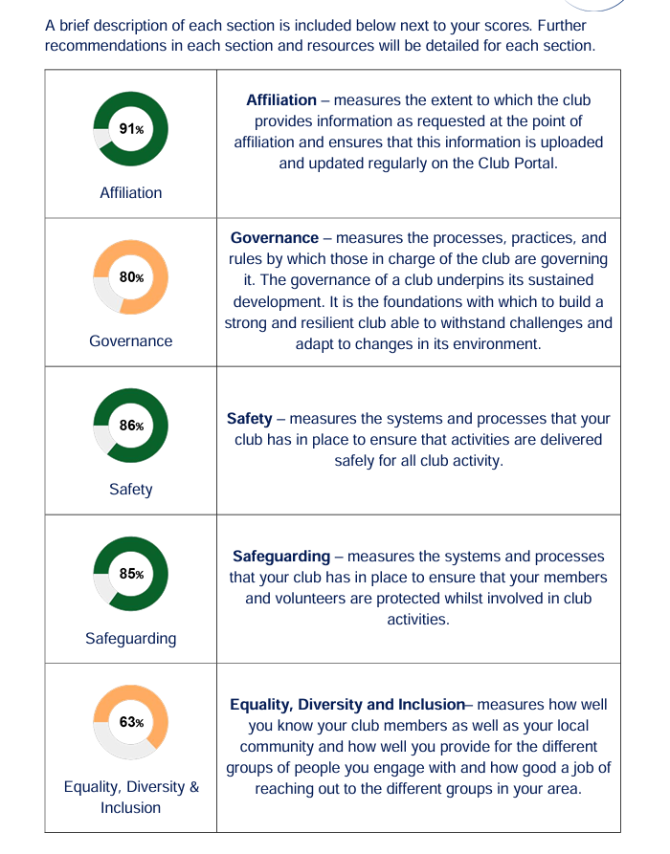
Quality Club Toolkit 2023 -2024 (79%) Completed in July 2024
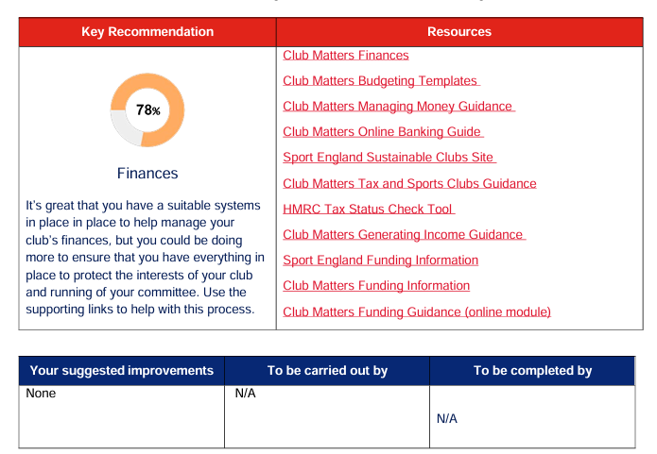
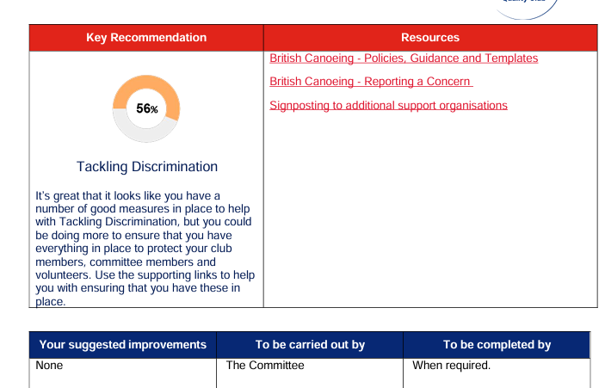
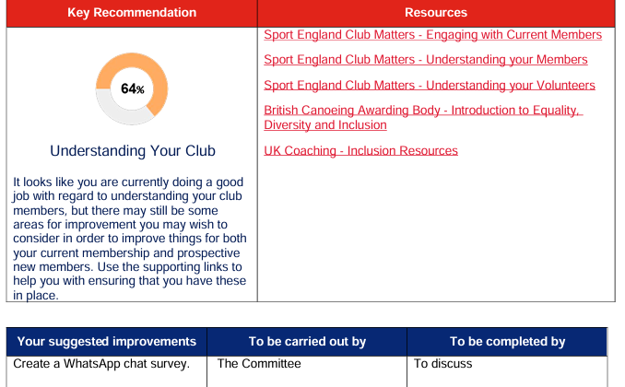
Quality Club Toolkit 2025-2026 (91%)
Governance
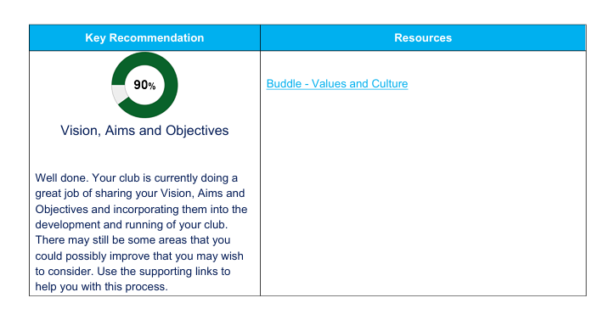

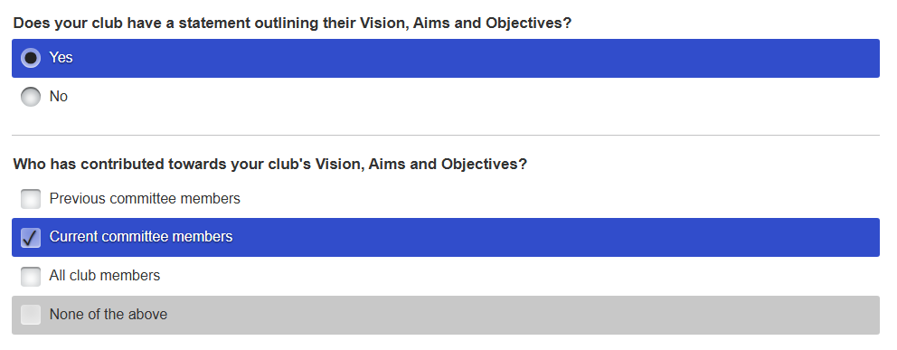

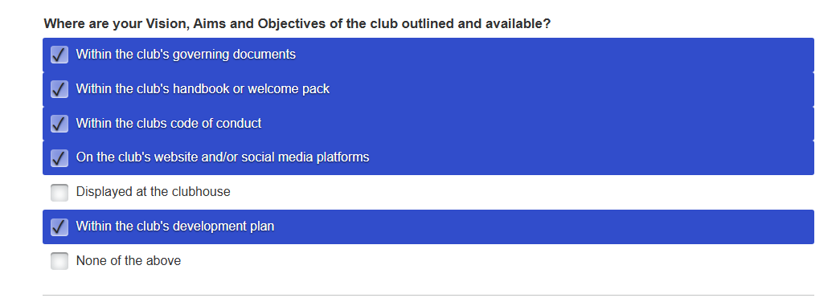

Q.How are Committee members in their busy employed roles spend their time reviewing resource documents to the detriment of their health & well being?
Conclusion:
Not display in clubhouse, is not achieveable as club do not have faculities.
Do Committee members have time to review Bundle – Values & Culture???
Policy Documents
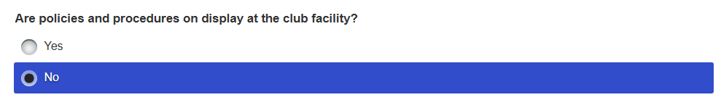
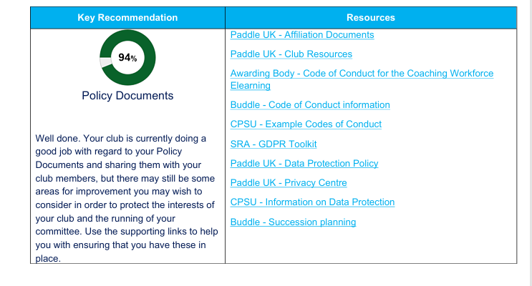
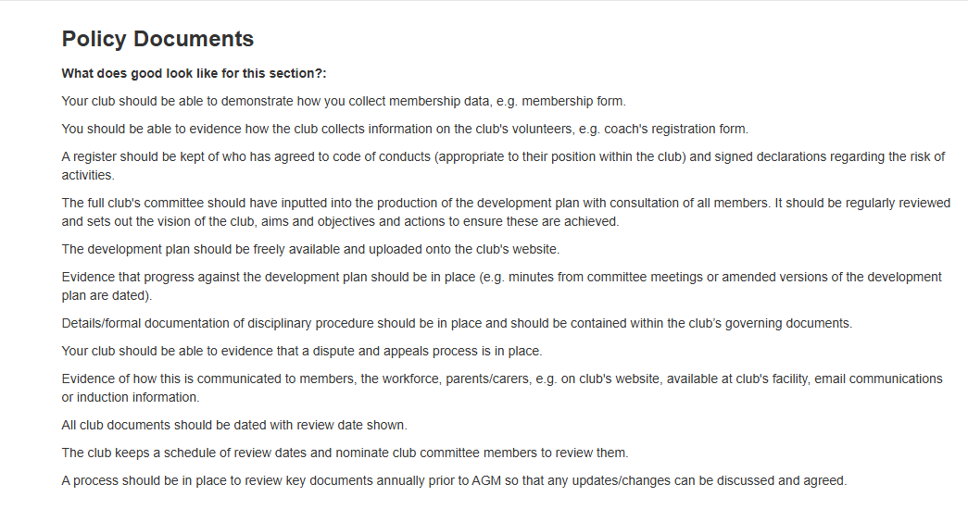
Describe what improvements will you be introducing to improve your club's Policy Documents.
The club committee will improve the club’s Policy documents as part of Paddle UK – Affiliation process in October, that includes the updating of the Club Portal and website such as membership data, qualifications etc, that are dated when reviewed. In addition, this will include current Code of Conduct and Trip Consent records, Disciplinary and other policy documents.
The Committee decision making is documented in the WKC – Consultation and Action Logbook, that supports the Three-year Strategic Development Plan will help the implementation of club policy as part of the “Quality Club” affiliation. Furthermore, it includes a Schedule of review dates, that are, annually checked. Club members will have an opportunity to contribute to the development plan at scheduled annual AGM, any issues that arise on WhatsApp, or the introduction of the Club Survey.
However, Data Protection may be considered when mainly the club’s WhatsApp is used as the format to communicate. In addition, Committee members are made aware of signed updated relevant documents are kept on the club website. With regards to personal data kept on the club website, this is managed and administered by a core of Committee members.
Who will implement the changes?
The club committee will implement operational compliance as part of the Paddle UK – Affiliation process in October.
When will they be implemented by?
Specific club committee members involved in the implementation of Paddle UK – Affiliation process in October.

Q. How exactly does one protect the interests of our club and the running of the Committee?
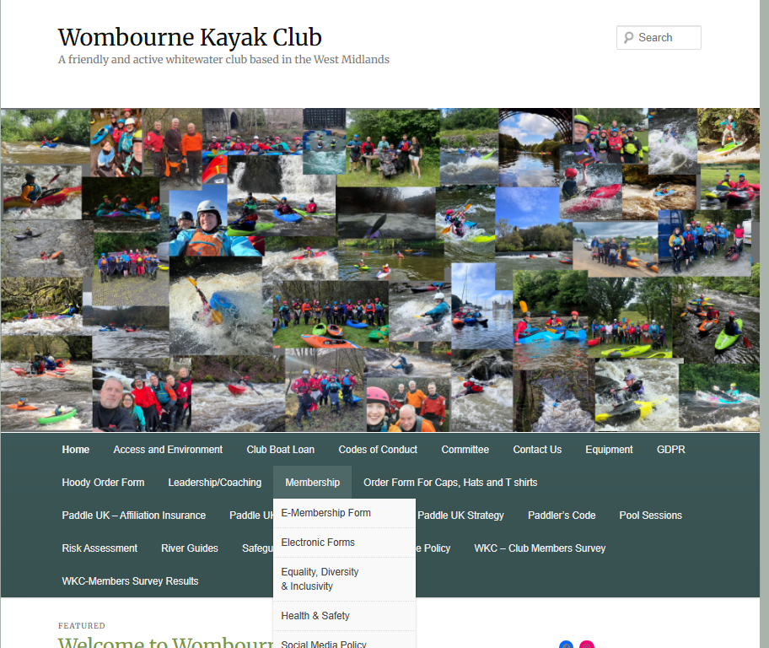
Answer NO –
No Club House Facilities
Succession Planning identified as a risk!
Solution: Equipment Management eLearning, Club Resources | Documents and Guidance | Paddle UK, which the club have evidence on the website!!!!

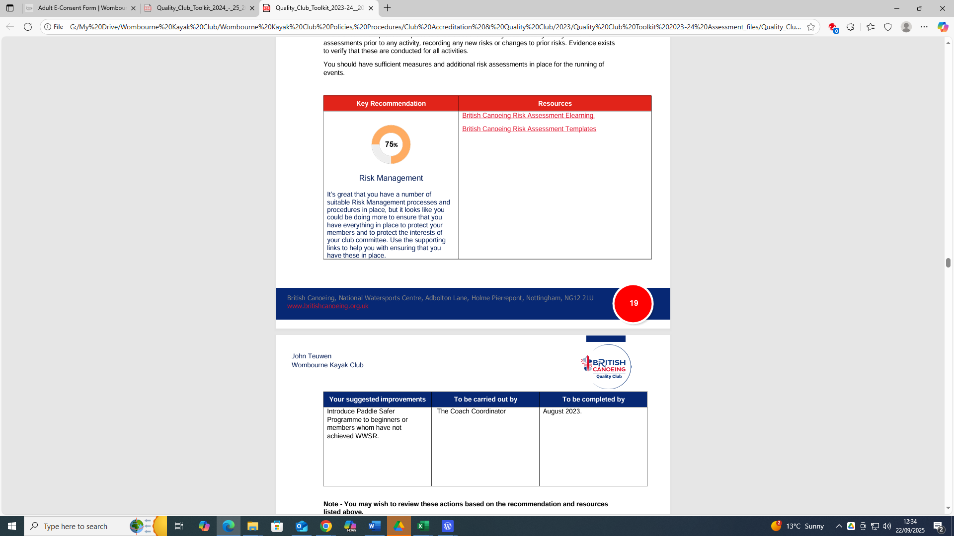
Risk Management -Quality Club Toolkit 2023 -2024 (79%) Completed in July 2024

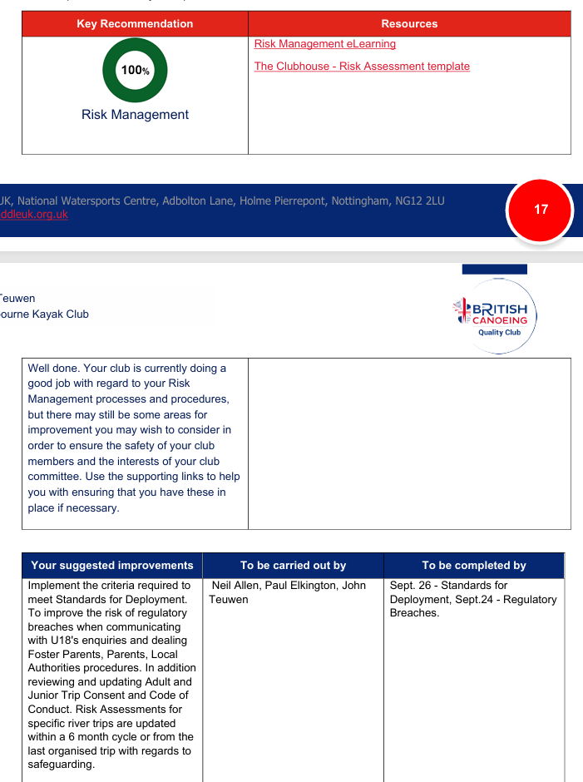
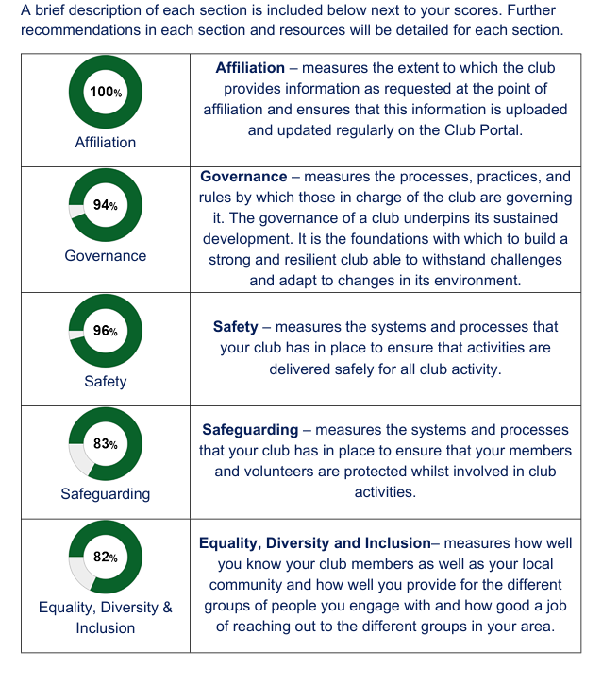
Quality Club Toolkit 2024 -2025 (89%) Completed in October 2024

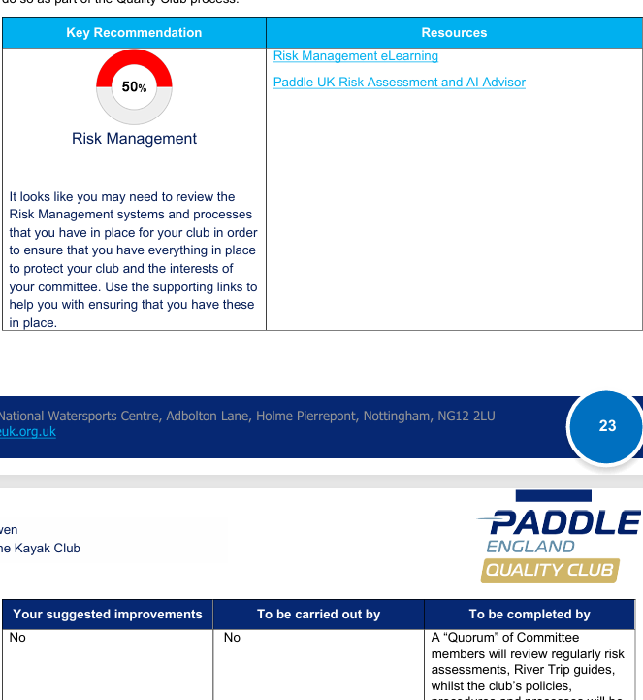
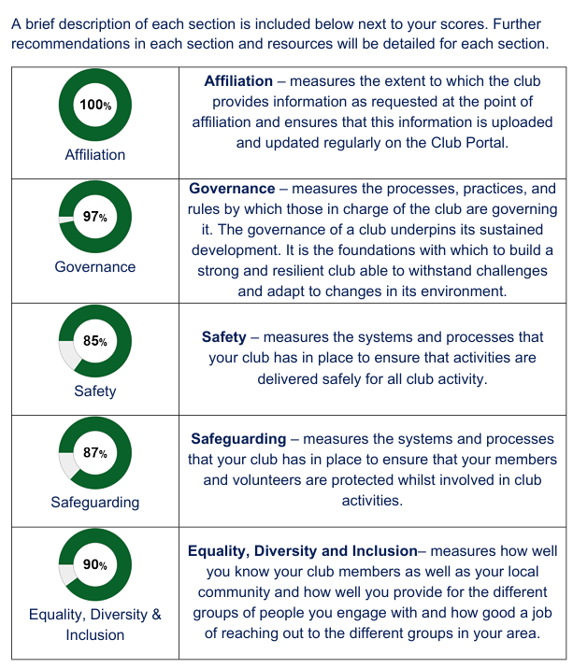
Quality Club Toolkit 2025-2026 (91%)

Describe any changes you will make to improve Risk Management at your club.
Copied & pasted, checked, saved!!! But not recorded in Quality Club Toolkit!!!!
Risk Assessments are undertaken and checked regularly or updated because of incident, e.g. The Llangollen Bridge incident in 2022 reported in “The Paddler”, Wombourne KC were present at that location and witnessed the impacts off the river to the participants involved. Consequently, we updated our risk assessment for this section of the Dee because of the hazard identified in this incident. The risk assessments identify “Generic, Specific” risks, which is supported by video footage River Conwy: Ysbyty Ifan to Rhydlanfair Bridge. The Risk Assessment used by WKC- replicates Paddle UK Template, with the addition of a ”Consequences and Likelihood” chart to score the risk.
Dynamic Risk Assessments are managed on the river by the coaches and leaders supported by experienced paddlers identified in WKC – Club Portal Club Members Qualifications and Credentials, e.g. AWWS 4% (3). 68.5% (48) WWSR, 5.5% (5) have FSRT/PSSW. Hence, the club puts great emphasis on the implementation and responsibility with regards to “Duty of Care” and has included a statement for those members participating in club activities within their Operating Standards Procedures on p10
Consequently, suitable procedures within the Health and Safety Policy, Operating Standards Procedures using the Paddle UK – Planned Activity Model, p3-7, supported by an annual review using H&S Checklist for Planned Activities, alongside the “Paddlesafer” and Paddle UK Risk Assessment guidance, is embedded within the club by promoting good practice to members and club volunteers during planned activities. Furthermore, a risk acknowledgement is included in WKC Consent Trip Form requiring the member consent/acceptance of risk, e.g. a tick box and signature is required as part of the joining process. The club has also produced a Pre-and On the water Emergency Plan, which Club Coaches and Leaders have been informed, with relevant links to support the planning of a trip and documents to assist an incident, e.g. Casualty Card, Major Incident Response, Emergency Response. Furthermore, the club has produced video River Trip Guides, e.g. River Conway to support members in identifying the location to “Access and Egress”
Who will implement the changes? A “Quorum” of Committee members will review regularly risk assessments, River Trip guides, whilst the club’s policies, procedures and processes will be updated accordingly, such as new Paddle UK policies updates as part of the “Quality Club” affiliation. The Committee will also sample the Paddle UK – A1 Risk Assessment Advisor to sample a WKC- Risk Assessment.
When will they be implemented by? Specific club committee members involved in the implementation of Paddle UK – Affiliation process in October. Finally, the Committee decision making is documented in the WKC – Consultation and Action Logbook, that supports the Three-year Strategic Development Plan, particularly in meeting the criteria for Standards of Deployment for 2026. The Committee will also sample the Paddle UK – A1 Risk Assessment Advisor to sample a WKC- Risk Assessment during the next year.

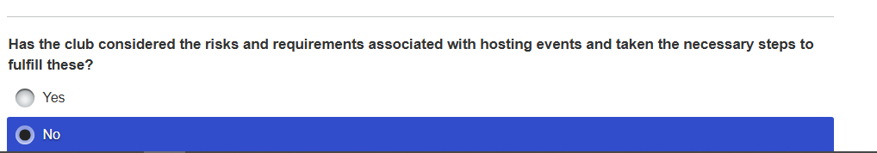

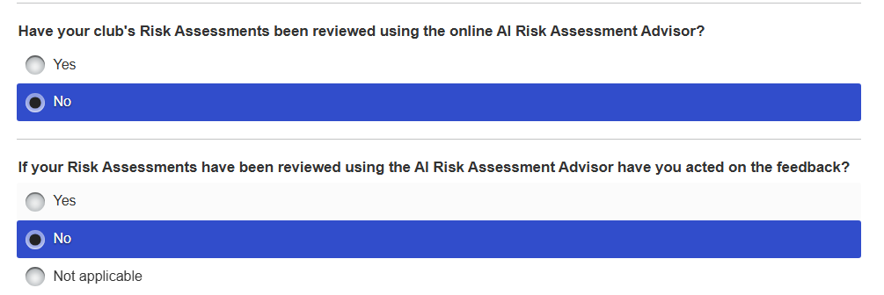

Q. How can the club be assessed at 100% in October 2024, then in September 2025 50%?
Answer NO –
The club does not host events! The H&S Officer has completed the eLearning for Events Safety Management.
It seems some evidence has not been considered! E.g. H&S Checklist for Planned Activities, Risk Assessment for
River Conwy: Ysbyty Ifan to Rhydlanfair Bridge.
Conclusion:
Assessment based on not using the AI Risk Assessment ADVISOR!!!

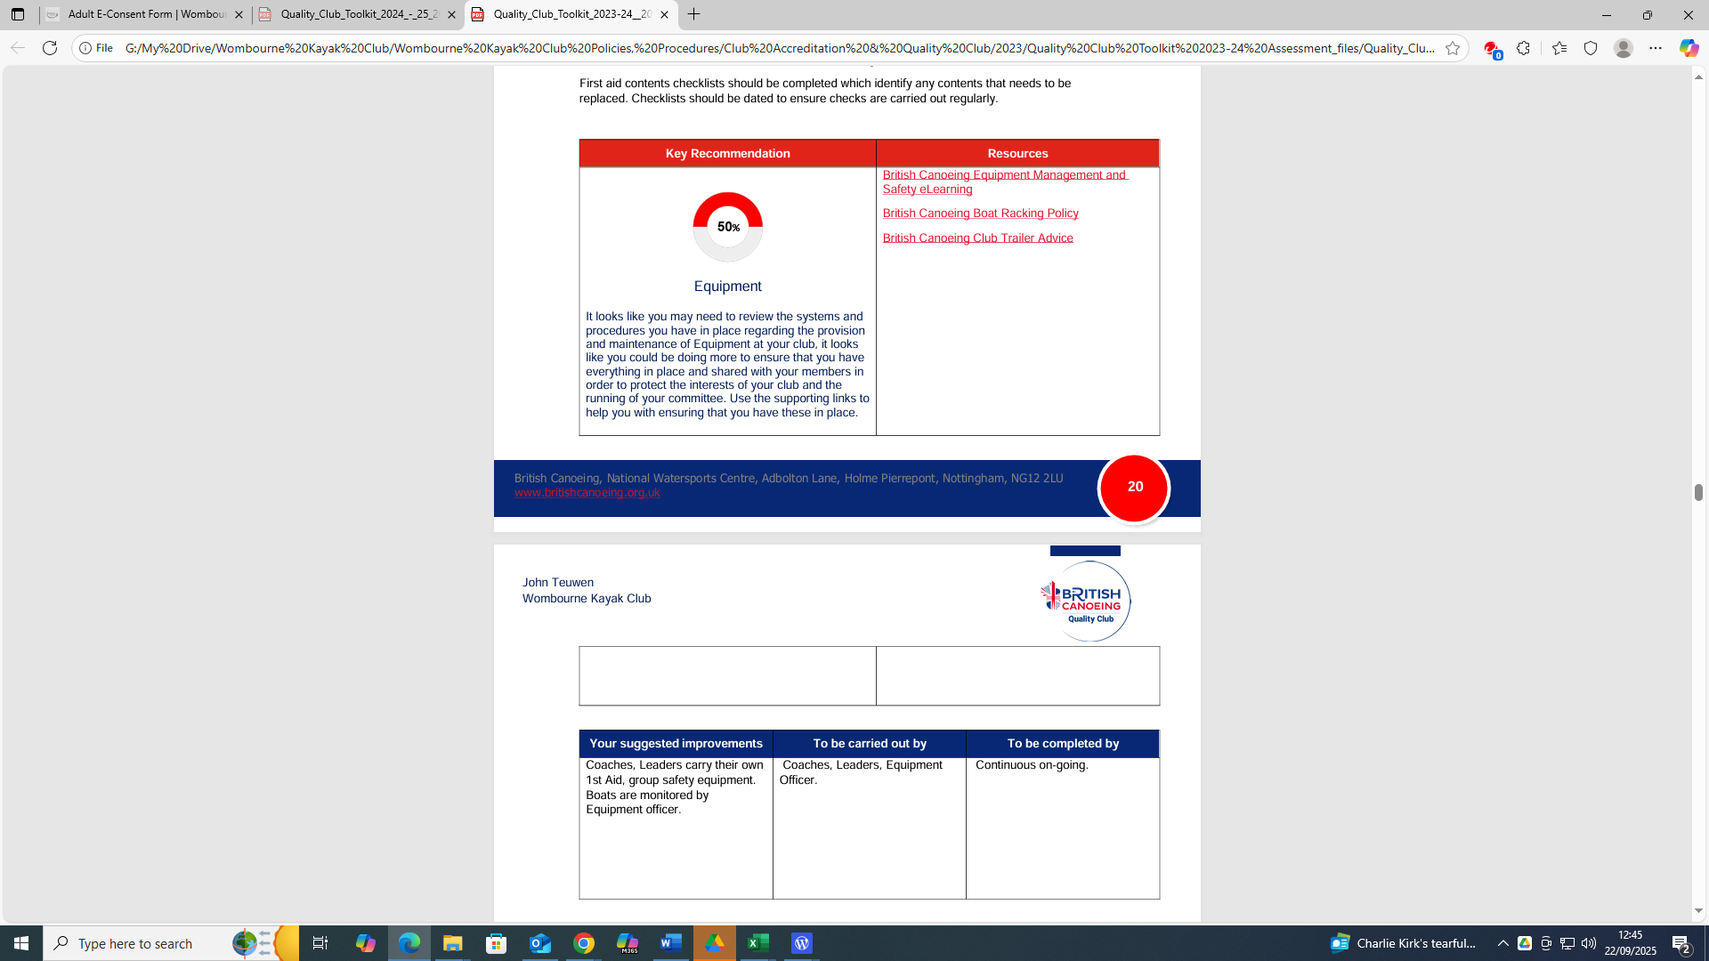
Equipment Quality Club Toolkit 2023 -2024 (79%) Completed in July 2024

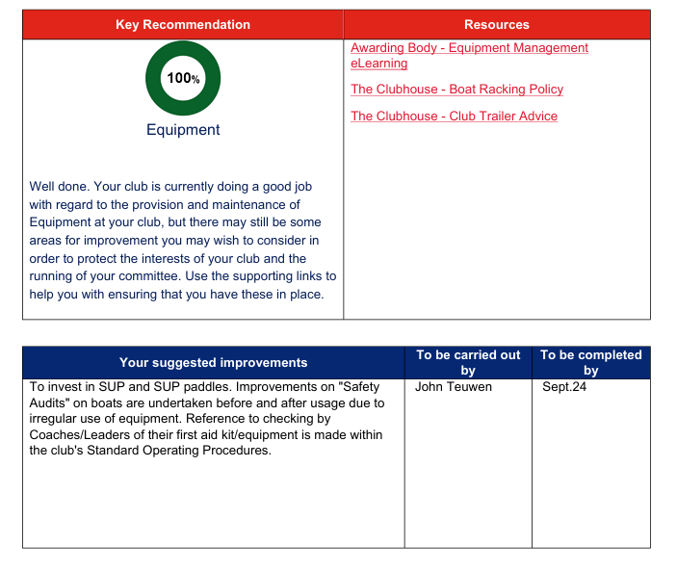
Quality Club Toolkit 2024 -2025 (89%) Completed in October 2024
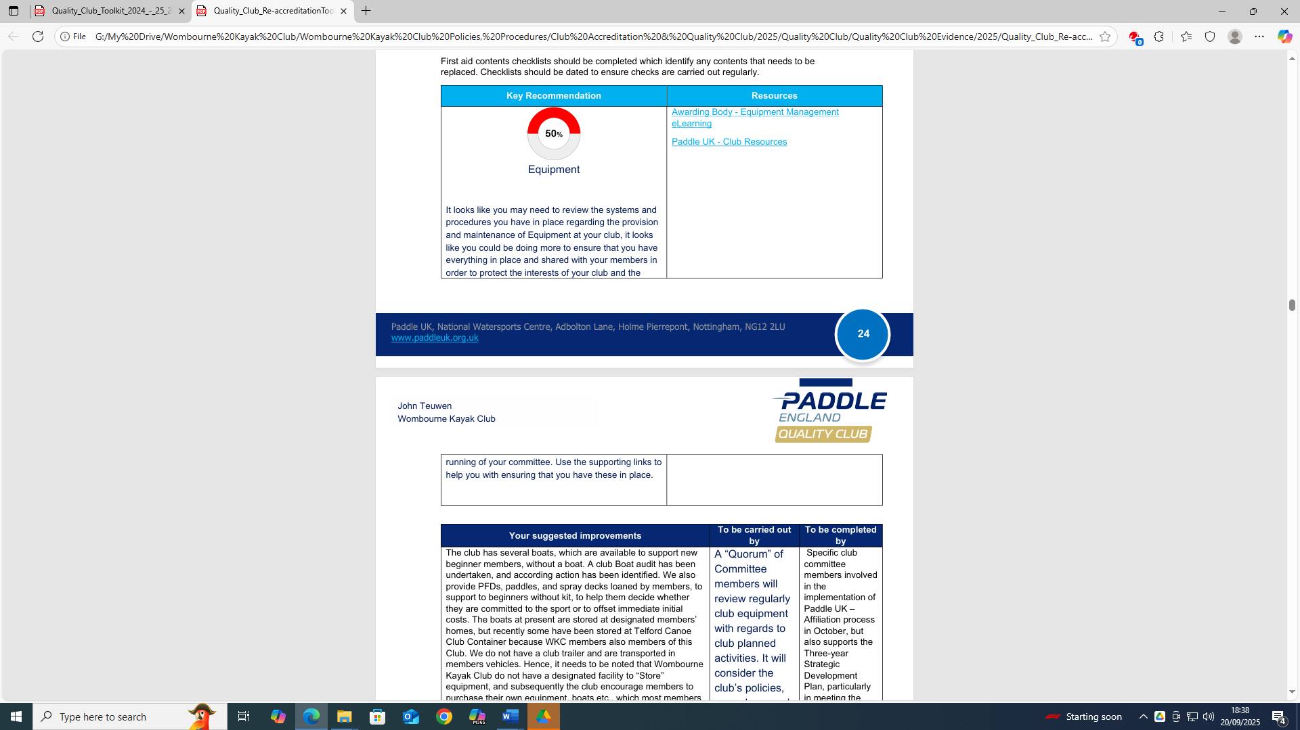
Quality Club Toolkit 2025-2026 (91%)

Q. How can the club be assessed at 100% in October 2024, then in September 2025 50%?
Conclusion:
No Club House to store equipment, boats stored at members houses to support beginners, whilst helmets, BA’s, paddles are provided by members’ personal kit. Hence, majority of members provide their own kit.
The club coaches/leaders have attended whitewater and safety training and have purchased appropriate safety equipment to manage an incident on the river, which includes 1st Aid kits, that are maintained by individual members to ensure timescales for checking contents.
Solution:
Equipment Management eLearning, Club Resources | Documents and Guidance | Paddle UK, which the club have evidence on the website!!!!
We have moved our Pool Sessions & Club Address to another venue from Codsall Community School to Arthog Sport & Outdoor Leisure Centre, to a Monday 6-9pm.
This means that the boats, buoyancy aids, paddles, helmets can be used by club members and checked by Arthog, which is Telford and Wrekin Council Sports and Outdoor department in which 2 of Wombourne Kayak Club Coaches are employed as voluntary staff to manage the pool sessions.

Safeguarding Procedures
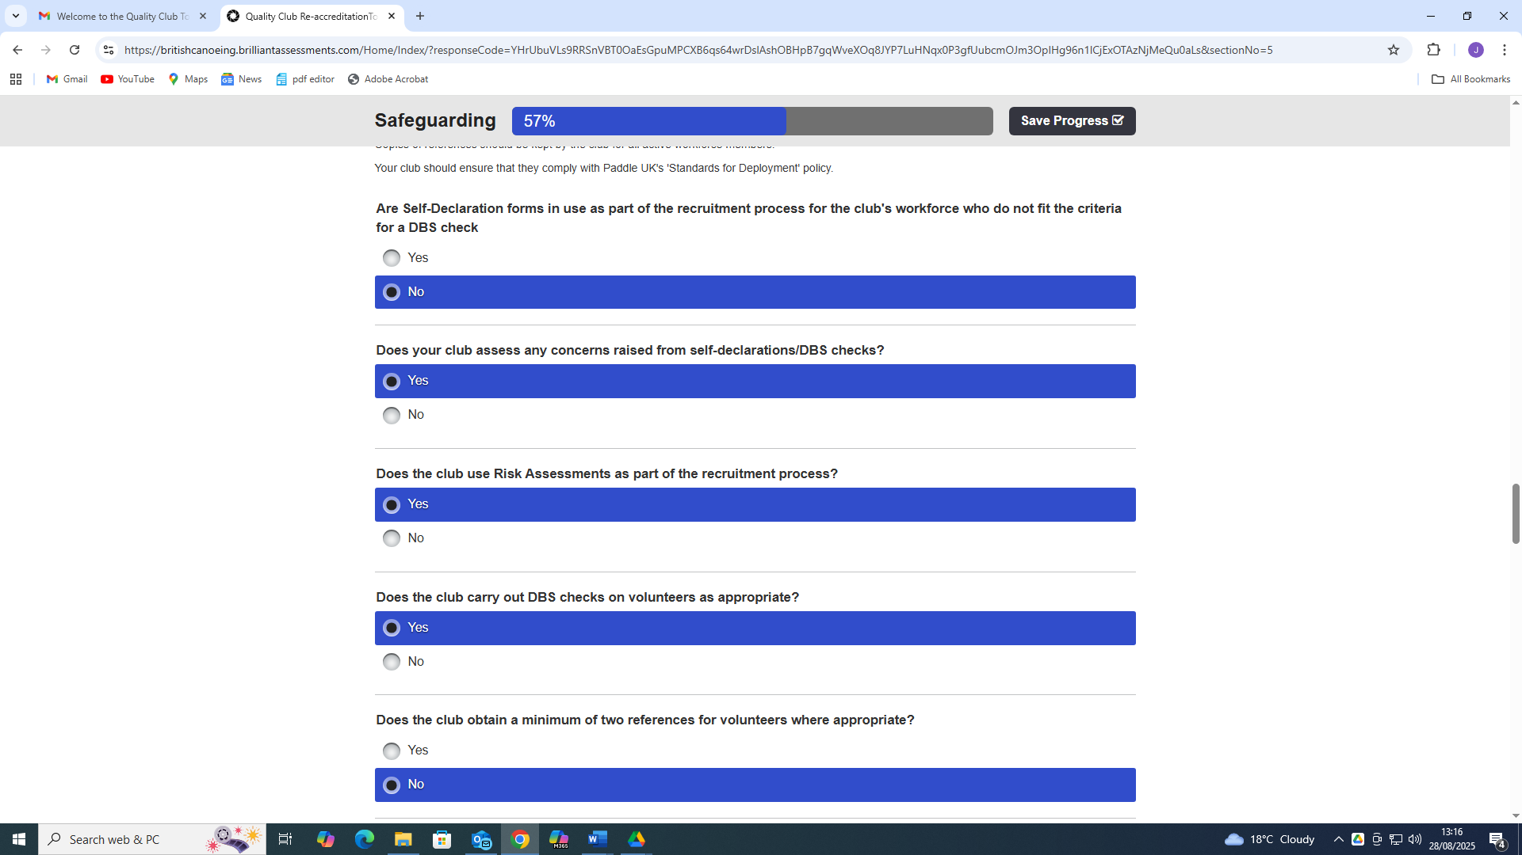
Quality Club Toolkit 2025-2026 (91%)
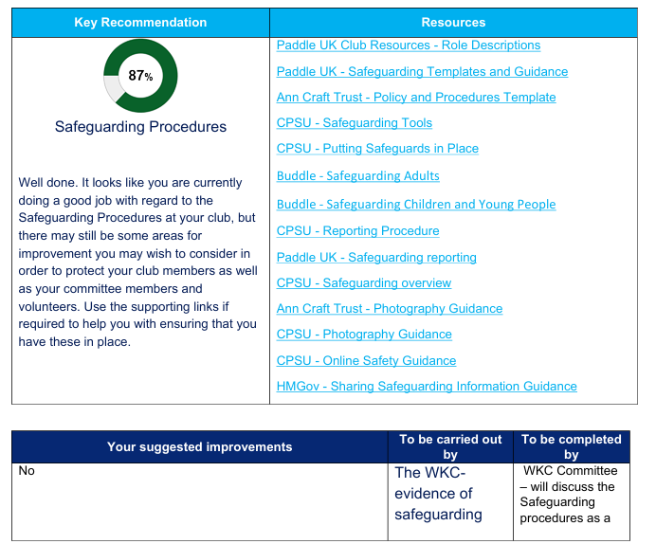

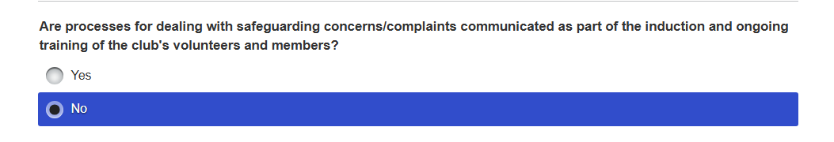

Conclusion:
The evidence of safeguarding policies communicated to all members, was highlighted as an issue in the WKC – Club Survey Results Report in Question 6:
The planned club activities meeting the needs of Young Members (U18) and Vulnerable Adults provided a mixed result between Very Satisfied, Satisfied and Don’t Know, that may suggest the membership has an understanding or lack of understanding with regards to managing “Safeguarding”. Hence, it is important to consider the next question before answering this anomaly.
Question 7:
This response to, “Does the Club provides appropriate Safeguarding Guidance to meet the needs of Young Members (U18) and Vulnerable Adults”? This response to supports the previous conclusion between Very Satisfied, Satisfied, Don’t Know, but identified further that 25% were “Very Dissatisfied” members! Hence, the Committee member responsible for the Survey informed the Chairperson about his concern that perhaps some members had not fully understood, lacked knowledge or the question was “Ambiguous”.
The chairperson also felt that some members may not understand “Safeguarding” and the necessary steps to ensure that good practice is embedded in the club, we had an example yesterday where we were ready to do the shuttles for all the drivers to collect their vehicles, but it would have meant a 15-year-old being left alone. One adult offered to stay with the junior but that’s also not acceptable, so the junior came on the shuttle leaving the adult at the bottom to watch the kayaks. In addition, Cris a Committee member stated it happens as a matter of course, but you probably wouldn’t spot it unless you were involved. Shellie also another Committee member mentioned that’s a great point, and I will post the link to the club chat. Subsequently, also Paul mentioned, that members may not know about “safeguarding” guidance because the club has never had any concerns and has implemented the policies, procedures and processes to reduce or prevent any situation from arising.
Finally, it must be noted that Wombourne Kayak Club do not have a “Clubhouse” to promote “Safeguarding” information on a notice board. In addition, most volunteers have no contact or irregular contact with minors under 18, and the club does not currently have any members identified as “Vulnerable adults”.
Who will implement the changes?
WKC Committee – will discuss the Safeguarding Policy issue of communicating to all members, as well as the Induction Pack, and Welcome Pack, and posting “How to find Information” Flowchart on. We will issue a WKC -WhatsApp message to all members to ask them to look at the policy, and provide a link to it, including the other listed documents. This will be supported by Chairperson Paul Elkington statement.

Recruitment & Deployment - Quality Club Toolkit 2023 -2024 (79%) Completed in July 2024
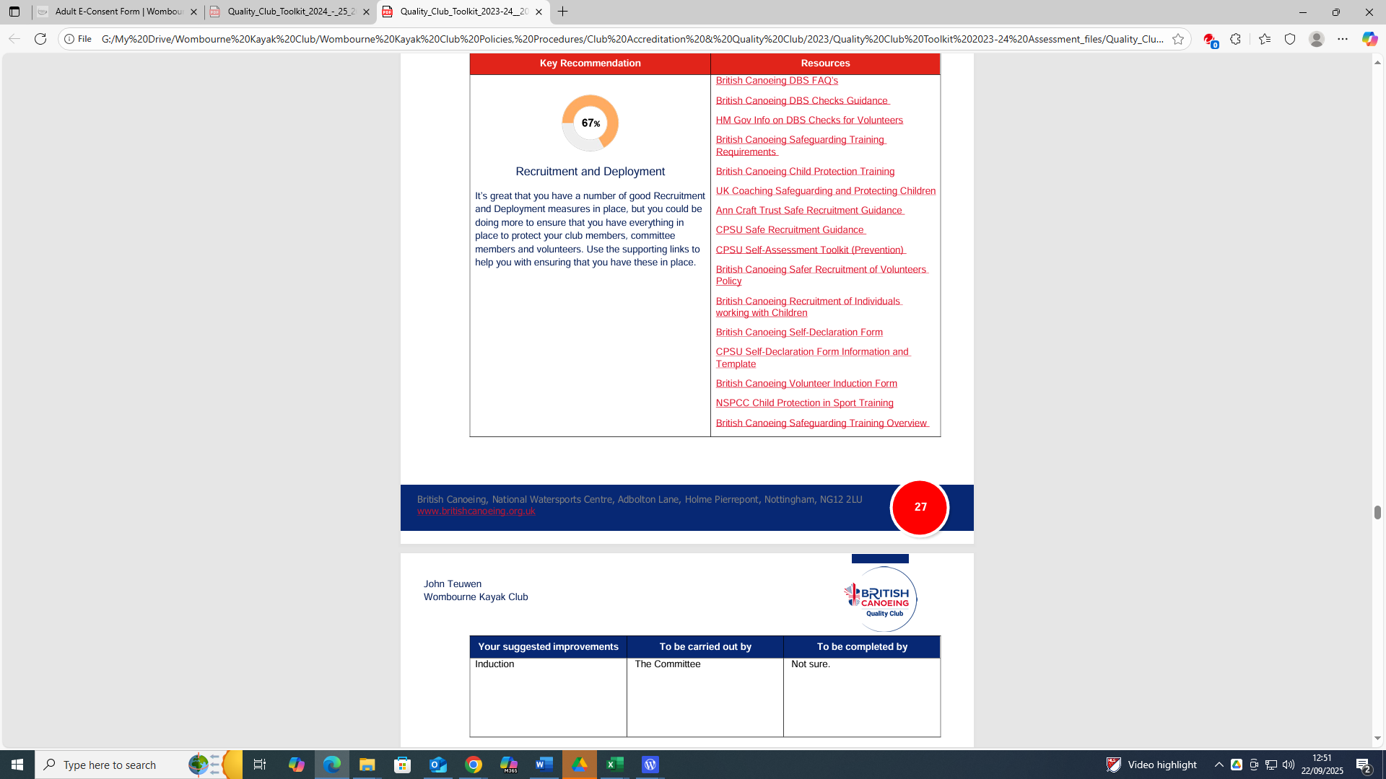

Quality Club Toolkit 2024 -2025 (89%) Completed in October 2024
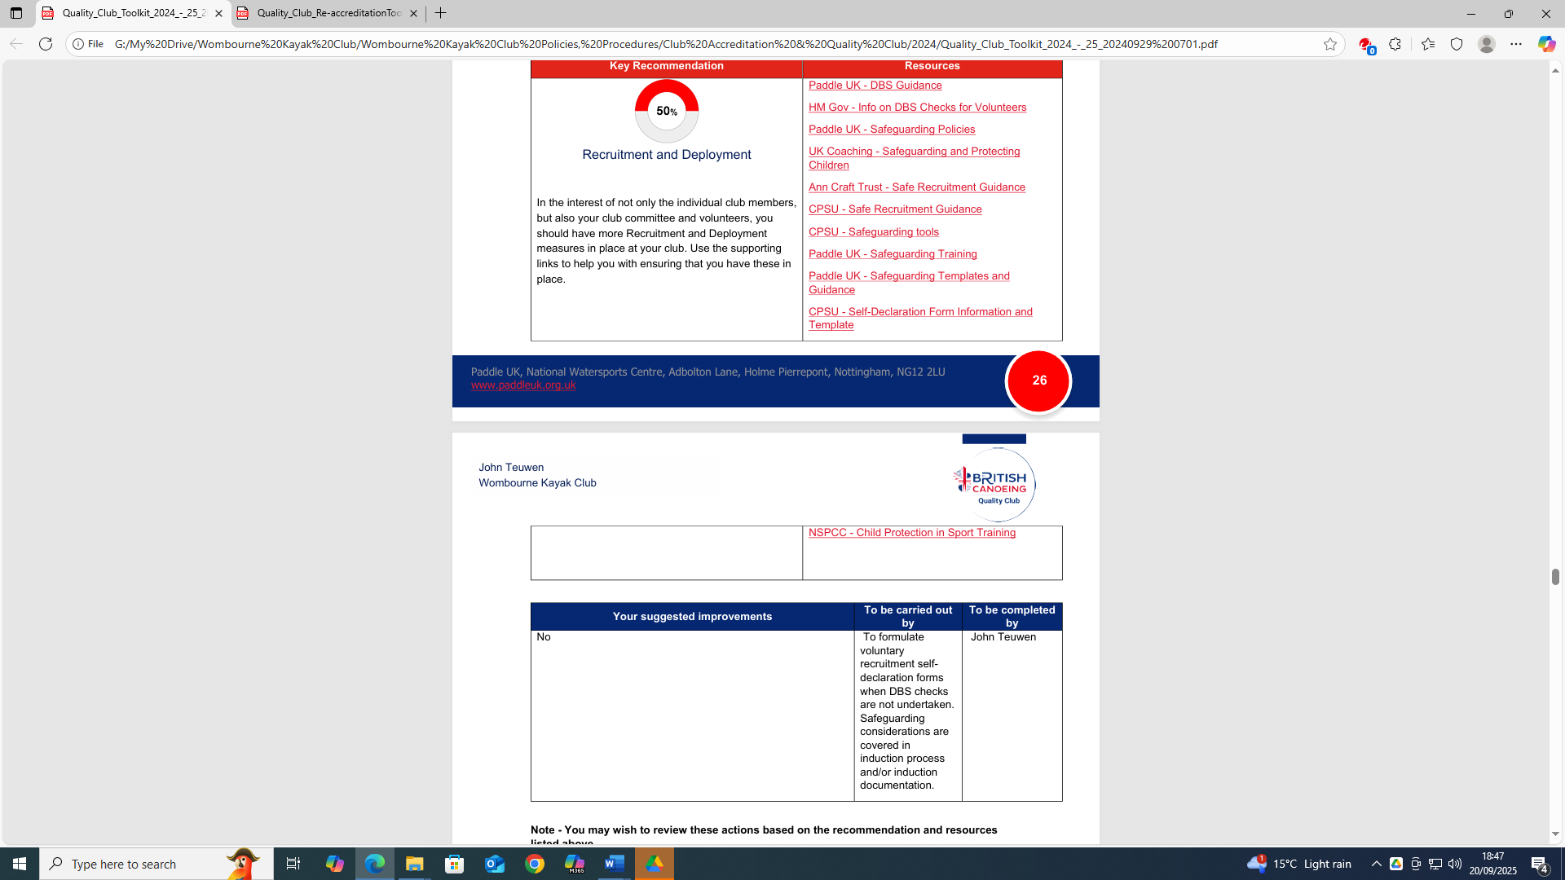

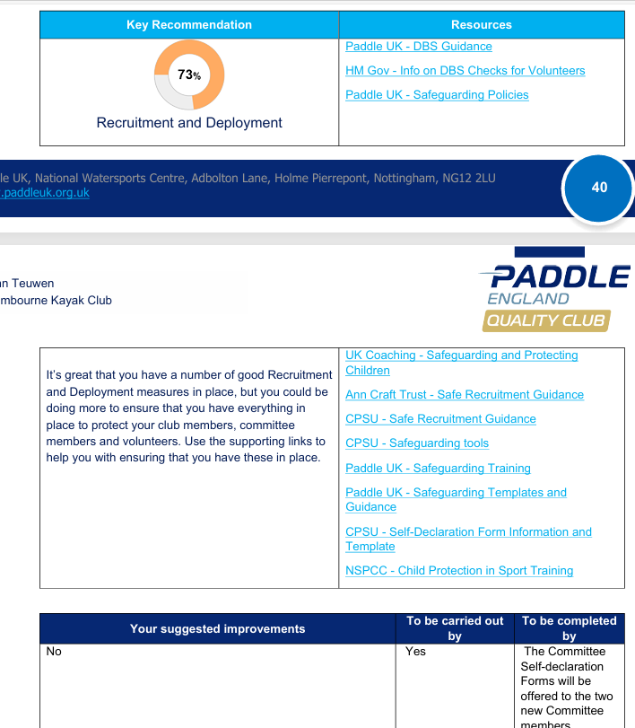
Quality Club Toolkit 2025 -2026 (91%)

Conclusion:
Consider Self Declaration Forms or undertake a DBS check for the two new Committee members, which will identify any safeguarding concerns. With regards to Safeguarding Training offer them the Free eLearning Safeguarding Training. Furthermore, it is difficult to recruit Volunteers who have extremely busy employment responsibilities to offer their help in managing a paddle club!! The Risk Register also identifies the reliance on one Committee member to manage the day to day club matters, fortunately this member is retired but is prepared to undertake these responsibilities using his “Skill set” to set up guidance in mentoring new Committee members into their roles. Finally, the recommended Paddle UK Safeguarding Policies are available on the website!!!!
Understanding your Local Community -Quality Club Toolkit 2023 -2024 (79%) Completed in July 2024
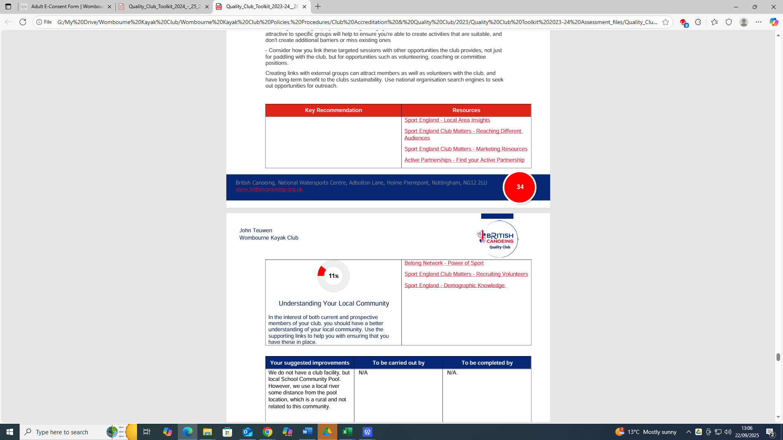

Quality Club Toolkit 2024 -2025 (89%) Completed in October 2024
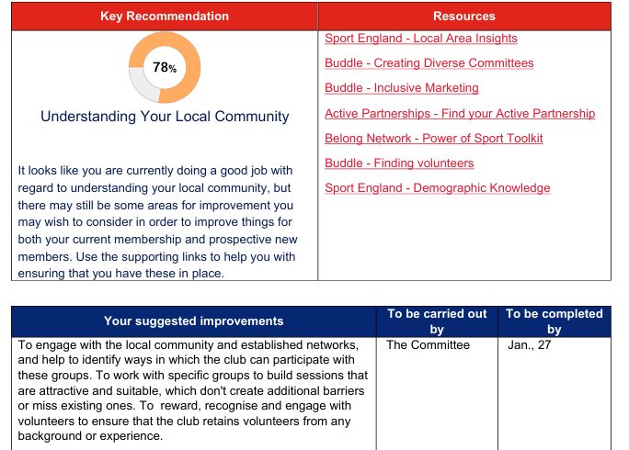
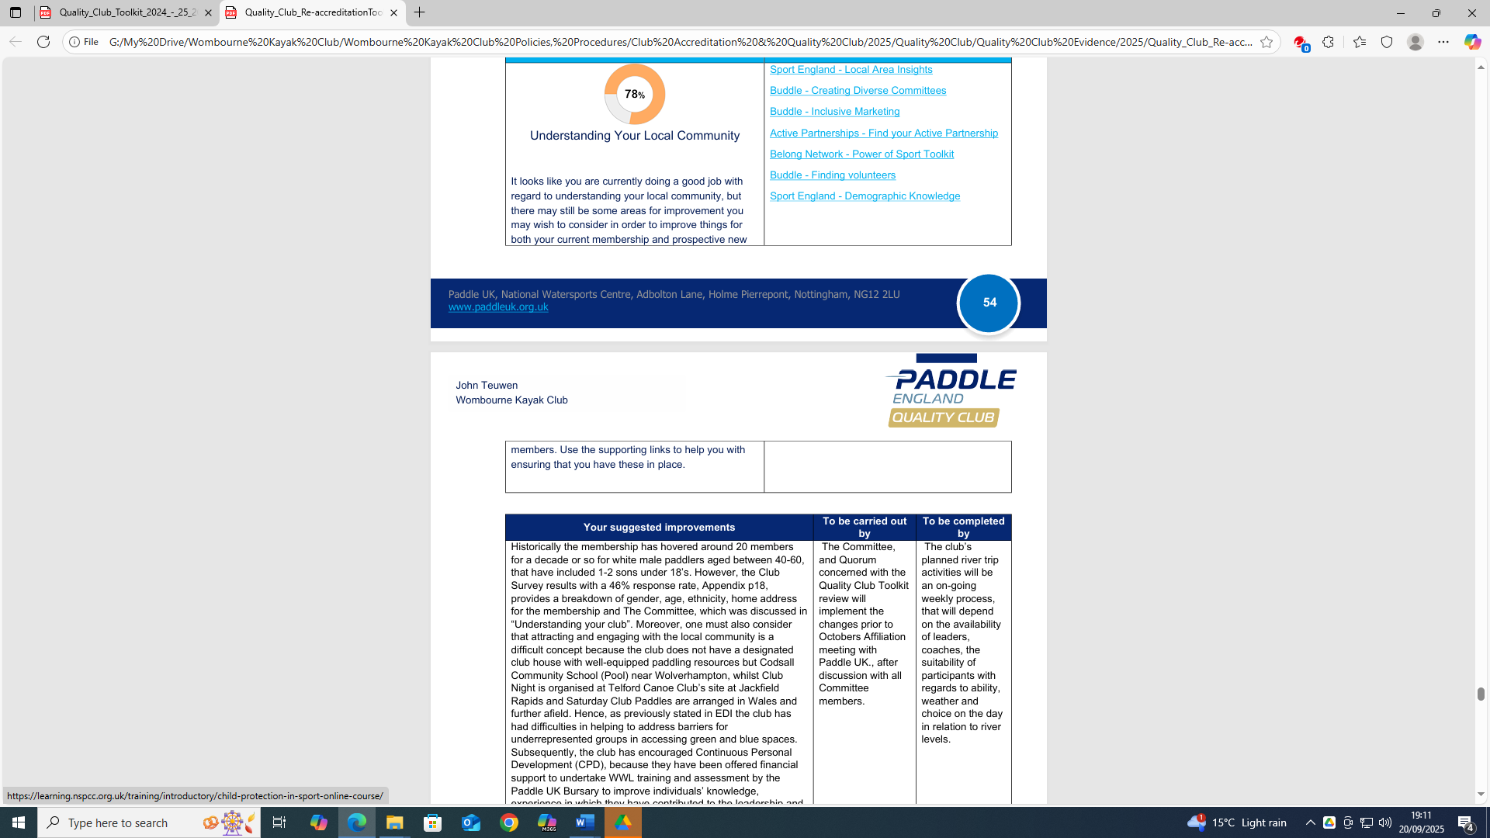
Quality Club Toolkit 2025 -2026 (91%)

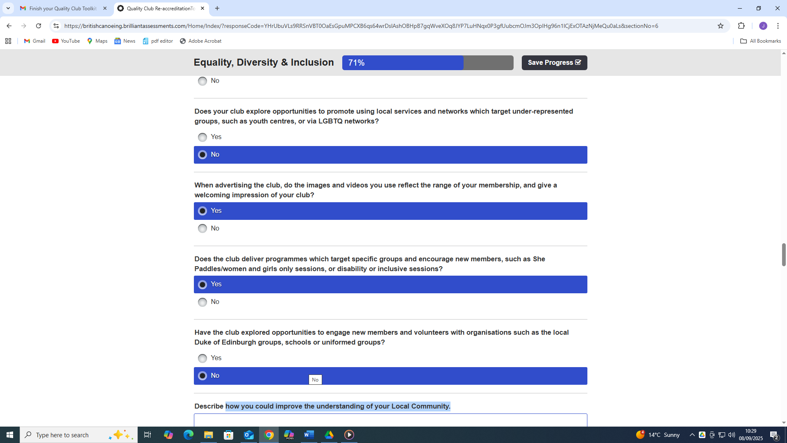

Q. How is the club attracting new members throughout the year by not understanding the local community needs to paddle on a weekly basis?
Conclusion:
The club is being penalised because we do not operate like a normal club.
- No Club House, club based at the pool location but has changed from Codsall to Wellington near Telford but can offer opportunities to beginners.
- The club operate in a rural environment and not an urban location.
- Members need transport to participate in club activities
- Cost factors such as travelling to various locations, e.g. Wales
- Membership from various locations, e.g. West & East Midlands, North-West, North Wales, South-West.
Making Paddling Accessible -Quality Club Toolkit 2023 -2024 (79%) Completed in July 2024
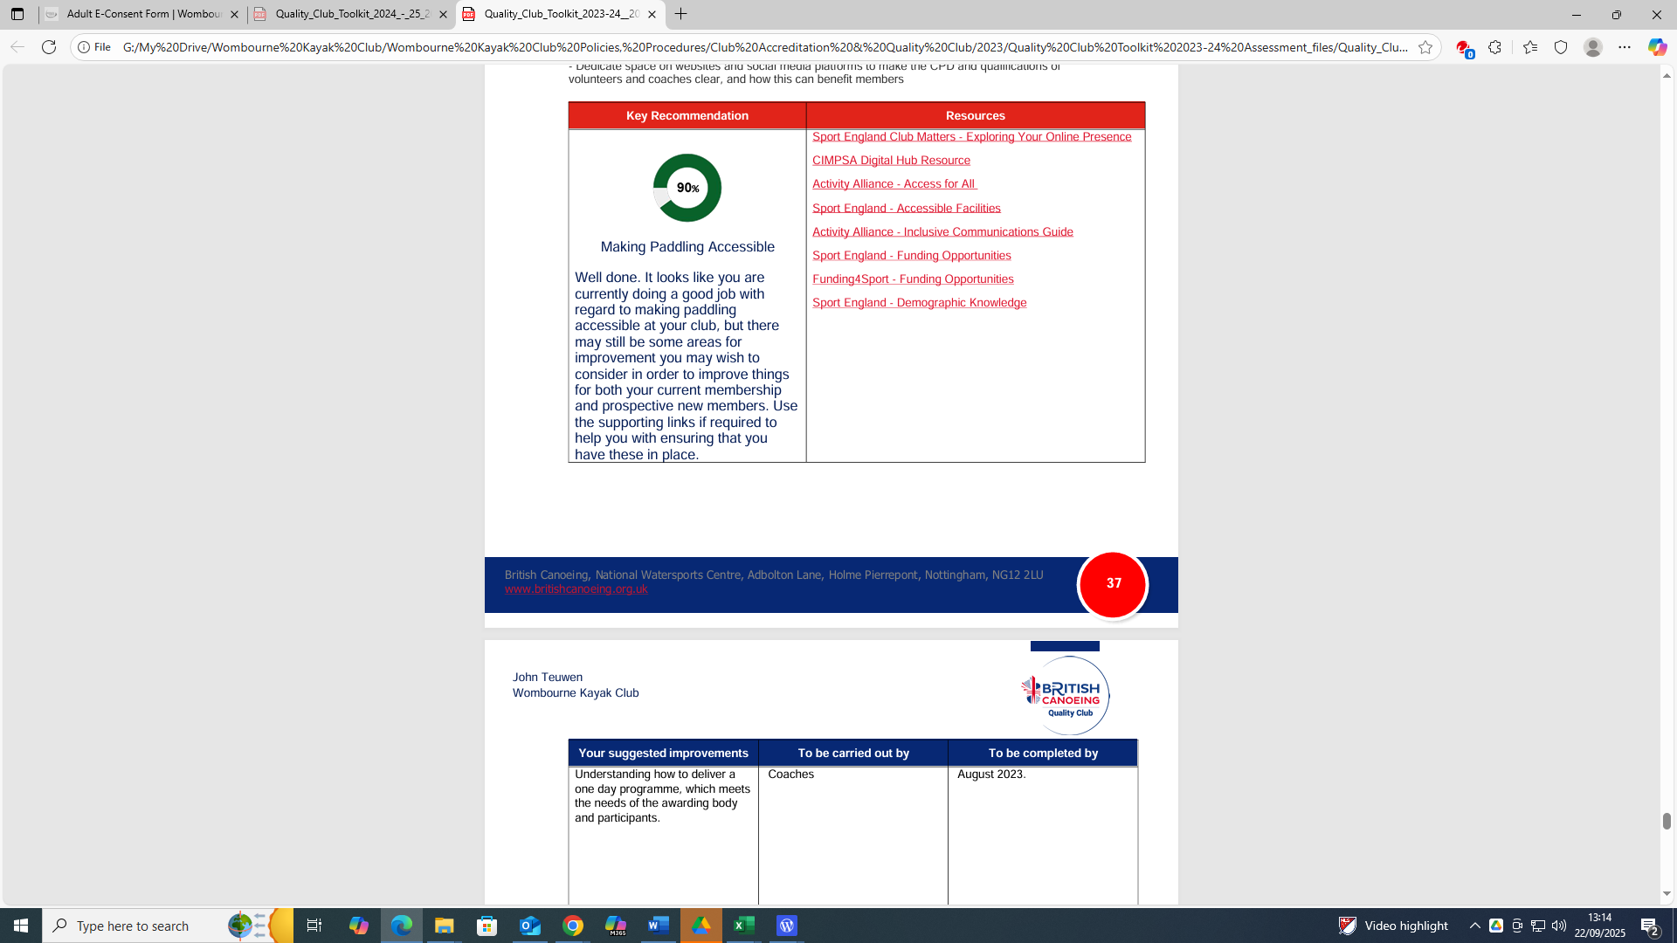

Quality Club Toolkit 2024 -2025 (89%) Completed in October 2024
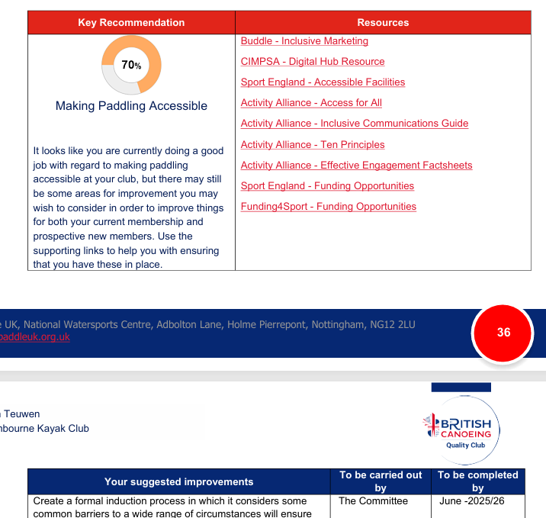
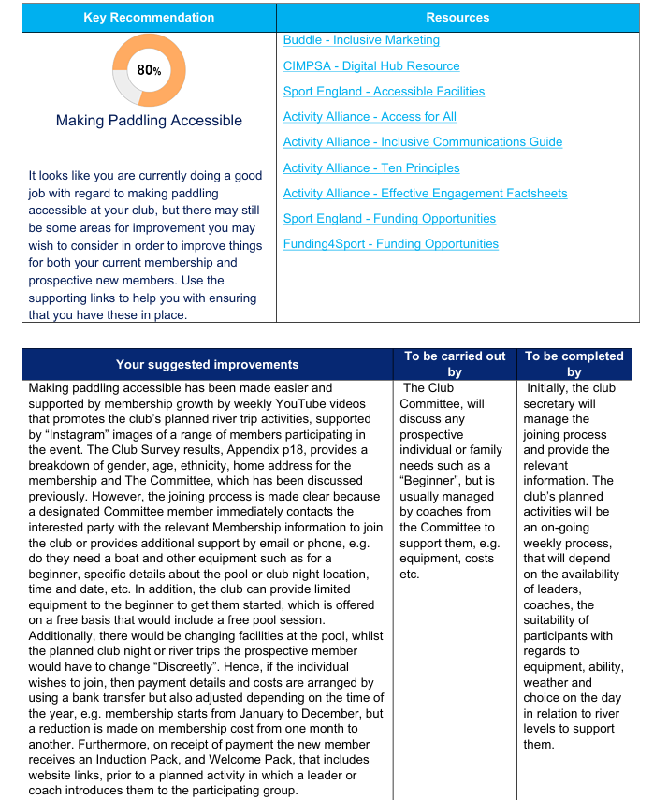
Quality Club Toolkit 2025 -2026 (91%)

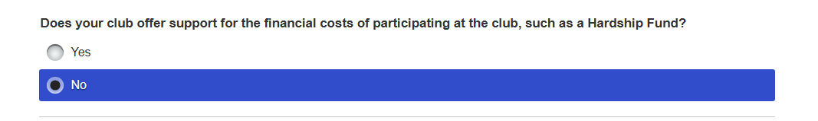

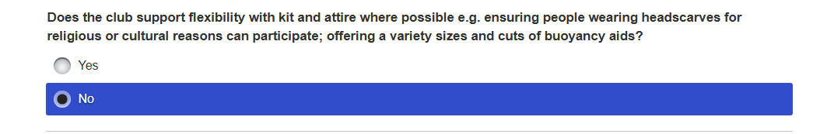

Q. How is the club attracting new members throughout the year by not understanding the local community needs to paddle on a weekly basis?
Conclusion:
- No Club House, club based at the pool location but has changed from Codsall to Wellington near Telford but can offer opportunities to beginners on a weekly basis at Arthog Sport & Outdoor Centre, using the available boats, paddles at the centre, which are free to use, whilst also supporting new paddlers with limited resource financial help, e.g. free pool sessions.
- The club has no experience of prospective participants requesting financial support or dealing with cultural, religious reasons.

