Location: | River Conwy – Ysbyty Ifan to Rhydlanfair Bridge  Post Code: LL24 0NH  Post Code: LL240SR  River Levels River Conwy  The Welsh Rivers Book p40  UK Rivers Guide | Grid Reference: | Access:  Ysbyty Ifan  SH 84219 48817  A5 Bridge  SH 85734 51231  footpath on the right down to the river.  Egress:  650m below Rhydlanfair Bridge where purpose-built steps have been created.  SH 82201 52860
Types of Trips: | Club recreational kayak trip
Video Footage: | See Videos:  https://www.youtube.com/watch?v=pbK-fX3Mgzk&t=639 14th November 2015 – John (1)  https://www.youtube.com/watch?v=aRM0fBagH1I 12th October 2019 Part A – John (2)  https://www.youtube.com/watch?v=3zHq88paZ90 12th October 2019 Part B – John (3)  https://www.youtube.com/watch?v=te4ozKY_T9E 6th April 2024 - John (4)  https://www.youtube.com/watch?v=1W6UxSpV3iU 6th April 2024 - Zed (5)  https://www.youtube.com/watch?v=pjI-huWcTuM 6th April 2024 - Paul (6)  https://youtu.be/Xu9ootu4OC8 22/11/25 (John) (7) | Date: | 11/11/25
Wombourne Kayak Club River Guide: Dulas - Corris

Feature | Ysbyty-Ifan Section  Grade 2-3+ https://www.youtube.com/watch?v=1W6UxSpV3iU 6th April 2024 - Zed (5) 0.10 – 5.50 minutes.  https://www.youtube.com/watch?v=te4ozKY_T9E 6th April 2024 - John (2) 0.52 – 1.18 minutes  (Hargreaves Folly depending on river level) Rapids. River Level needs to be 1.7m, otherwise a “Pinning” issue!  Route: Hargreaves Folly; take  Left side drop as the channel is shorter than the right side.  Boof off rock on the left side before drop, you may need a “Low brace” to assist into deep water.  Note: main danger is “Overhanging” branches, particularly in the Spring, Summer & Autumn months.  https://www.youtube.com/watch?v=te4ozKY_T9E 6th April 2024 - John (2) 0.19 – 0.52 minutes
Feature | A5 -1st Bridge: drops & wave trains, “S” bends, left side for passing through bridge.  https://www.youtube.com/watch?v=pbK-fX3Mgzk&t=639 14th November 2015 John (1) 0.01 – 5.28 mins  https://www.youtube.com/watch?v=aRM0fBagH1I 12th October 2019 Part A – John (2) 0.01 – 4.0 mins  https://www.youtube.com/watch?v=te4ozKY_T9E 6th April 2024 - John (4) 1.18 – 4 minutes
Feature | 1st Bridge – 2nd Bridge: drops & wave trains as before, but there was a tree on the opposite side of bridge, in 2015.  https://www.youtube.com/watch?v=pbK-fX3Mgzk&t=639 14th November 2015 John (1) 5.28 - 7.40 mins  https://www.youtube.com/watch?v=aRM0fBagH1I 12th October 2019 Part A – John (2) 4.0 – 6.34mins  https://www.youtube.com/watch?v=te4ozKY_T9E 6th April 2024 - John (4) 4 – 5.54 minutes

Feature | 2nd Bridge – 3rd Bridge: drops, wave trains & “S” bend, take left side route through bridge.  https://www.youtube.com/watch?v=pbK-fX3Mgzk&t=639 14th November 2015 John (1) 7.40 10.36 mins  https://www.youtube.com/watch?v=aRM0fBagH1I 12th October 2019 Part A – John (2) 6.34 – 11.06 mins  https://www.youtube.com/watch?v=te4ozKY_T9E 6th April 2024 - John (4) 5.54 – 8.32 minutes
Feature | “The Cannon” start from the right to be left side, straighten up, take central right position, be aware of “Plume” in 1.3 level as current as it can push to the right. Find eddy on right.  https://www.youtube.com/watch?v=pbK-fX3Mgzk&t=639 14th November 2015 John (1) 10.36 – 11.45 mins.  https://www.youtube.com/watch?v=aRM0fBagH1I 12th October 2019 Part A – John (2) 11.51 – 13.11 mins  https://www.youtube.com/watch?v=te4ozKY_T9E 6th April 2024 - John (4) 8.36 – 10.07 minutes  Entrance to “The Cannon” blocked by tree, need to keep “Hard” right by road wall down to the entrance of  Bryn- Bras Falls!!!!!!!
Feature | Bryn- Bras Falls – start right near the road wall, then turn to the left onto “S” bend move between rocks, straighten up, keep tight to right side then turn about 5m. But if you miss there is another gap, straighten up and head down succession of mini drops, big eddy on the left.  https://www.youtube.com/watch?v=pbK-fX3Mgzk&t=639 14th November 2015 John (1) 11.51 – 12.36 mins.  https://www.youtube.com/watch?v=aRM0fBagH1I 12th October 2019 Part A – John (2) 13.26 - 14.42 mins  https://www.youtube.com/watch?v=te4ozKY_T9E 6th April 2024 - John (4) 11.11 – 14.49minutes

Feature | Bryn- Bras Falls – Egress, 650m on the right beyond Rhydlanfair Bridge. As previous, grade 2-3, drops & wave trains as.  https://www.youtube.com/watch?v=pbK-fX3Mgzk&t=639 14th November 2015 John (1) 12.36 – 18.40 mins.  https://www.youtube.com/watch?v=3zHq88paZ90 12th October 2019 Part B – John (3) 0.01- 4.38 mins.  https://www.youtube.com/watch?v=te4ozKY_T9E 6th April 2024 - John (4) 10.07 – 11.09 minutes

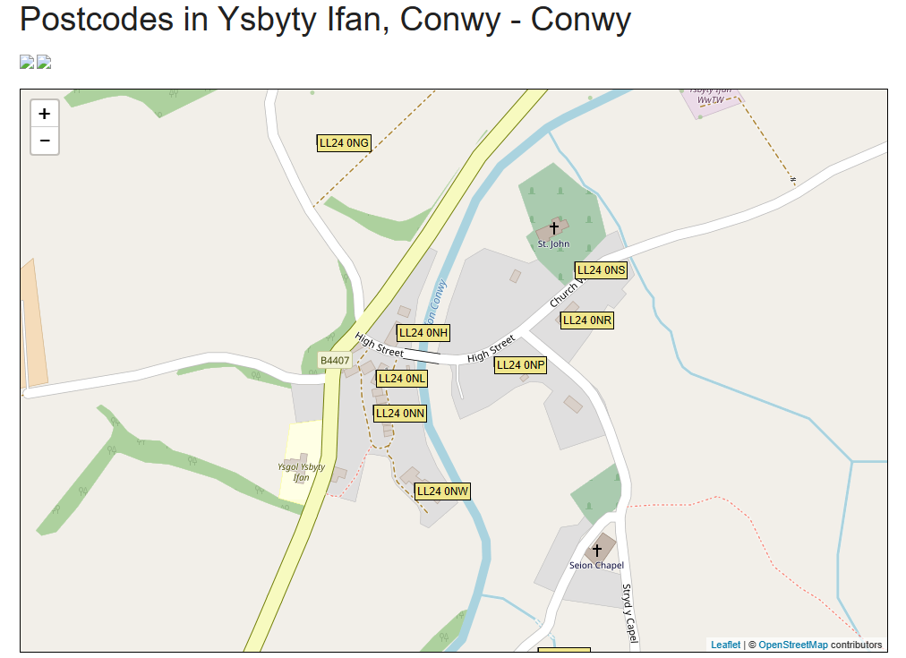
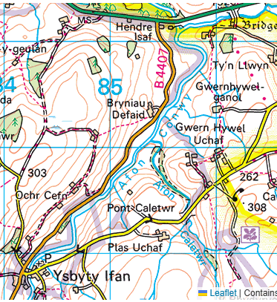
Ysbyty Ifan to A5 Bridge Section

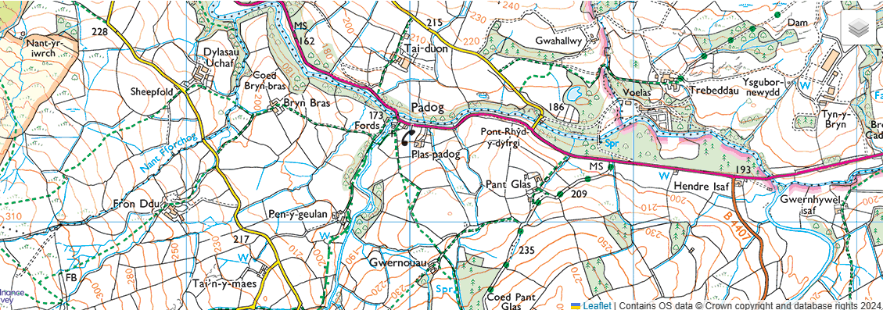
A5 Section to Bryn Bras Falls
Egress:
`
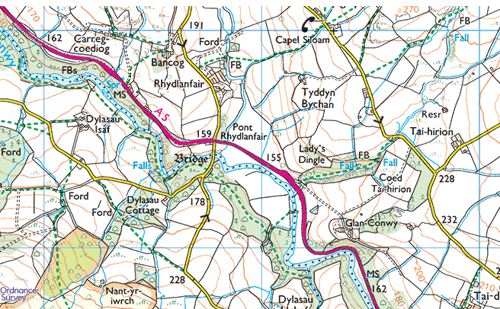
650m below Rhydlanfair Bridge where purpose-built steps has been created to enable paddlers access to the layby on A5.
53°03'33.8"N 3°45'25.6"W
